#include <iostream>

using namespace std;

#include <string>

int main()

{

system("pause");

return 0;

}

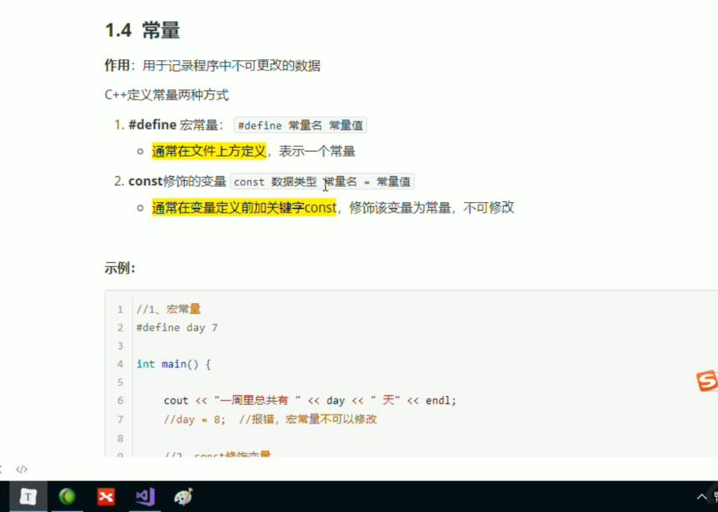

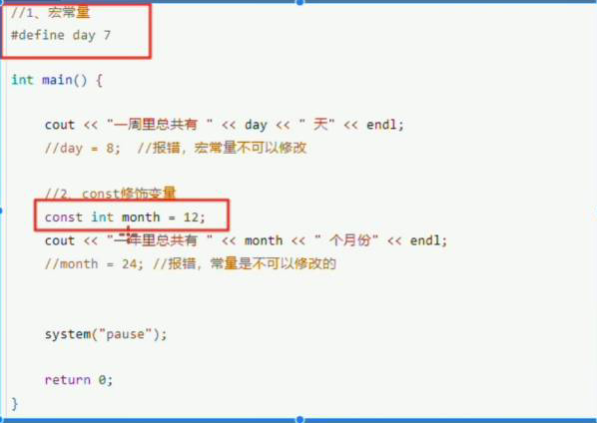

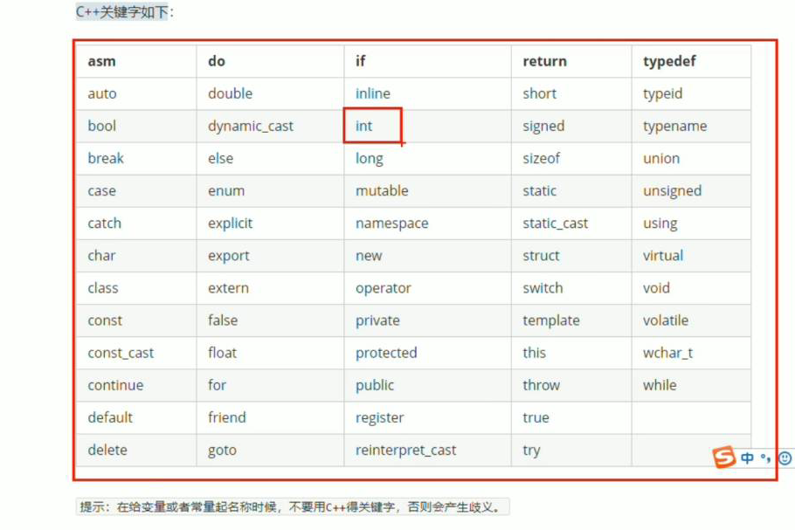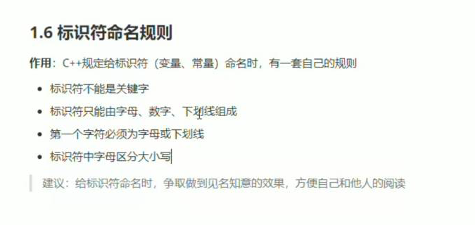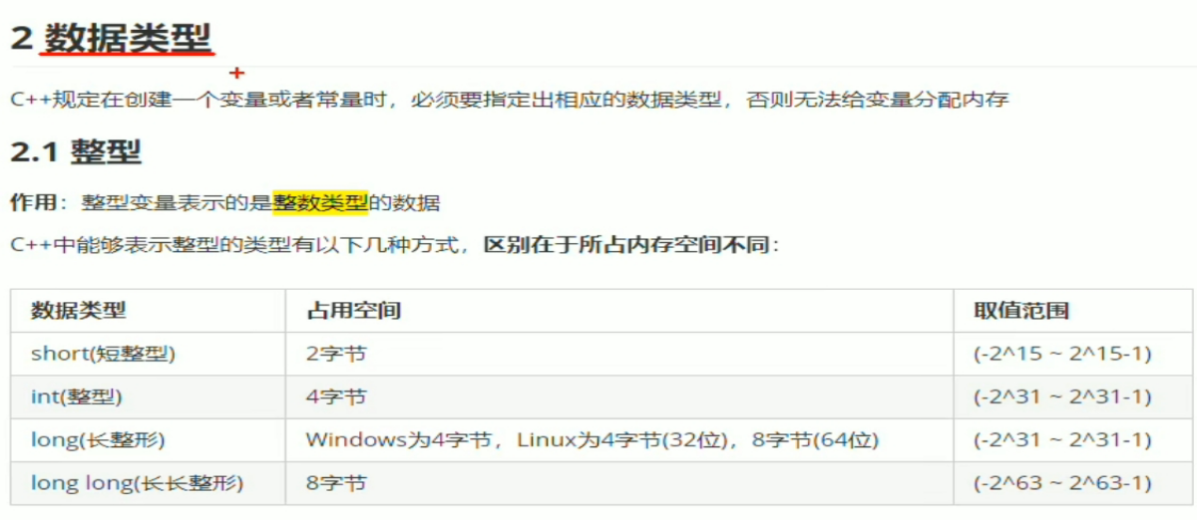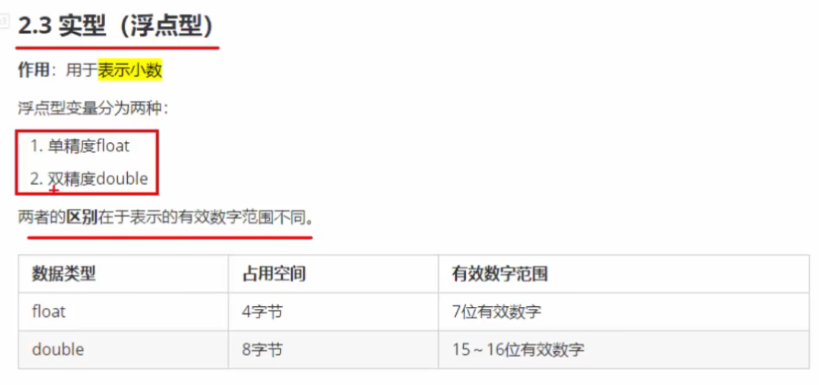

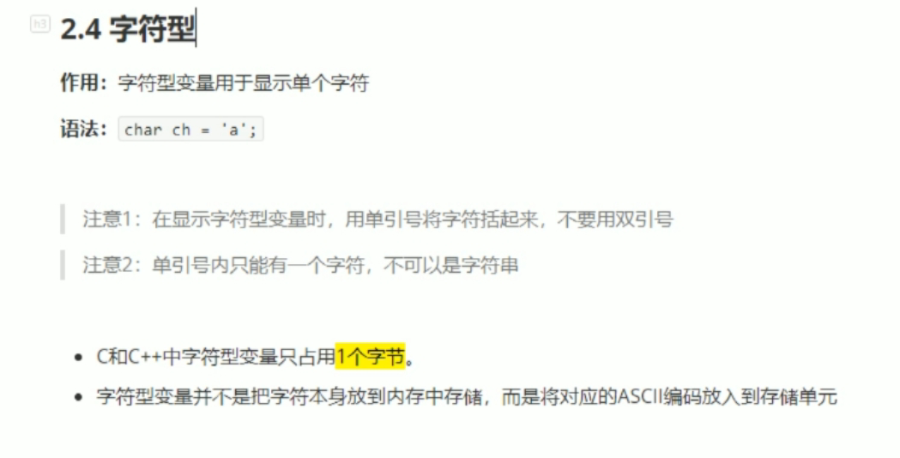

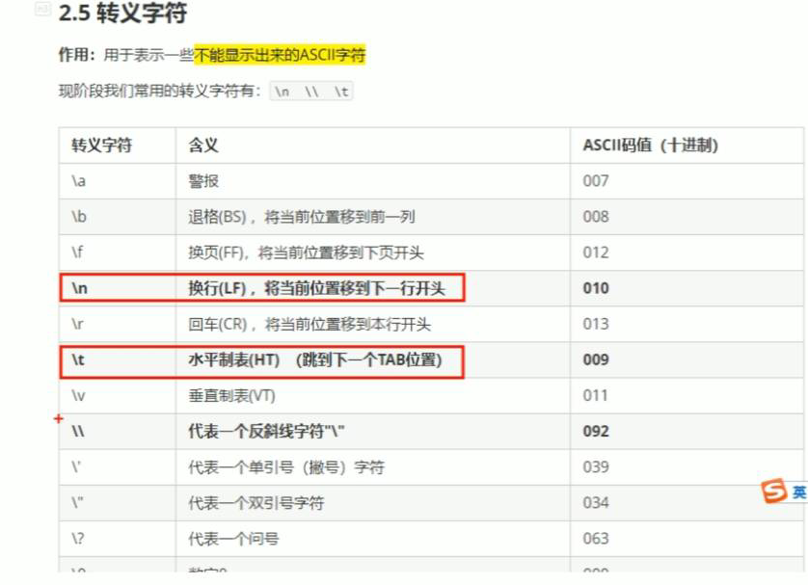

\t占八个空格，自动补齐整齐

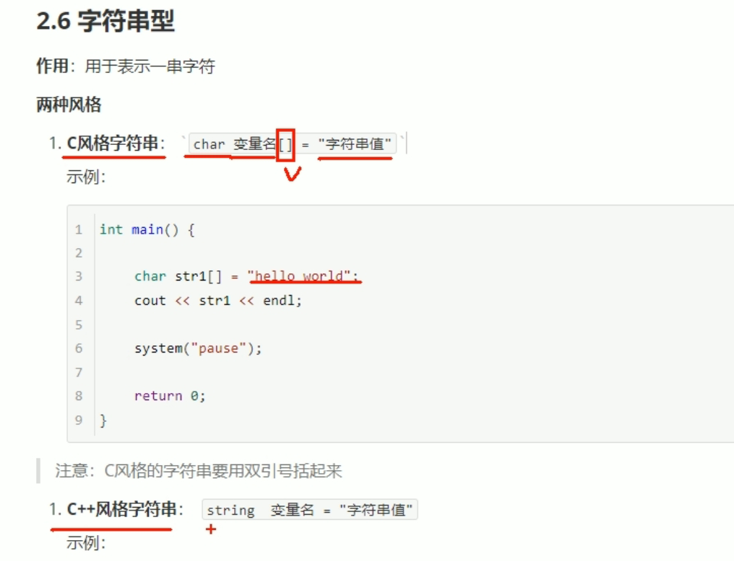

#include <string>

string str = "杨过";//必须包含头文件。

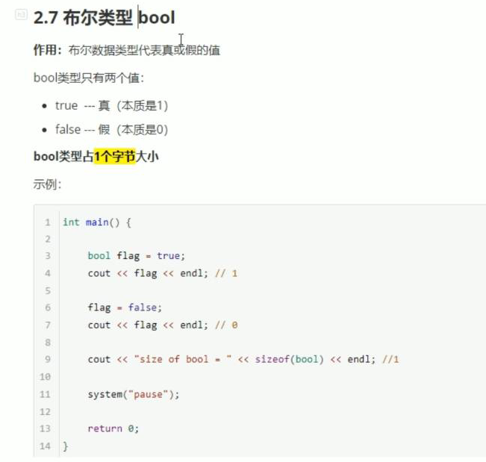

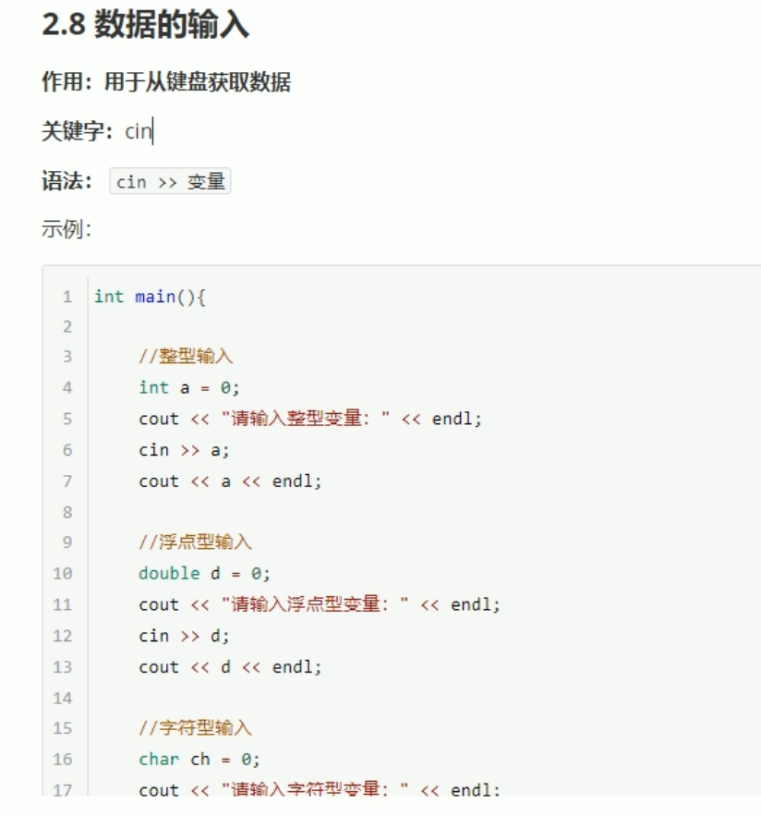

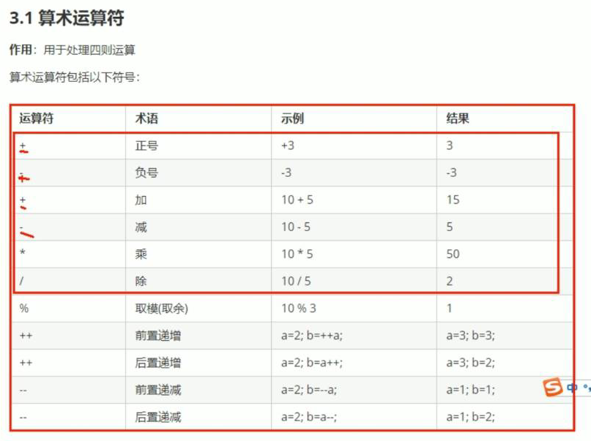

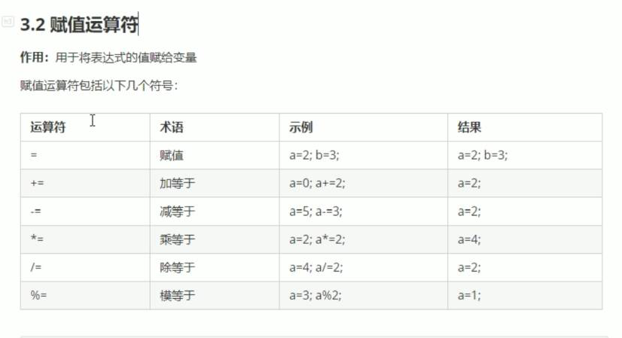

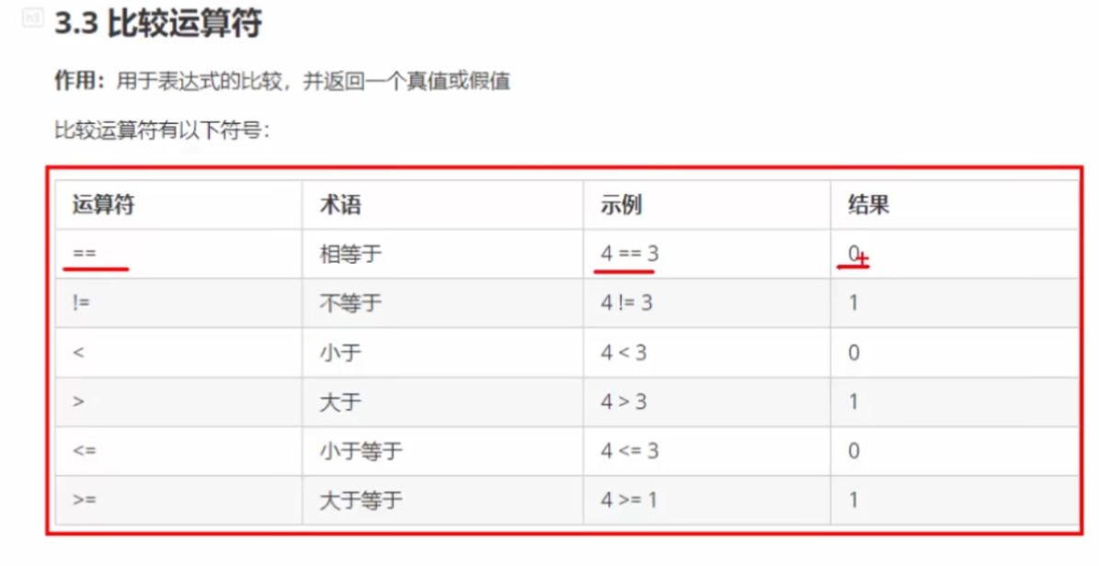

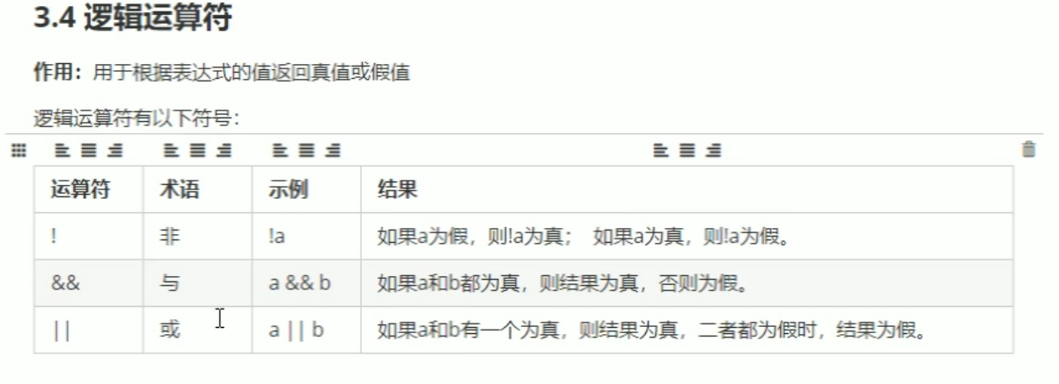

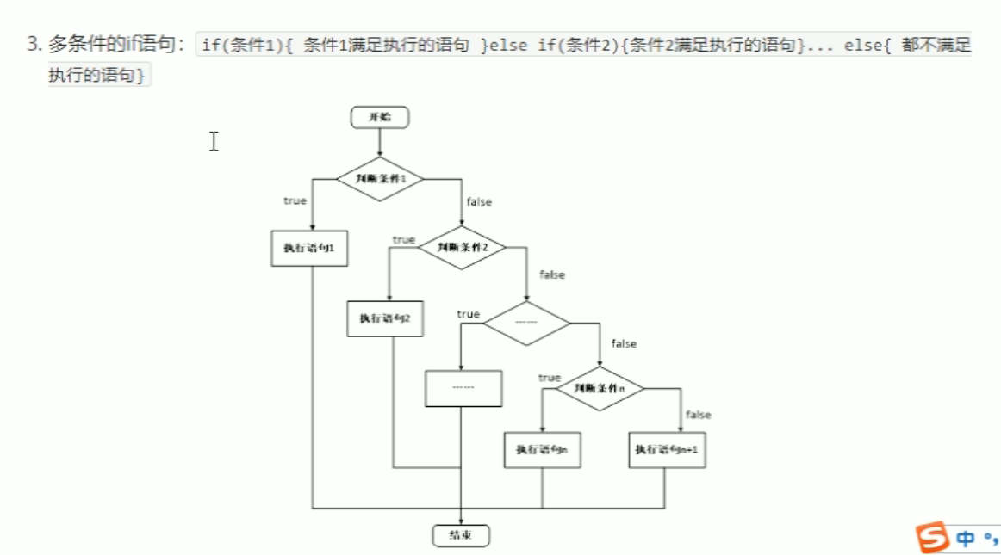

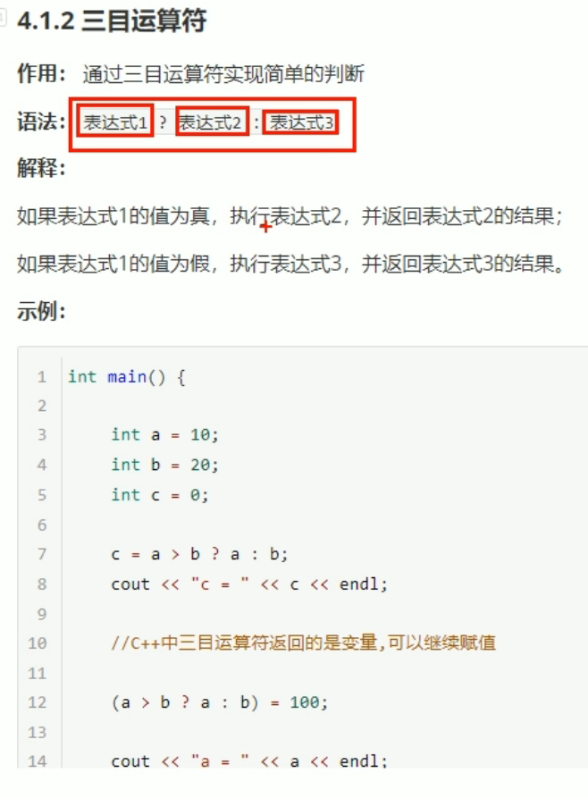

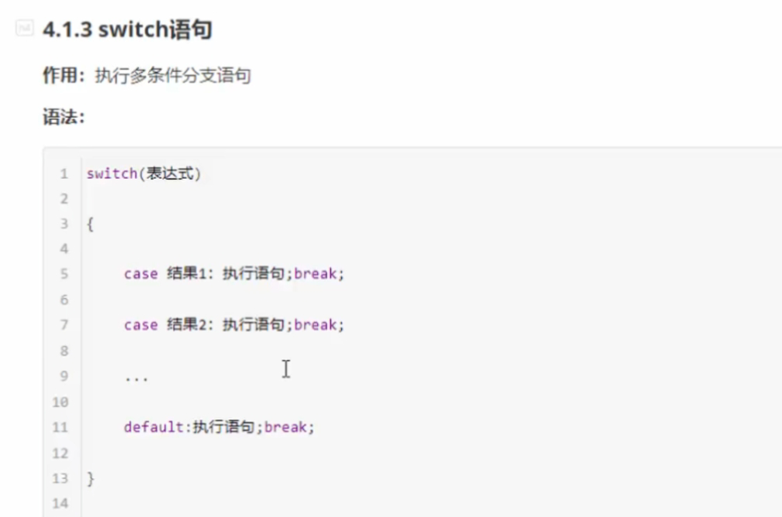

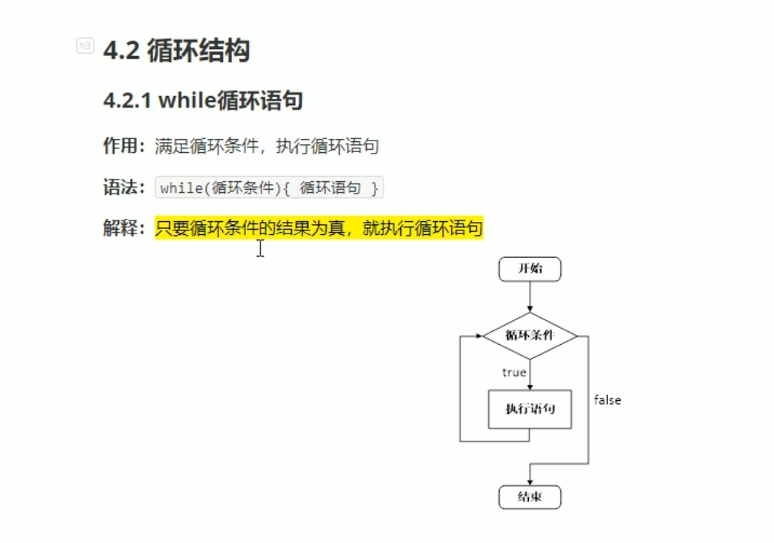

#include <iostream>

using namespace std;

#include<ctime>

int main()

{

srand((unsigned int)time(NULL));

int num = rand() % 100 + 1;

int val = 0;

while (1)

{

cin >> val;

if (val > num)

{

cout << "猜测的数过大" << endl;

}

else if (val < num)

{

cout << "猜测的数过小" << endl;

}

else

{

cout << "猜测正确" << endl;

break;

}

}

system("pause");

return 0;

}

以上为猜测一百以内的数字代码

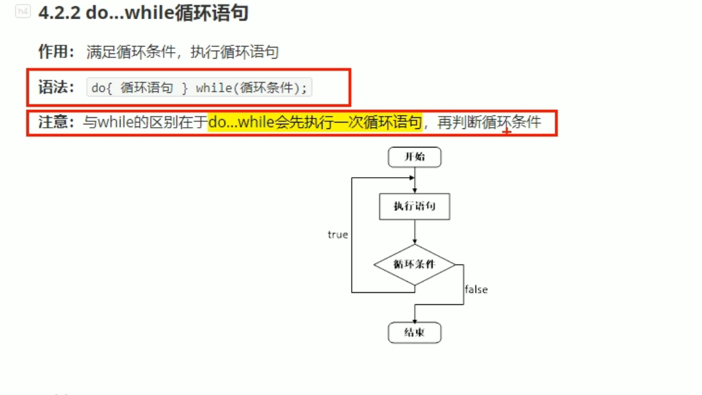

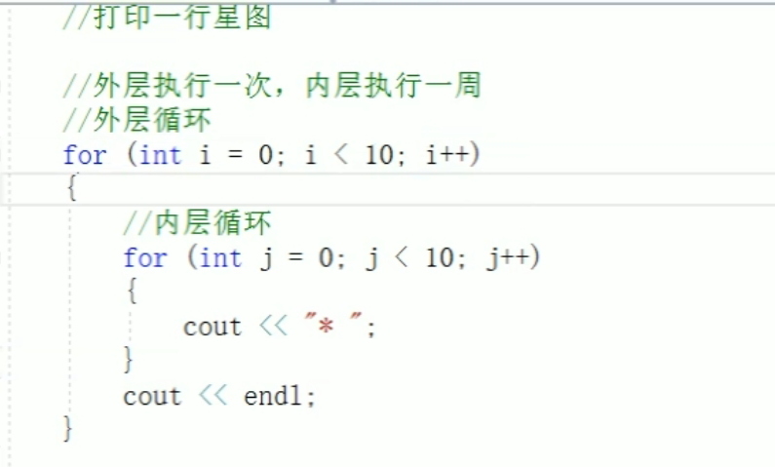

嵌套句式。

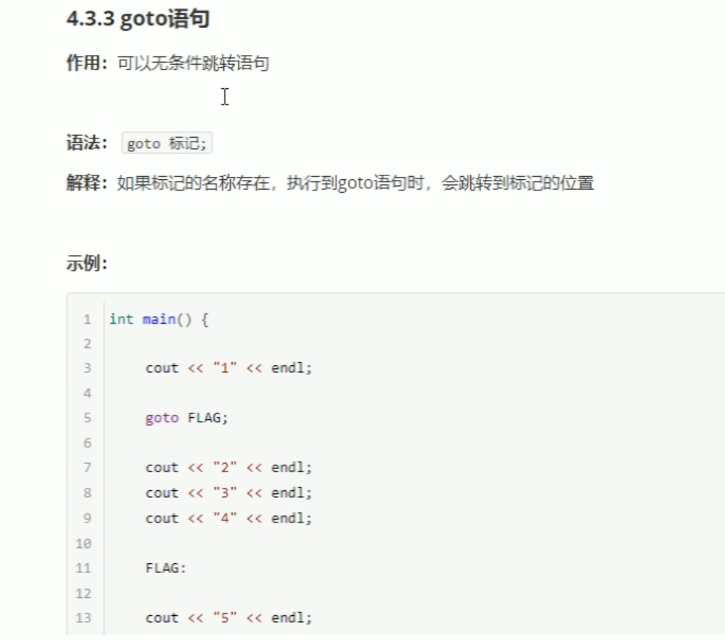

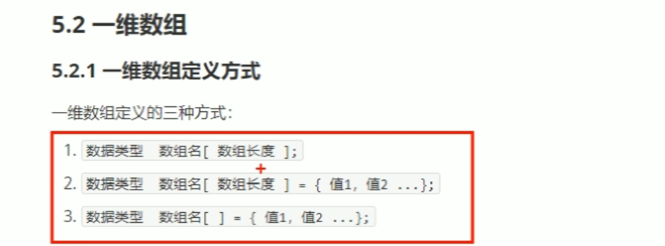

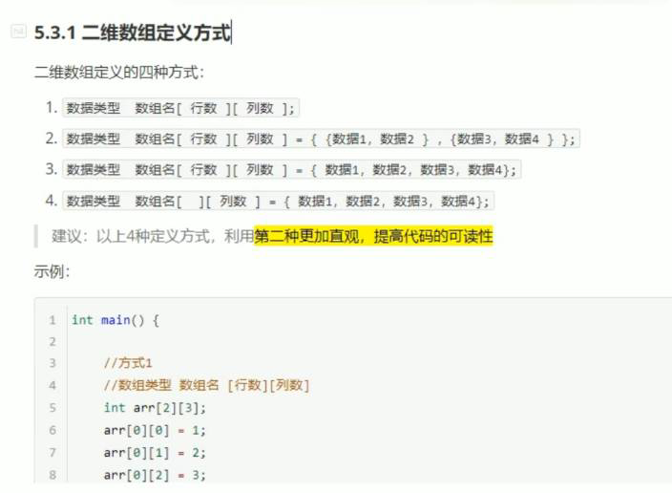

函数：

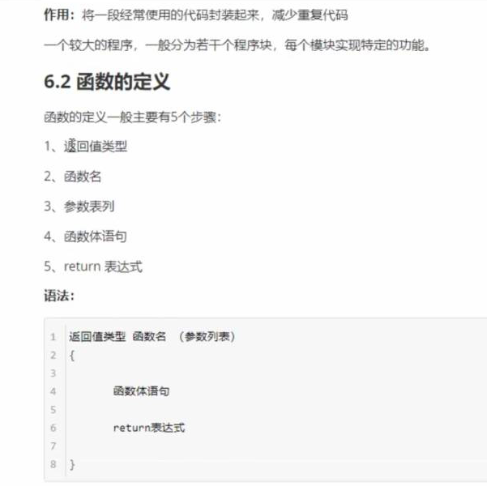

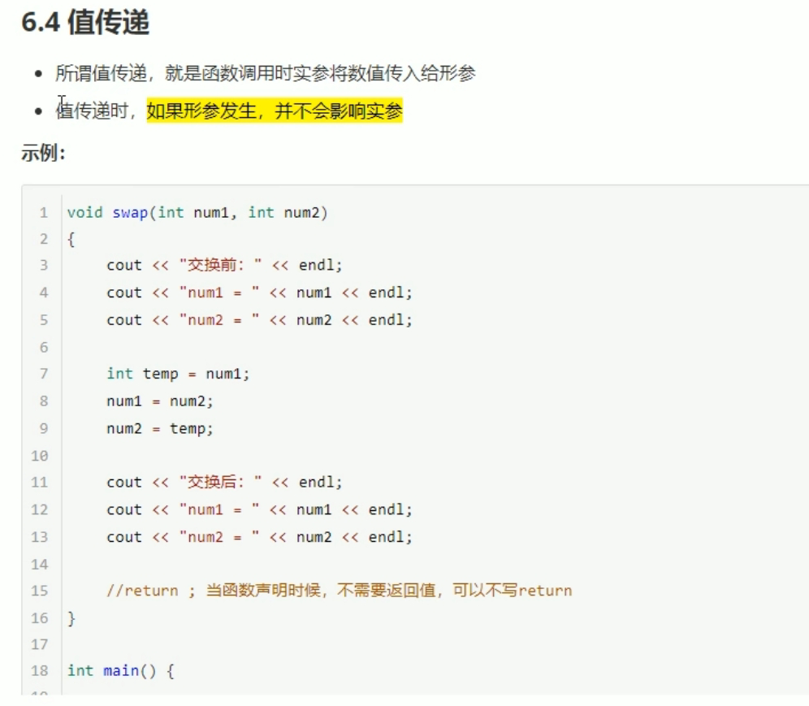

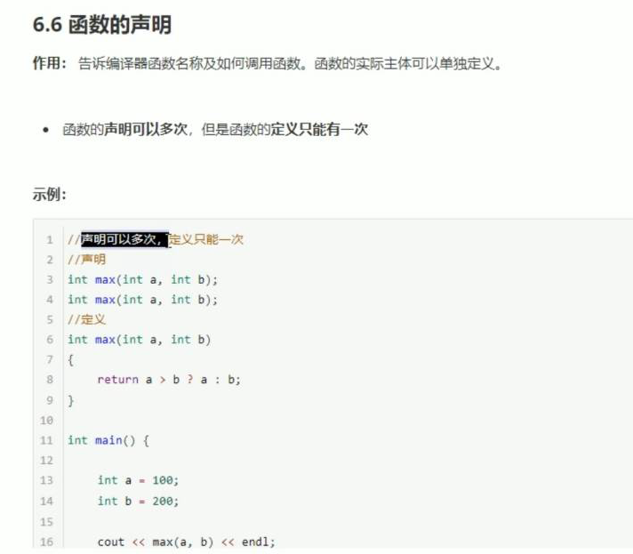

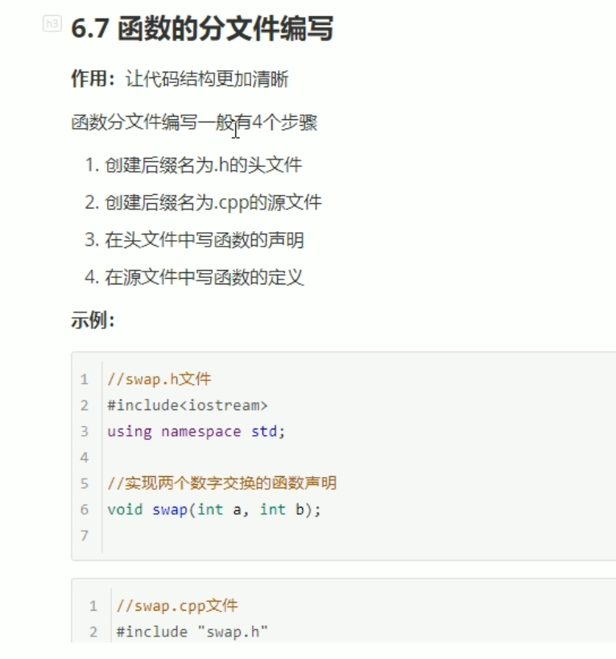

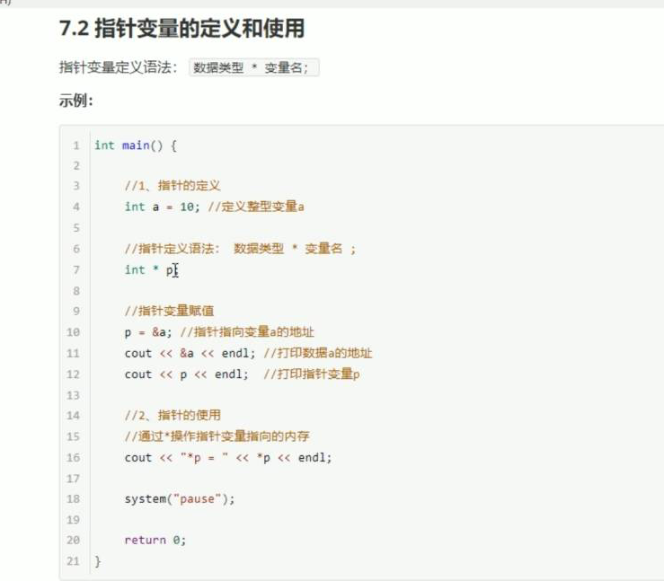

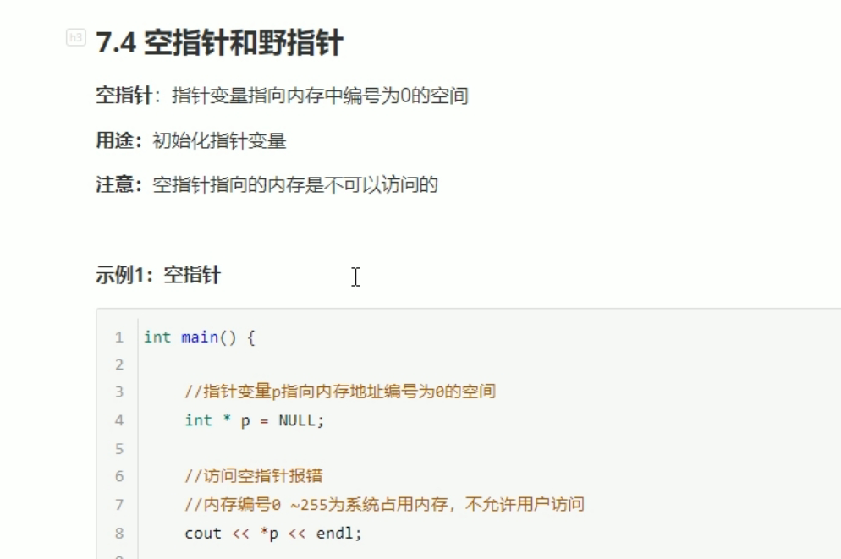

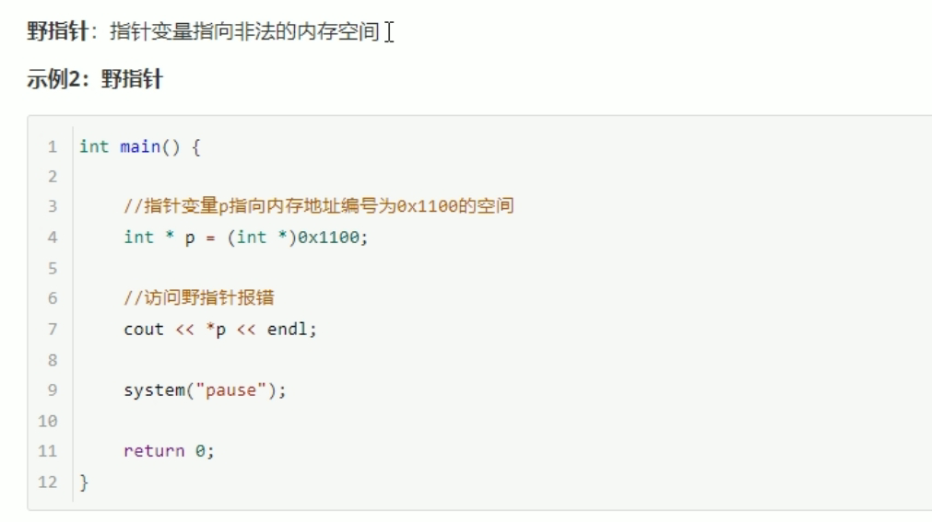

注意：空指针和野指针都不是我们申请的空间，因此不要访问。

Int a = 10;

Int b = 20;

Int *p =&a;

一．常量指针：const修饰指针

Const int *p =&a;

常量指针特点：指针的指向可以修改，但是指针指向的值不可以修改。

*p = 20;错误的，指针指向的值不可以修改。

p = &b;正确的，指针的指向可以修改。

二．指针常量：const修饰常量

Int * const p = &a;

指针常量特点：指针的指向不可以改，指针指向的值可以改。

*p = 20; 正确的，

p = &b; 错误的。

1. Const即修饰指针，又修饰常量。

Const int * const p = &a;

特点：指针的指向和指针指向的值都不能改。

*p = 20; 错误的，

p = &b; 错误的。

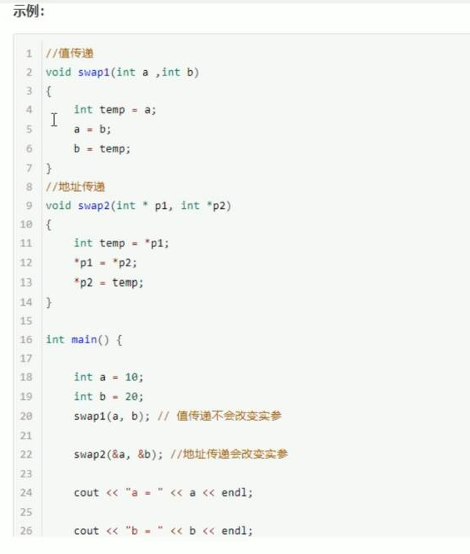

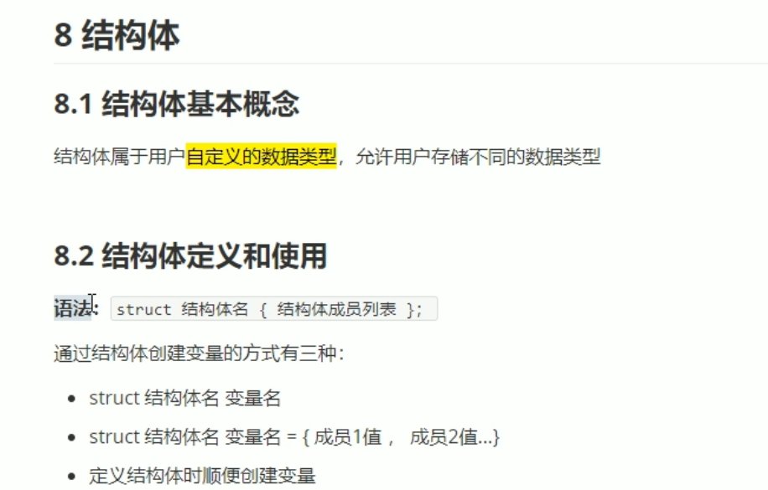

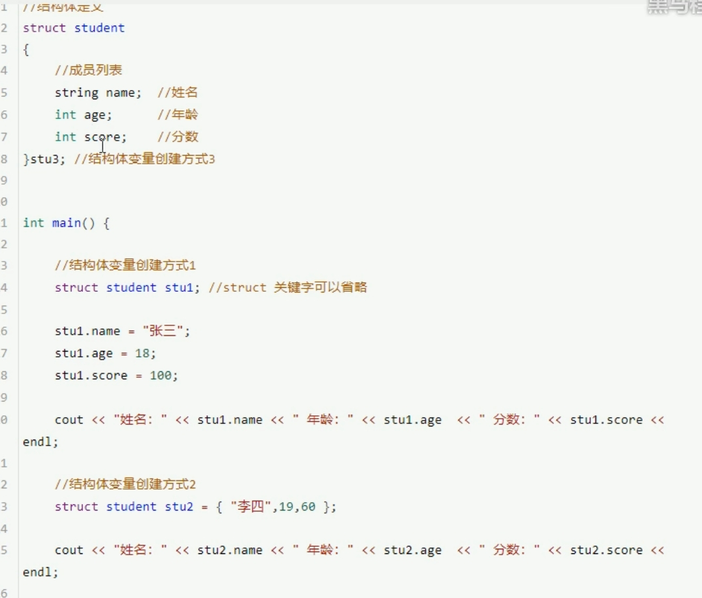

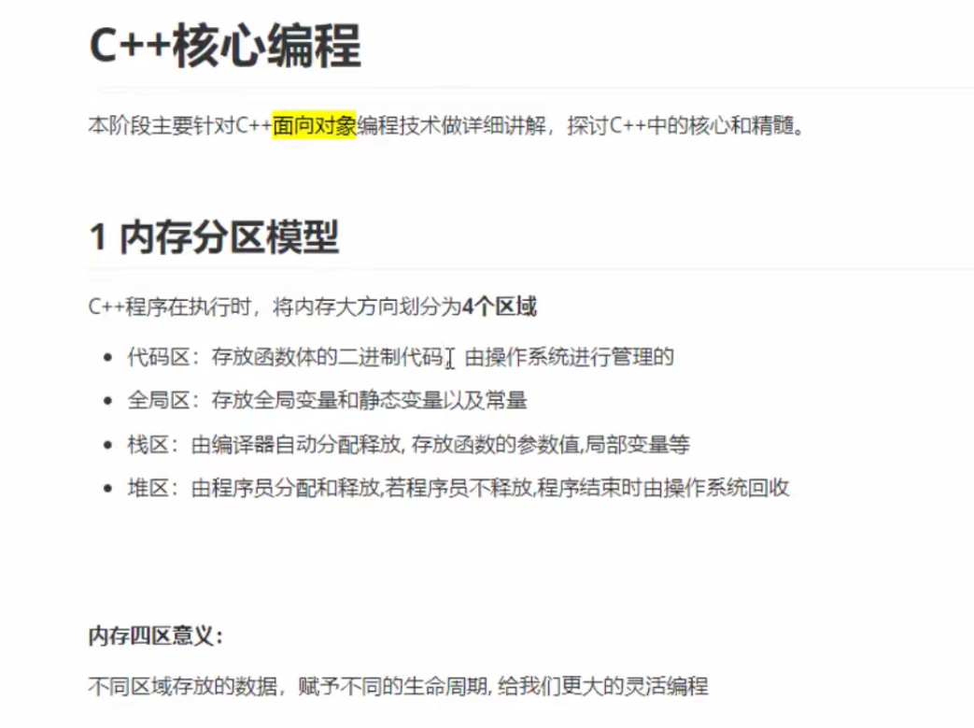

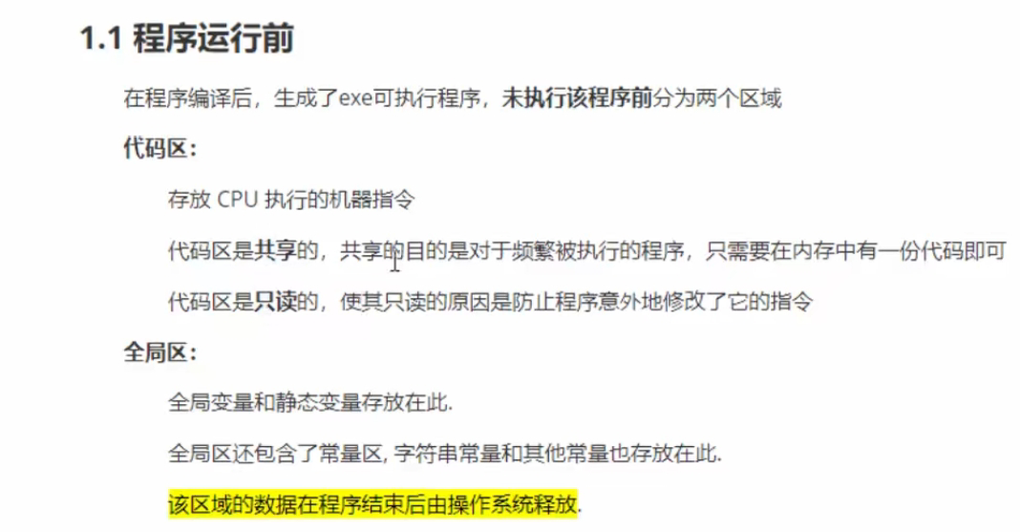

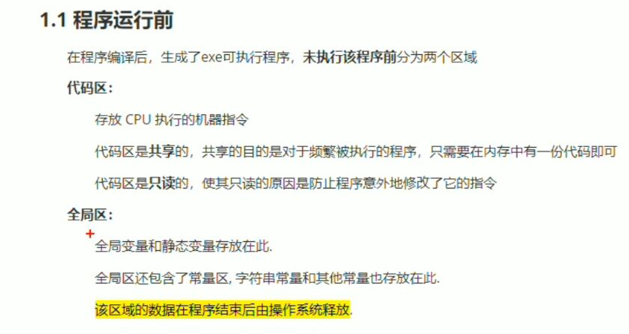

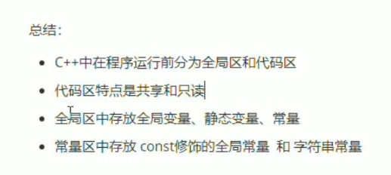

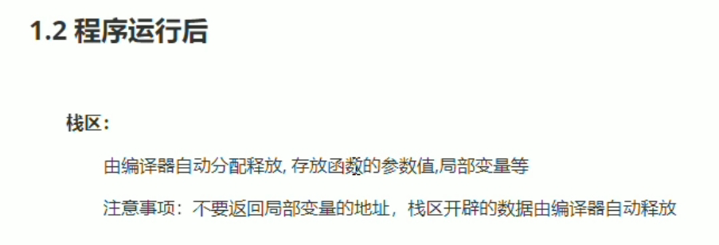

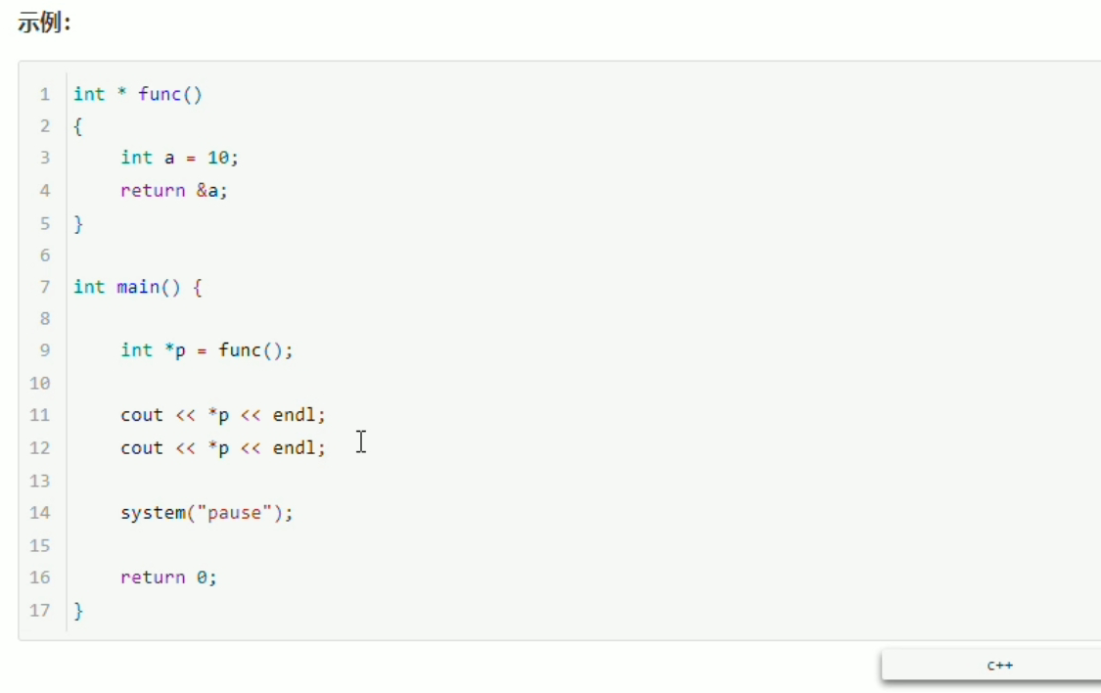

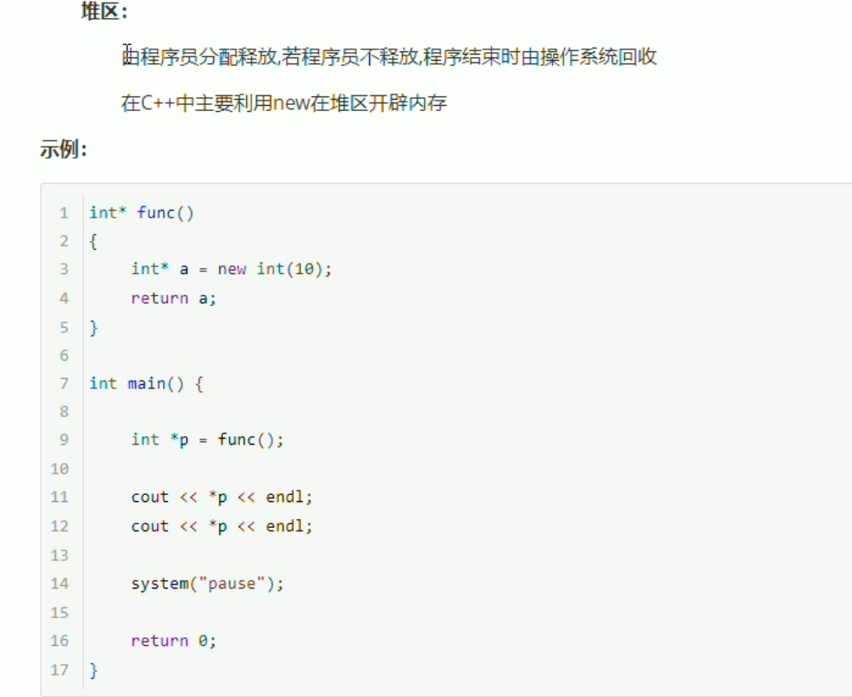

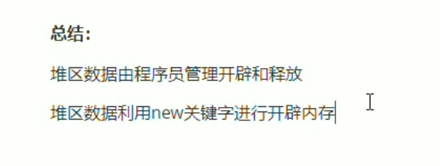

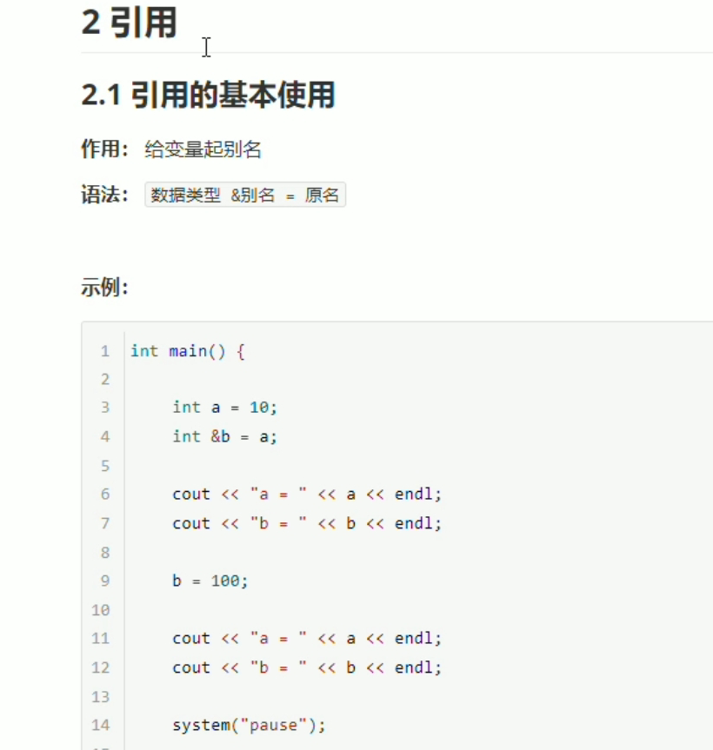

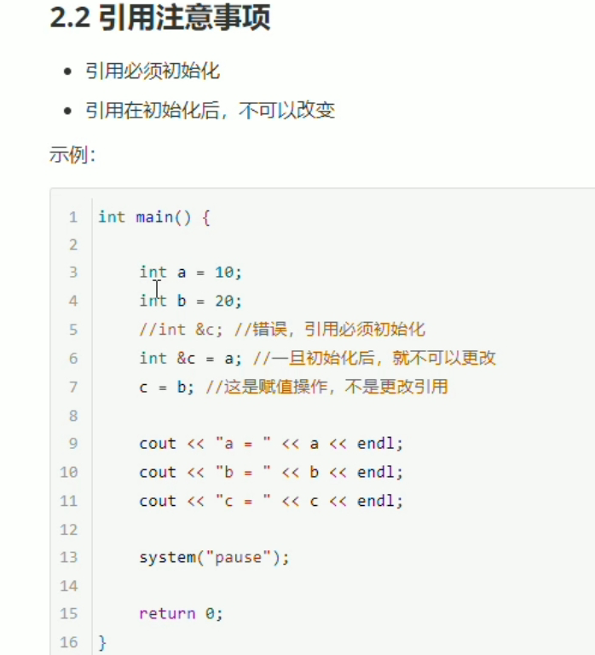

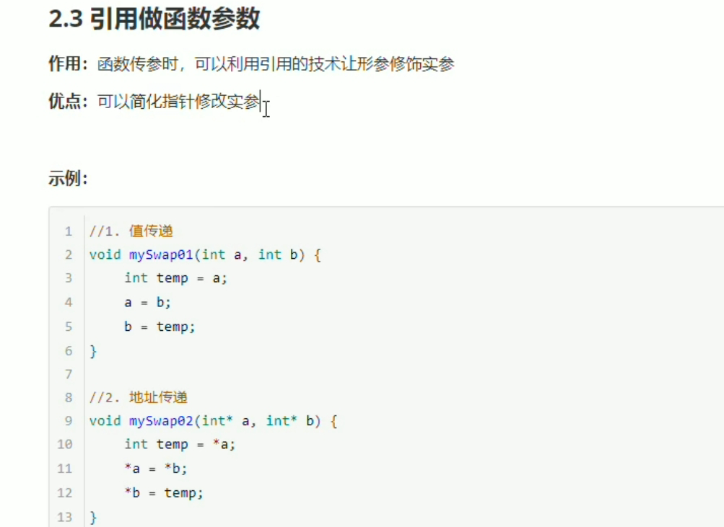

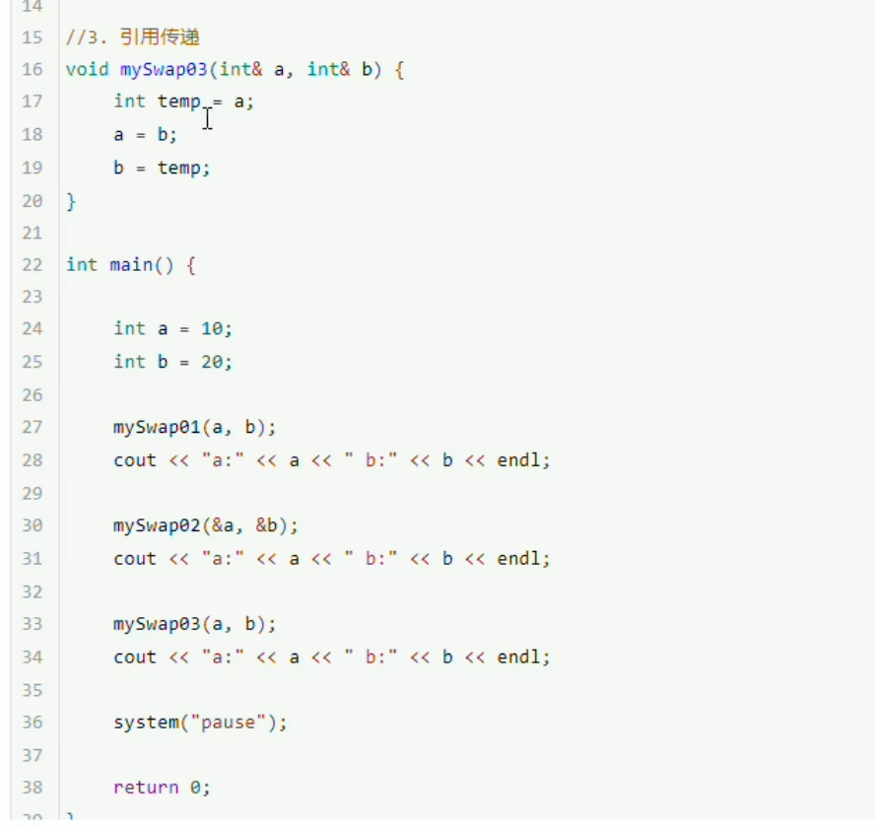

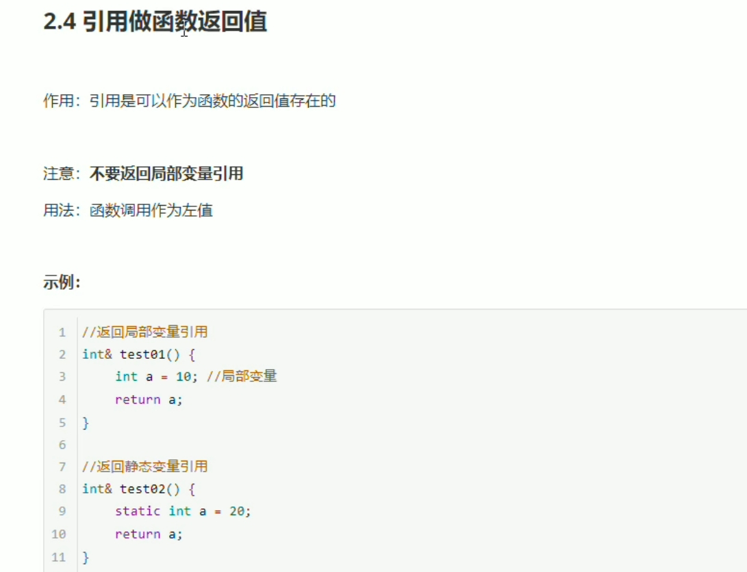

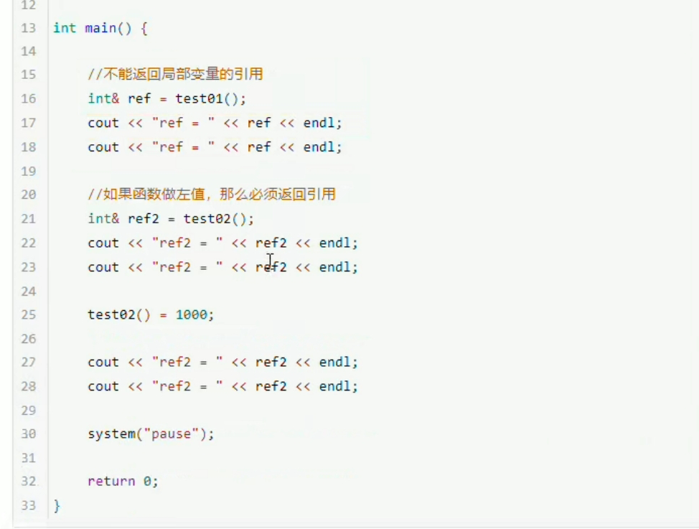

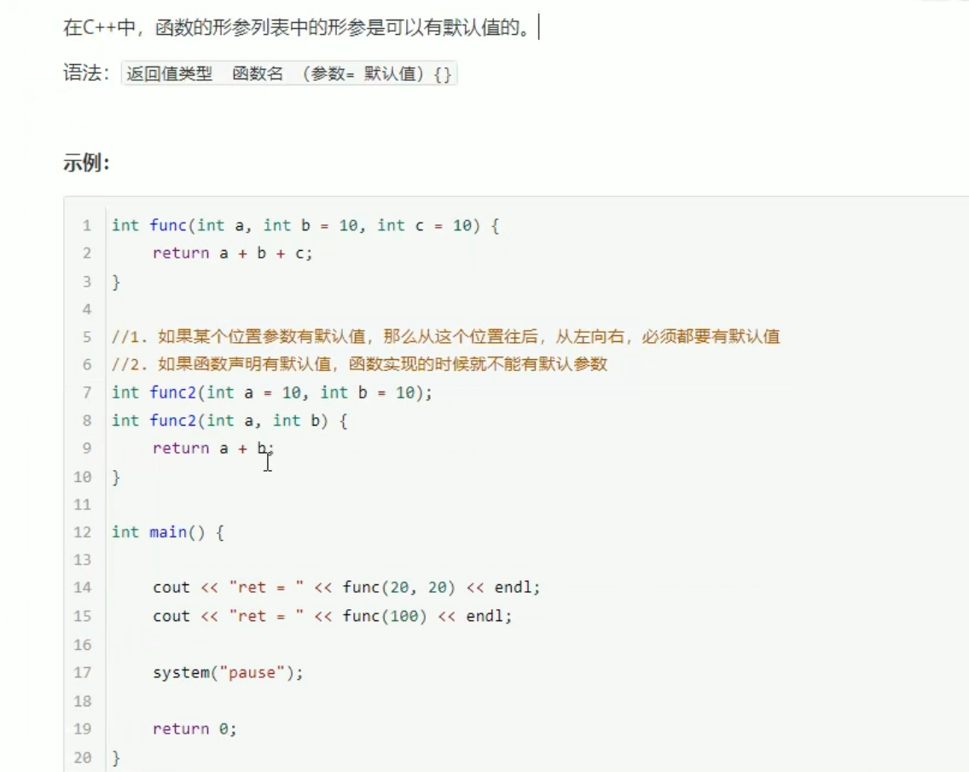

声明和函数只能有一个有默认参数。

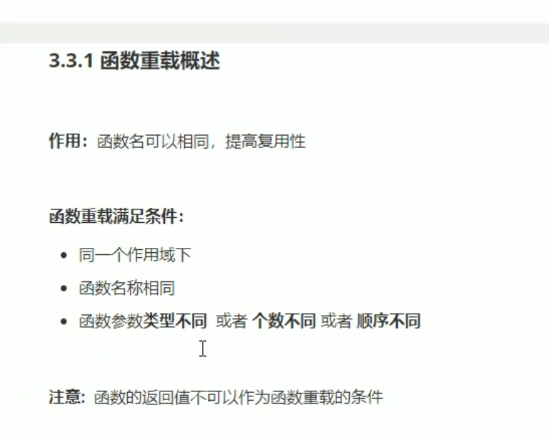

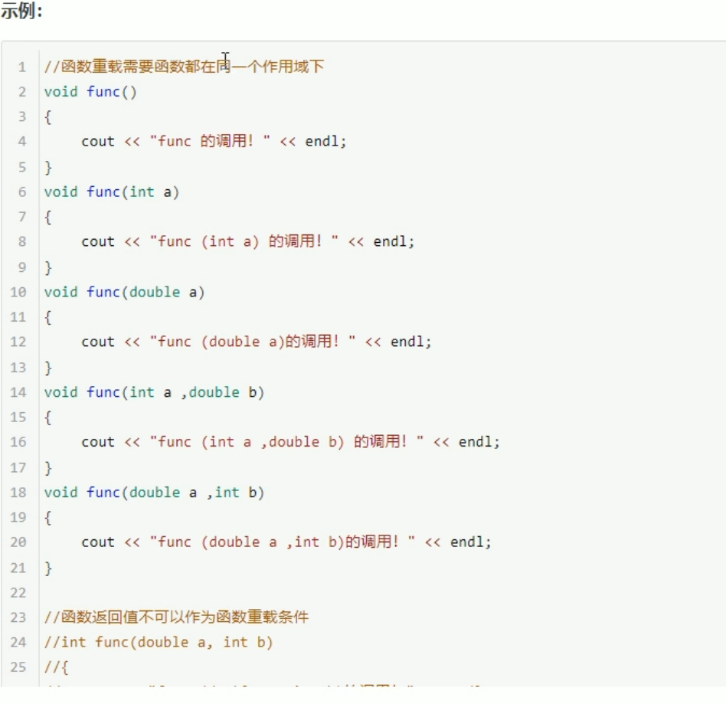

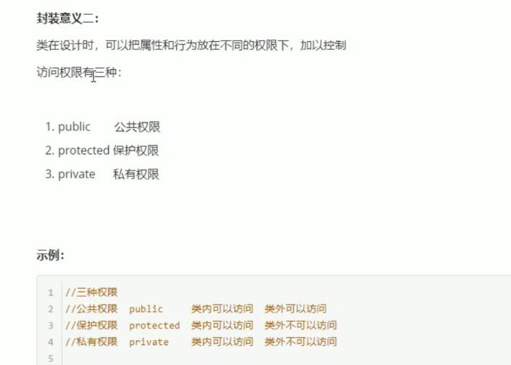

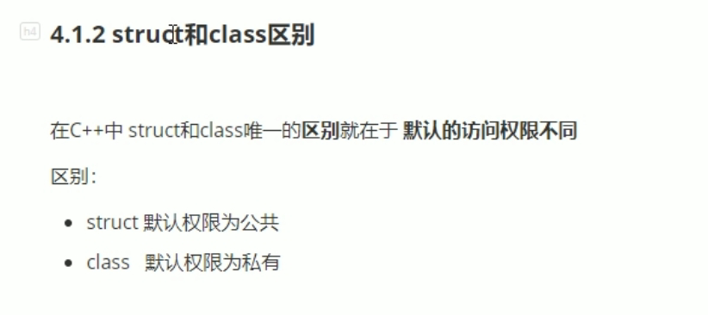

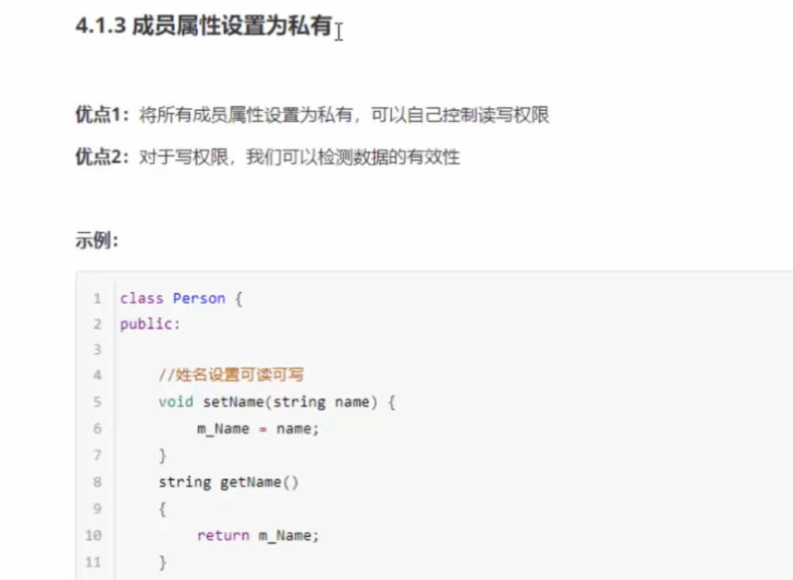

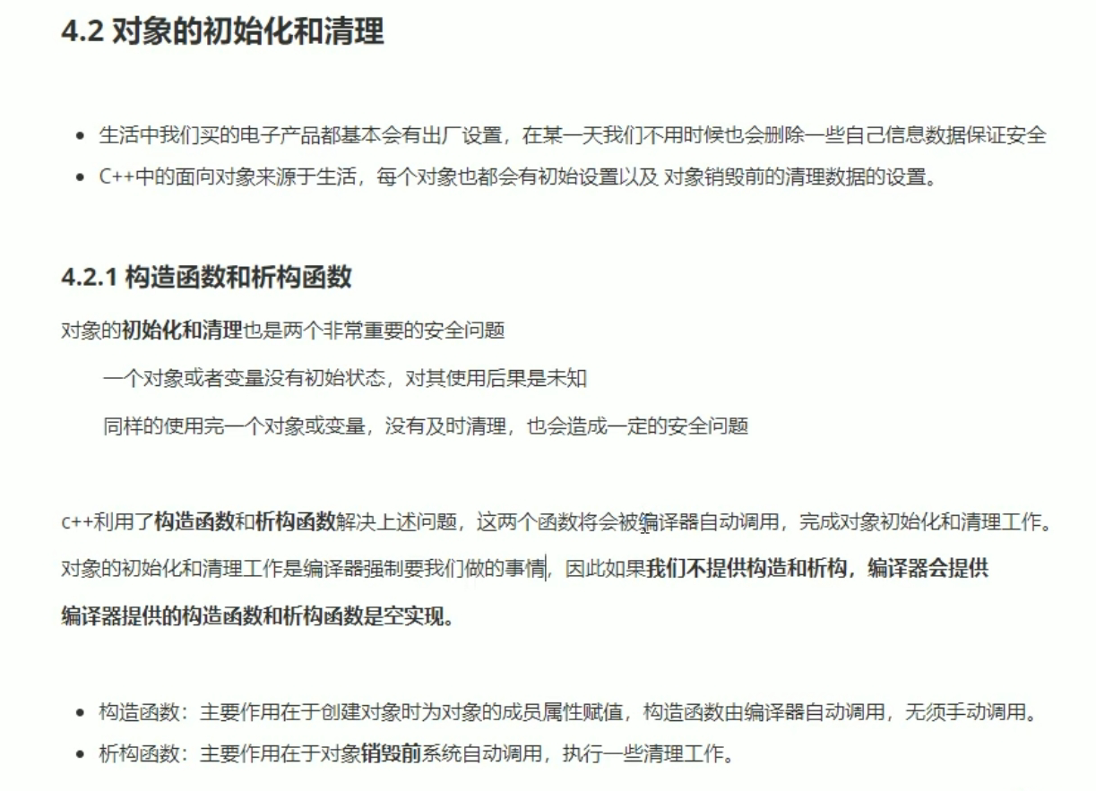

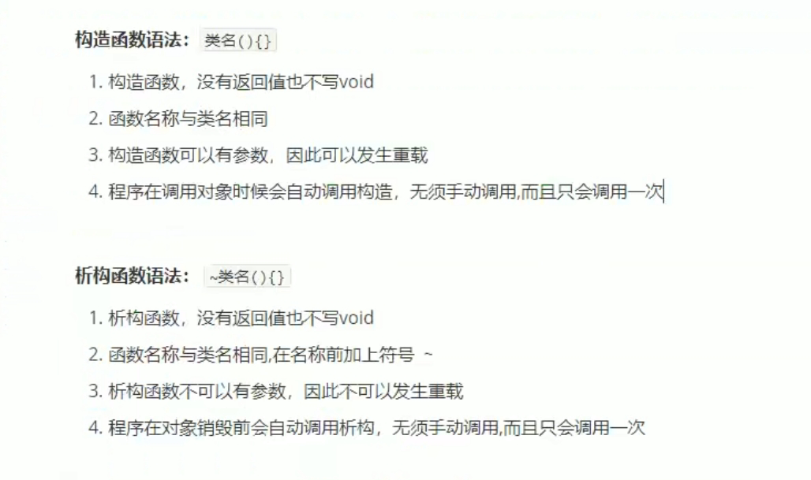

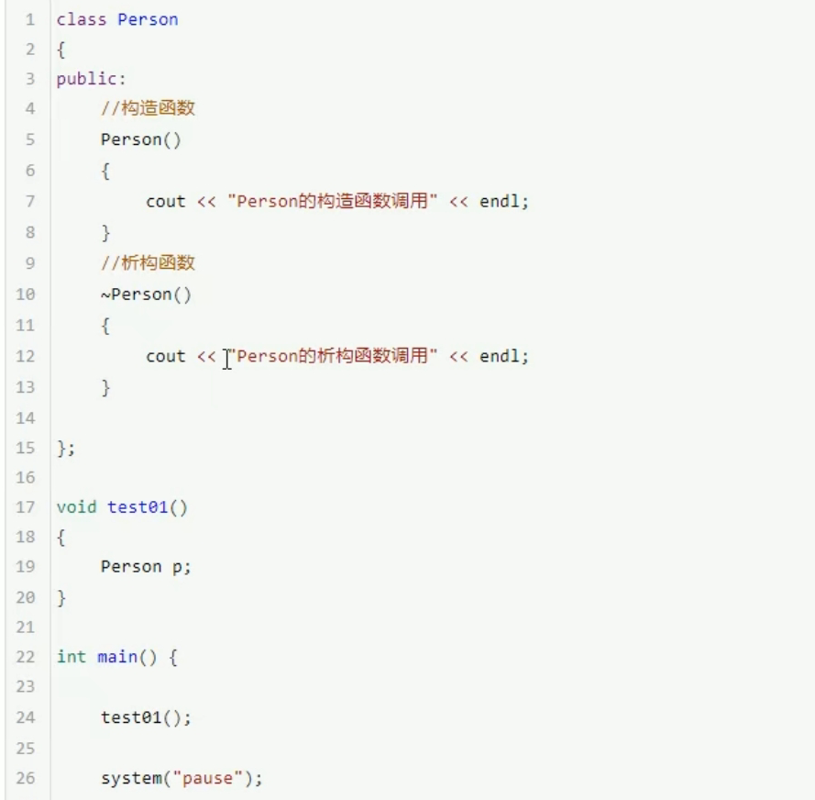

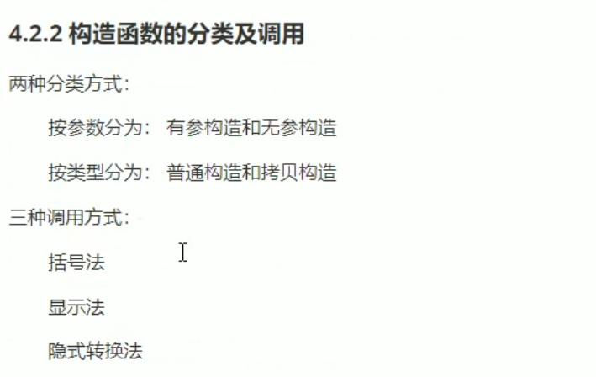

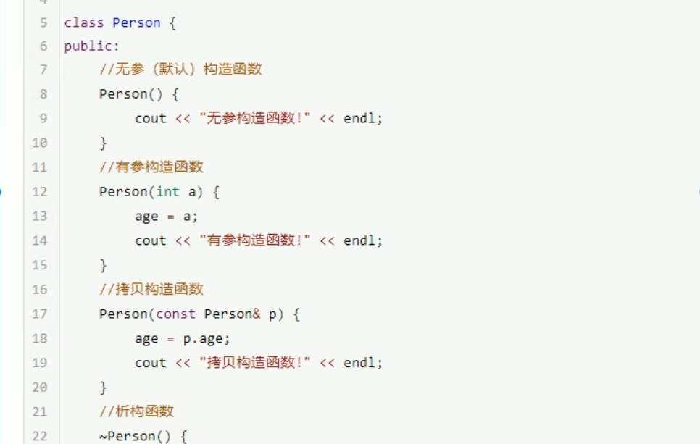

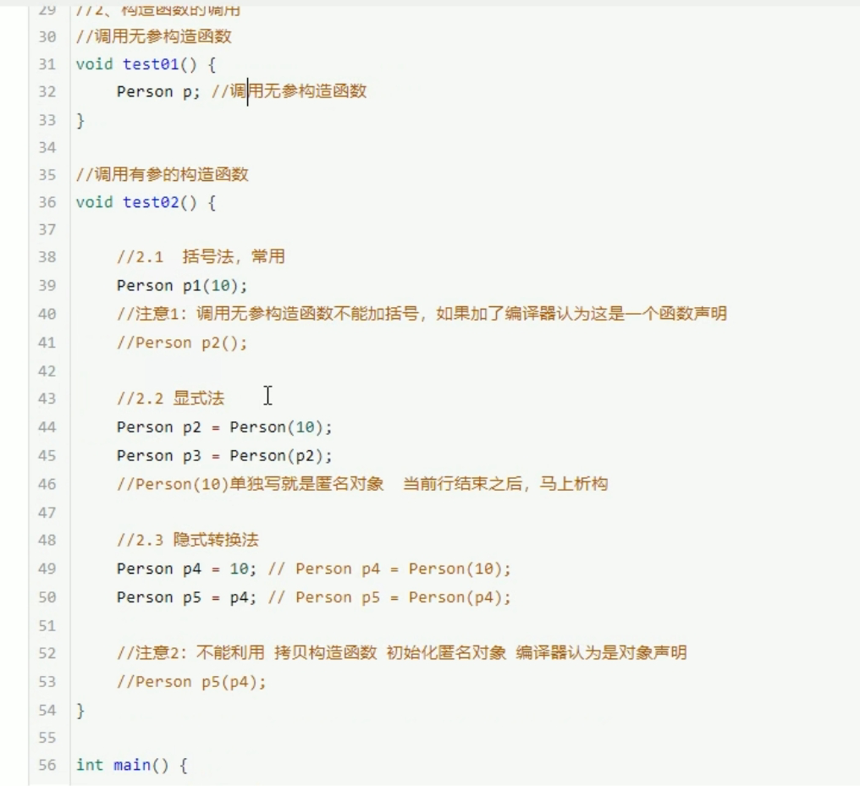

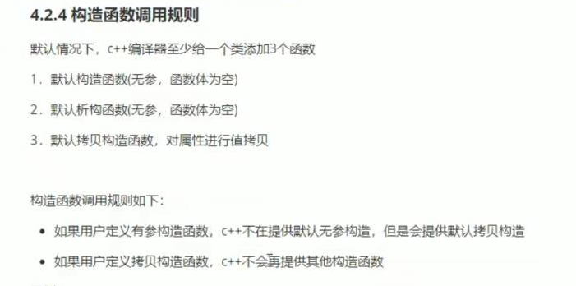

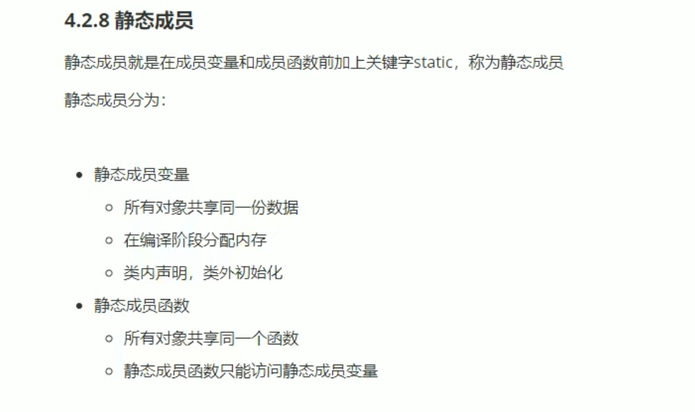

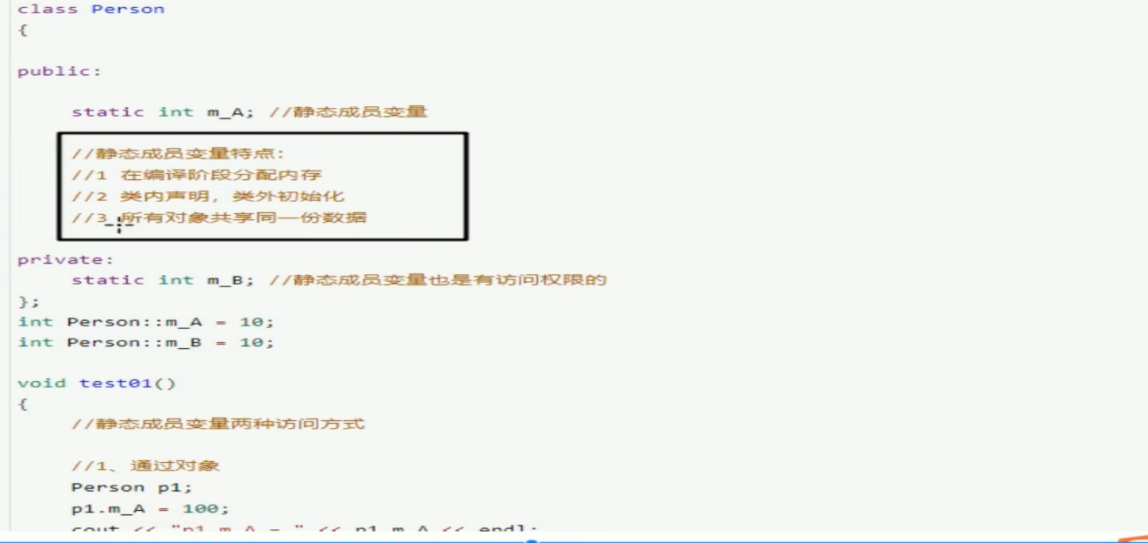

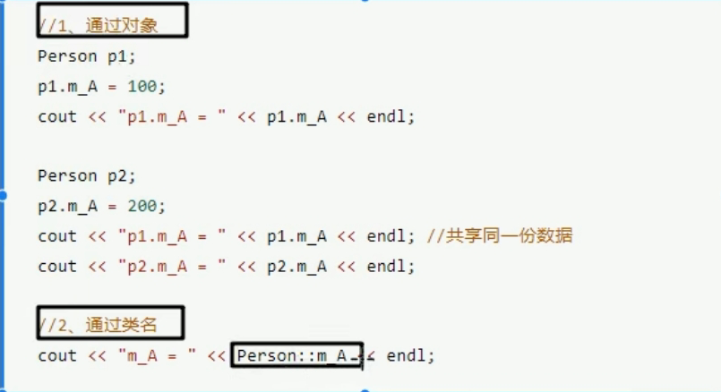

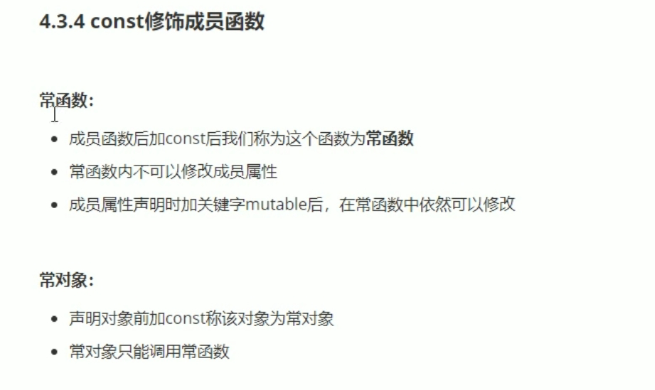

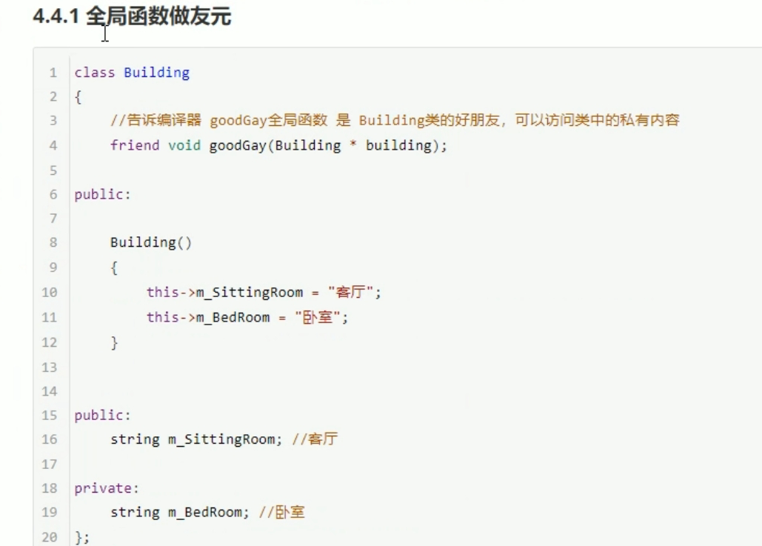

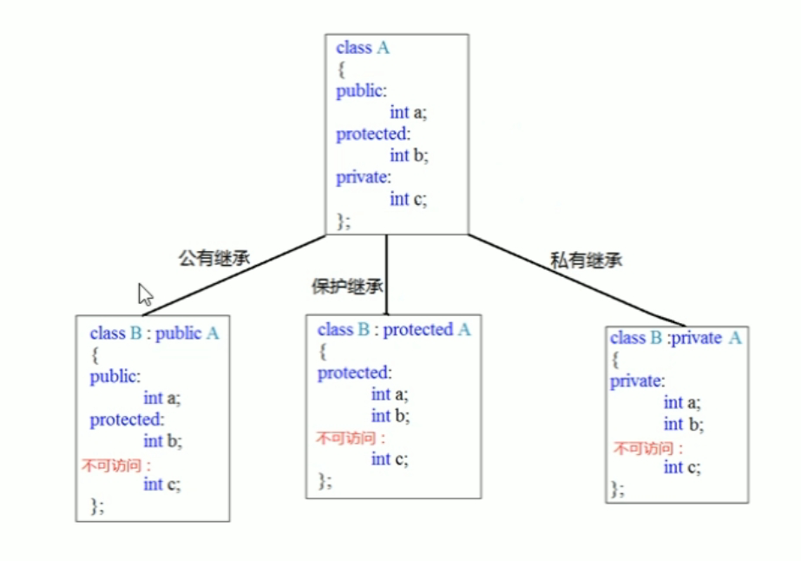

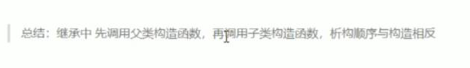

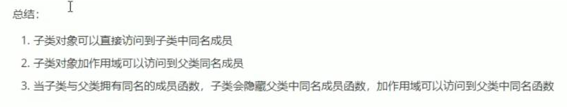

Virtual 可以解决菱形继承的问题。

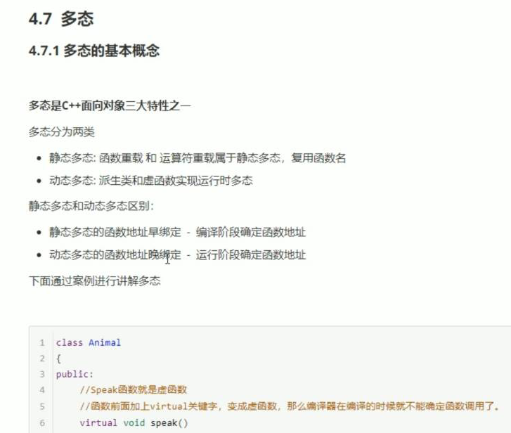

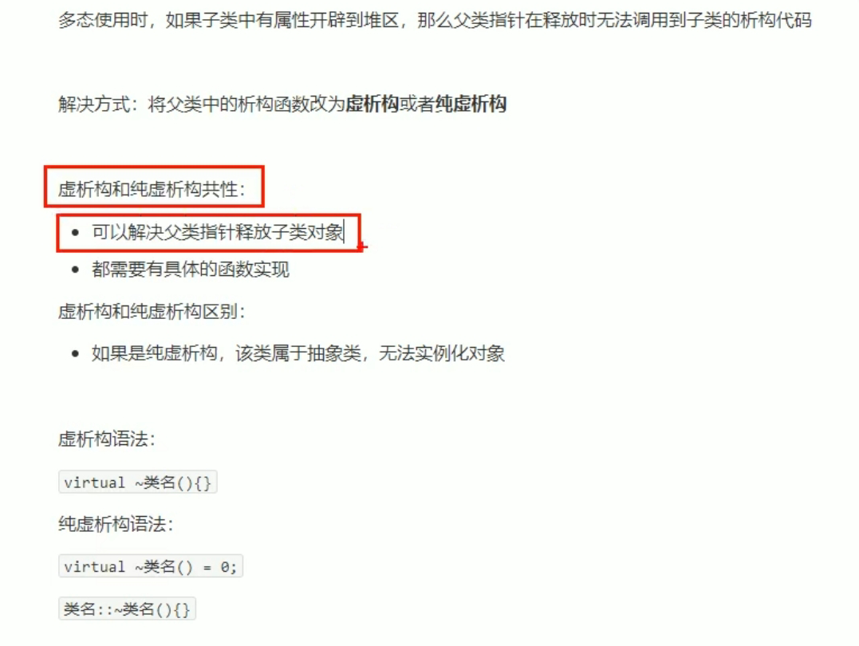

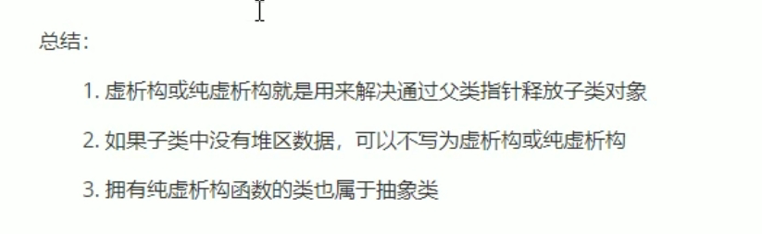

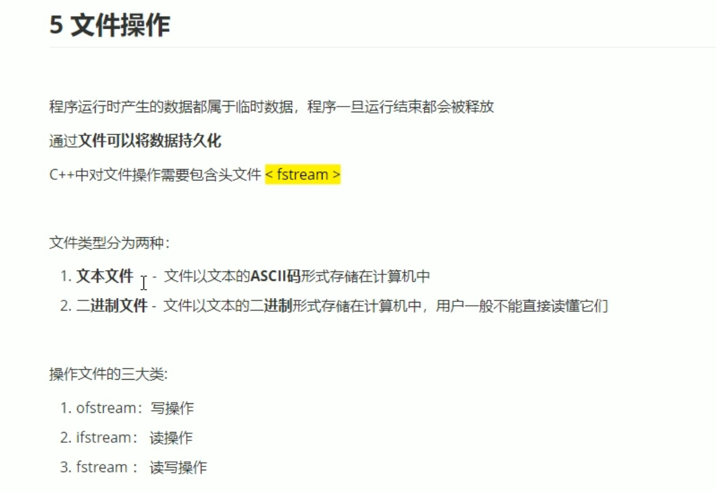

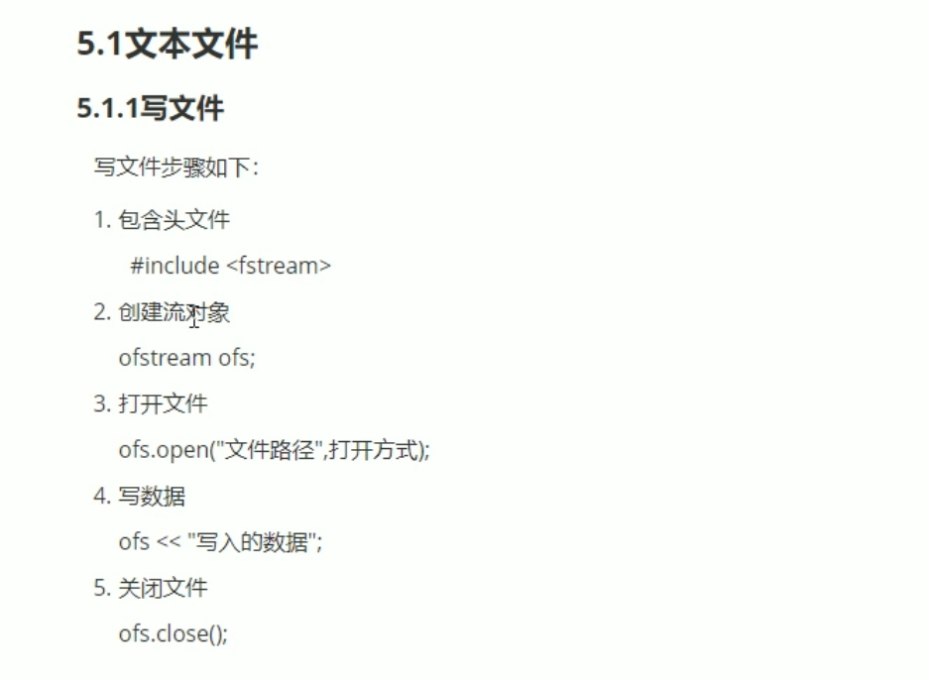

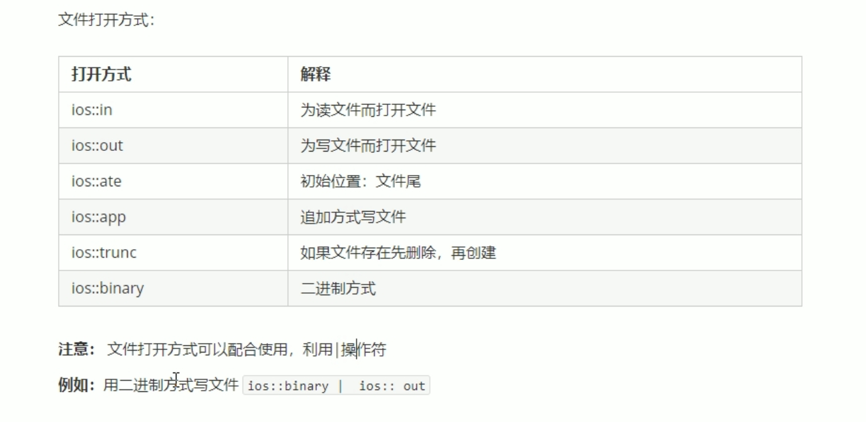

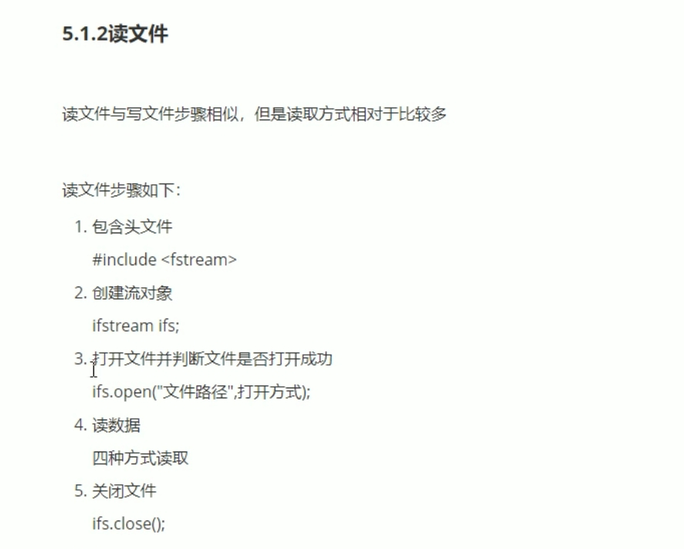

#include <iostream>

using namespace std;

#include <string>

#include <fstream>

void test01()

{

ifstream ifs;

ifs.open("test.txt",ios::in);

if (!ifs.is_open())

{

cout << "文件打开失败" << endl;

return;

}

//读数据第一种

//char buf[1024] = { 0 };

//while (ifs>>buf)

//{

// cout << buf << endl;

//}

//第二种

//string buf;

//while (getline(ifs ,buf))

//{

// cout << buf << endl;

//}

//第三种

//char buf[1024] = { 0 };

//while (ifs.getline(buf, sizeof(buf)))

//{

// cout << buf << endl;

//}

//第四种

char c;

while ((c = ifs.get()) != EOF)

{

cout << c;

}

ifs.close();

}

int main()

{

test01();

system("pause");

return 0;

}

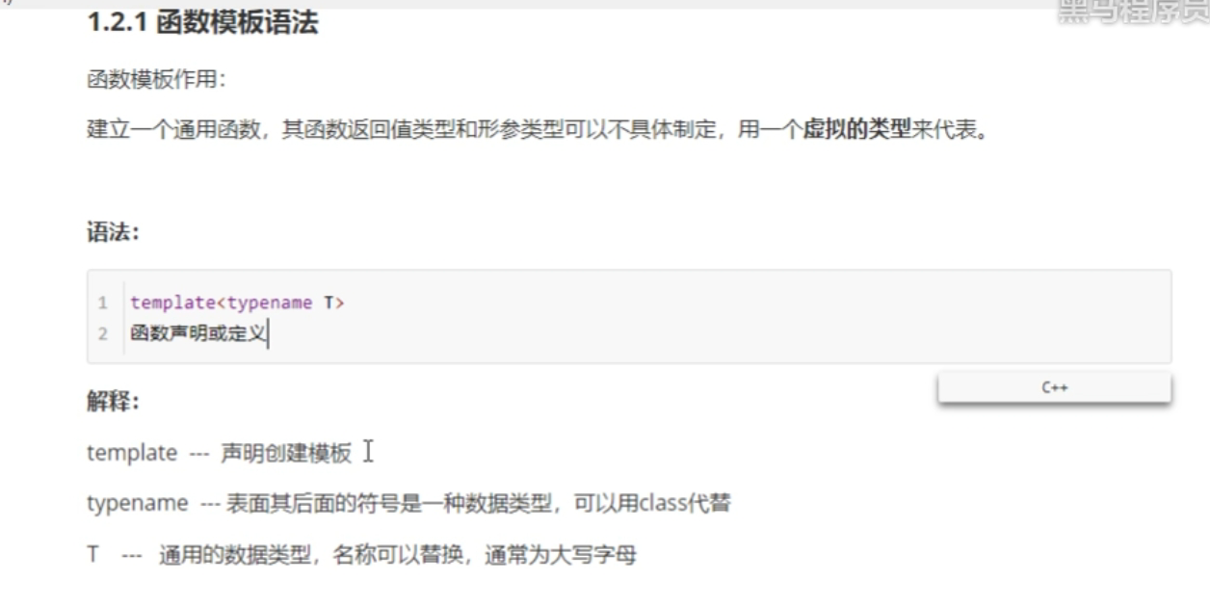

#include <iostream>

using namespace std;

#include <string>

void swapInt(int &a, int &b)

{

int temp = a;

a = b;

b = temp;

}

void swapDouble(double &a, double &b)

{

double temp = a;

a = b;

b = temp;

}

template<typename T>

void mySwap(T &a, T &b)

{

T temp = a;

a = b;

b = temp;

}

void test01()

{

int a = 10;

int b = 20;

//mySwap<int>(a, b);第一种方法

//mySwap(a, b)；第二种方法

cout << "a =" << a << endl;

cout << "b=" << b << endl;

double c = 1.11;

double d = 2.22;

swapDouble(c, d);

cout << "a =" << c << endl;

cout << "b = " << d << endl;

}

int main()

{

test01();

system("pause");

return 0;

}

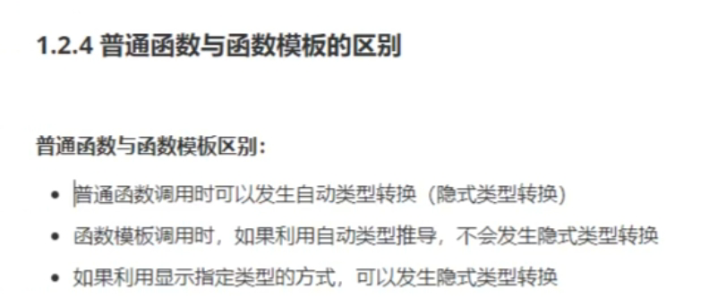

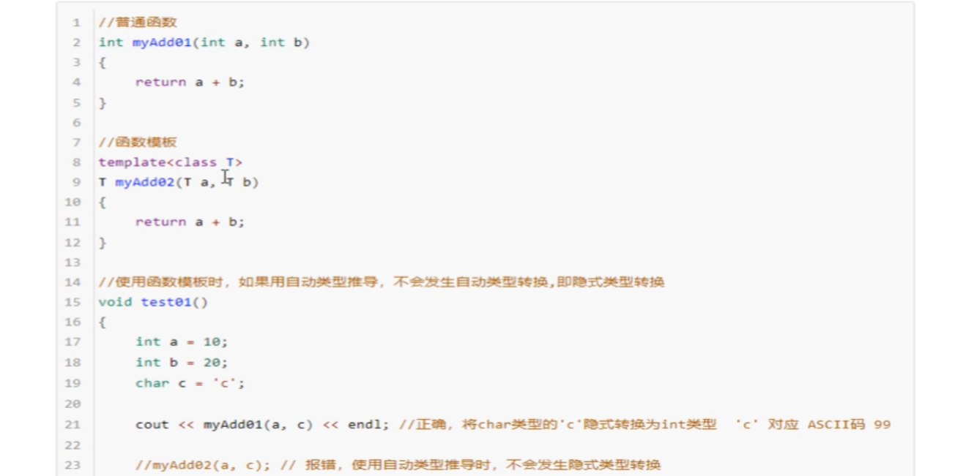

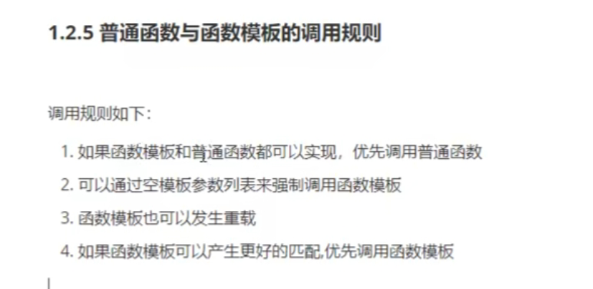

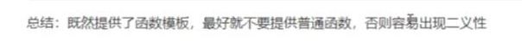

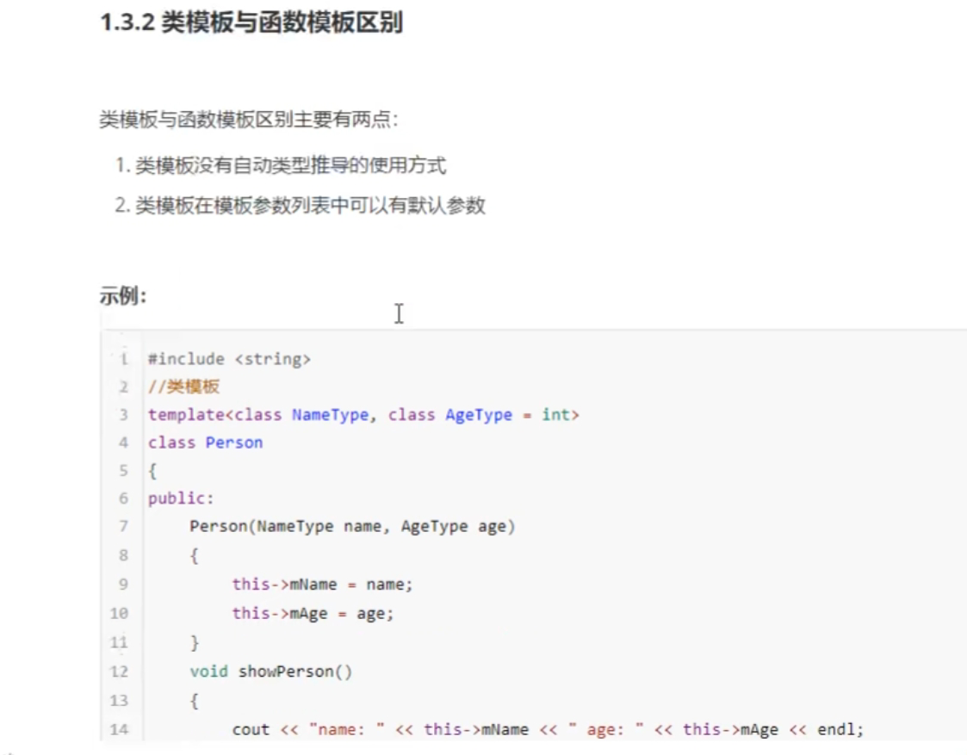

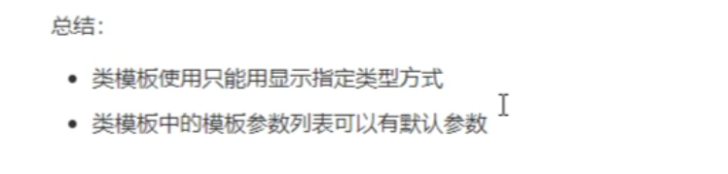

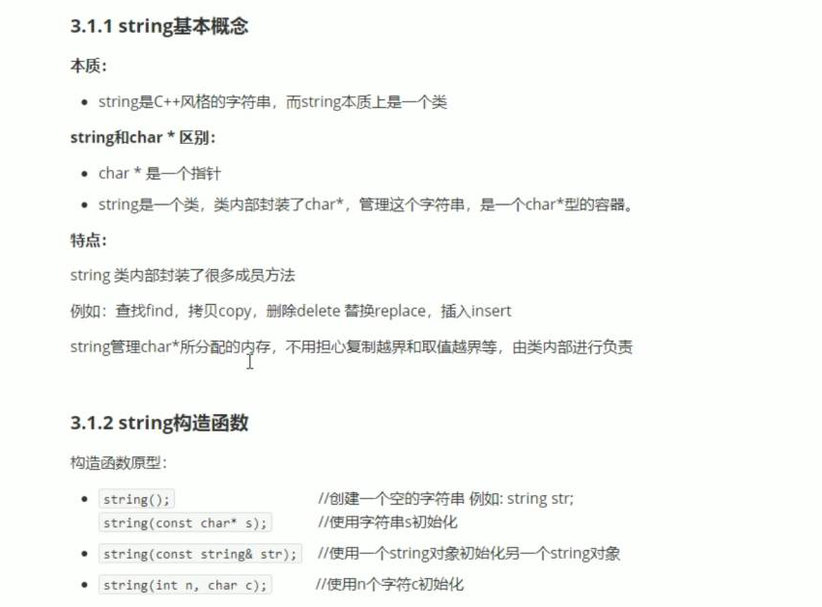

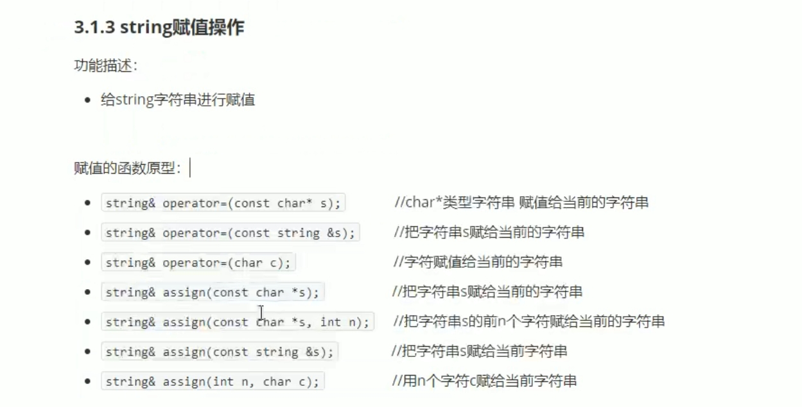

#include <iostream>

using namespace std;

#include <string>

void test01()

{

//string s1;

//const char* str = "hello world";

//string s2(str);

//cout << "s2= " << s2 << endl;

//string s3(10, 'a');

//cout << "s3= " << s3 << endl;

string str1;

str1 = "hello world";

cout << "str1 = " << str1 << endl;

string str2;

str2 = str1;

cout << "str2 = " << str2 << endl;

string str3;

str3.assign("hello world");

cout << "str3 = " << str3 << endl;

}

int main()

{

test01();

system("pause");

return 0;

}

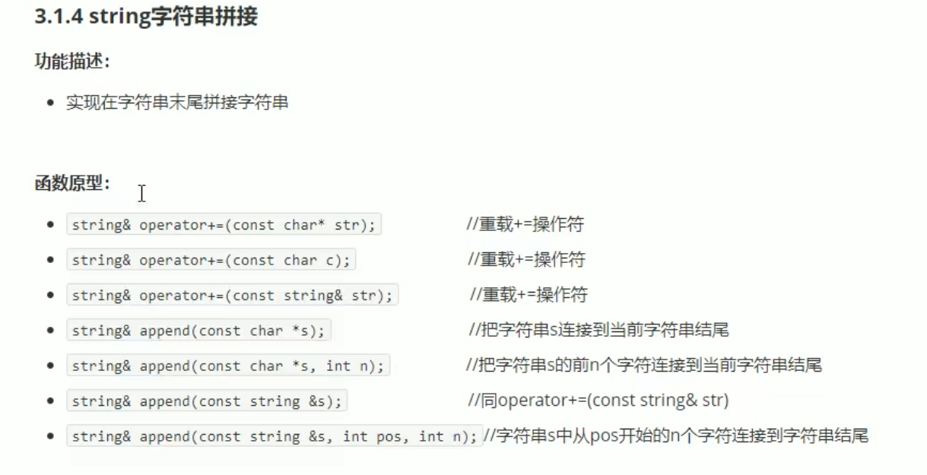

#include <iostream>

using namespace std;

#include <string>

void test01()

{

string str1 = "我";

str1 += "是骚远";

cout << "str1 = " << str1 << endl;

//string str2 = ":";

//str1 += str2;

//cout << "str2 = " << str2 << endl;

//string str3 = "蛇皮";

//str1 += str3;

//cout << "str1 = " << str1 << endl;

//

string str4 = "I";

str4.append(" love");

cout << "str4 = " << str4 << endl;

str4.append(" lovewarff",6);

cout << "str4 = " << str4 << endl;

str4.append(str1);

cout << "str4 = " << str4 << endl;

str4.append(str1, 0 ,4);//第二个是从几开始，第三个是截取几个字节

cout << "str4 = " << str4 << endl;

}

int main()

{

test01();

system("pause");

return 0;

}

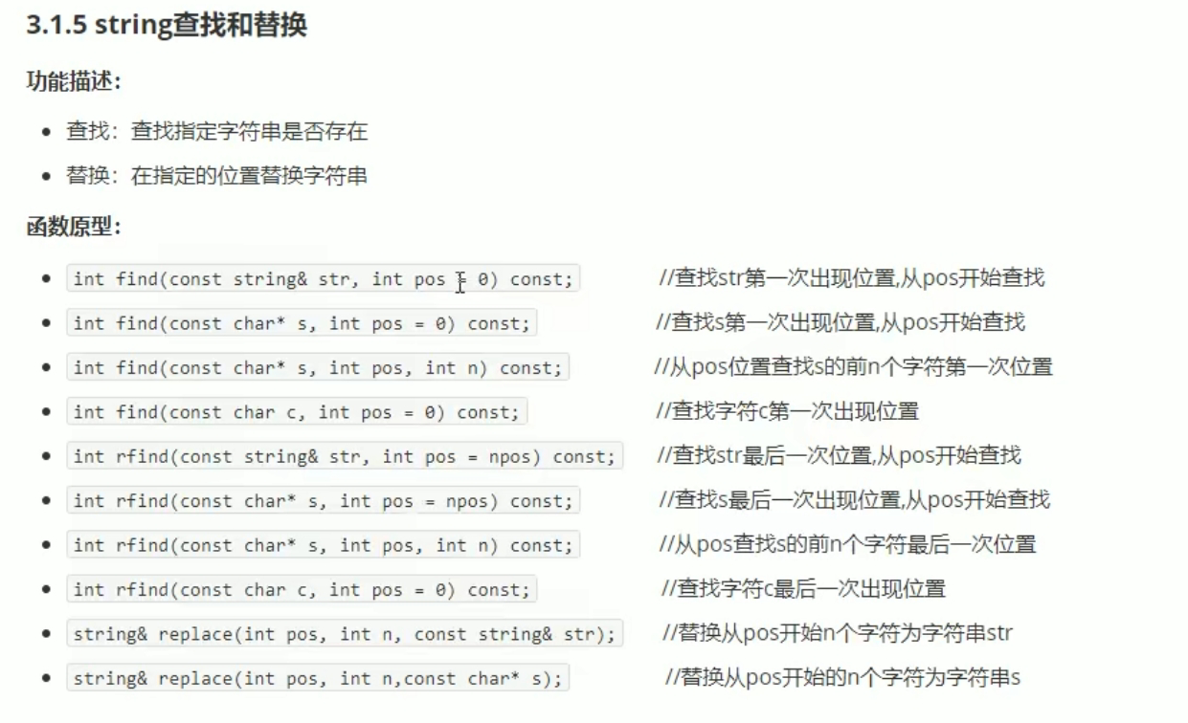

#include <iostream>

using namespace std;

#include <string>

void test01()

{

string str1 = "dawafaignadfa";

int pos = str1.find("fa");

if (pos == -1)

{

cout << "找不到这个字符串。" << endl;

}

else

{

cout << "找到这个字符串， pos = " << pos << endl;

}

//rfind和find 区别：rfind从右往左查，find从左往右查。

int pos1 = str1.rfind("fa");

cout << "pos1 = " << pos1 << endl;

}

void test02()

{

string str1 = "abcdefg";

str1.replace(1, 3, "1111");//从一号位置其3个字符替换为"1111";

cout << "str1 = " << str1 << endl;

}

int main()

{

test01();

test02();

system("pause");

return 0;

}

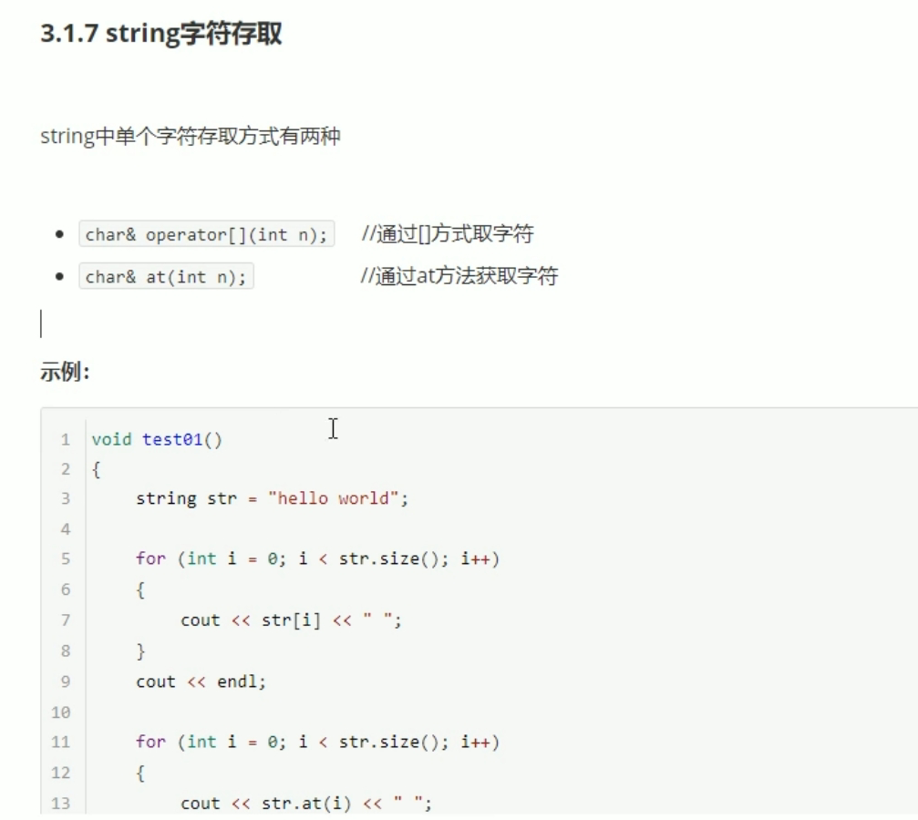

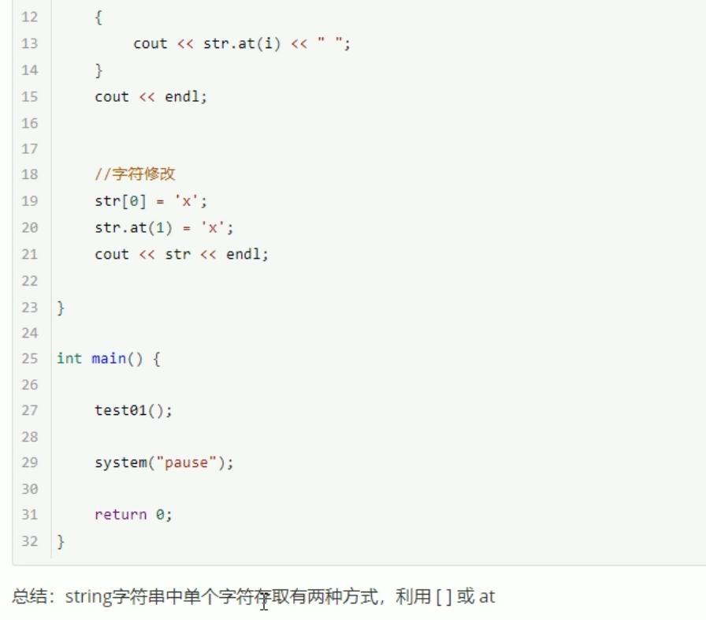

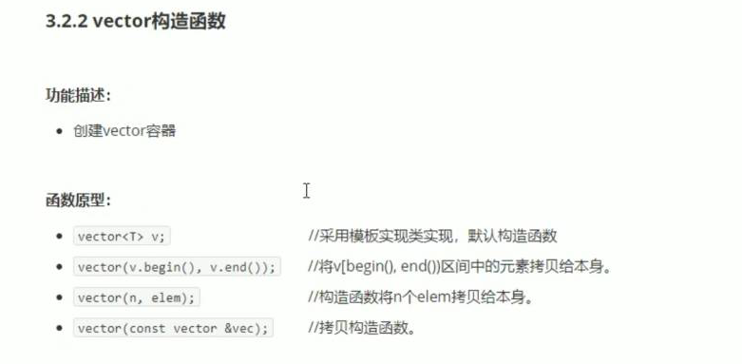

#include <iostream>

using namespace std;

#include <string>

#include<vector>

void printVector(vector<int> v)

{

for (vector<int> ::iterator it = v.begin(); it != v.end();it++ )

{

cout << *it << " ";

}

cout << endl;

}

void test01()

{

vector<int> v1;

for (int i = 0; i < 10; i++)

{

v1.push_back(i);

}

printVector(v1);

vector<int>v2(v1.begin(), v1.end());

printVector(v2);

vector<int>v3(10, 100);

printVector(v3);

vector<int>v4(v3);

printVector(v4);

}

int main()

{

test01();

system("pause");

return 0;

}

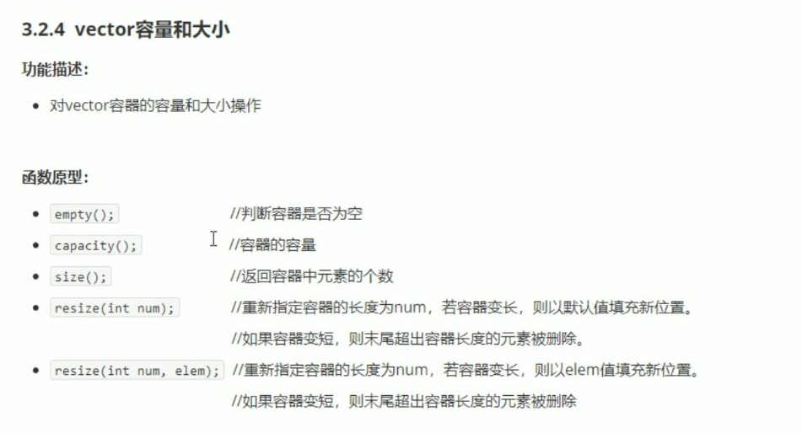

#include <iostream>

using namespace std;

#include <string>

#include <vector>

void printVector(vector<int> &v)

{

for (vector<int>::iterator it = v.begin();it !=v.end(); it++)

{

cout << *it << " ";

}

cout << endl;

}

void test01()

{

vector<int> v1;

for (int i = 0; i < 10; i++)

{

v1.push_back(i);

}

printVector(v1);

if (v1.empty())

{

cout << "v1为空。" << endl;

}

else

{

cout << "v1不为空。" << endl;

cout << "v1的容量大小为： " << v1.capacity() << endl;

cout << "v1的大小为： " << v1.size() << endl;

}

v1.resize(15,100);//填充值为 2；100这个数。

printVector(v1);//重新定义的指定的比原来长了，默认用0填充新的位置。

v1.resize(5);//缩短。

}

int main()

{

test01();

system("pause");

return 0;

}

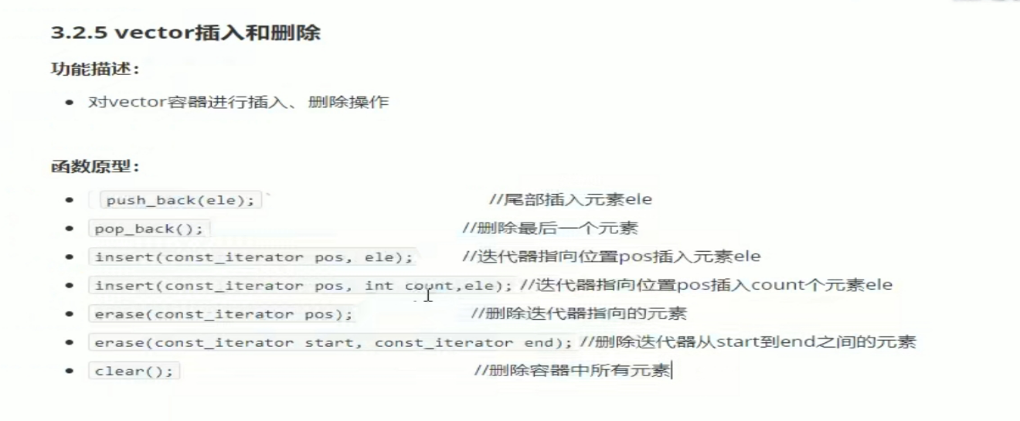

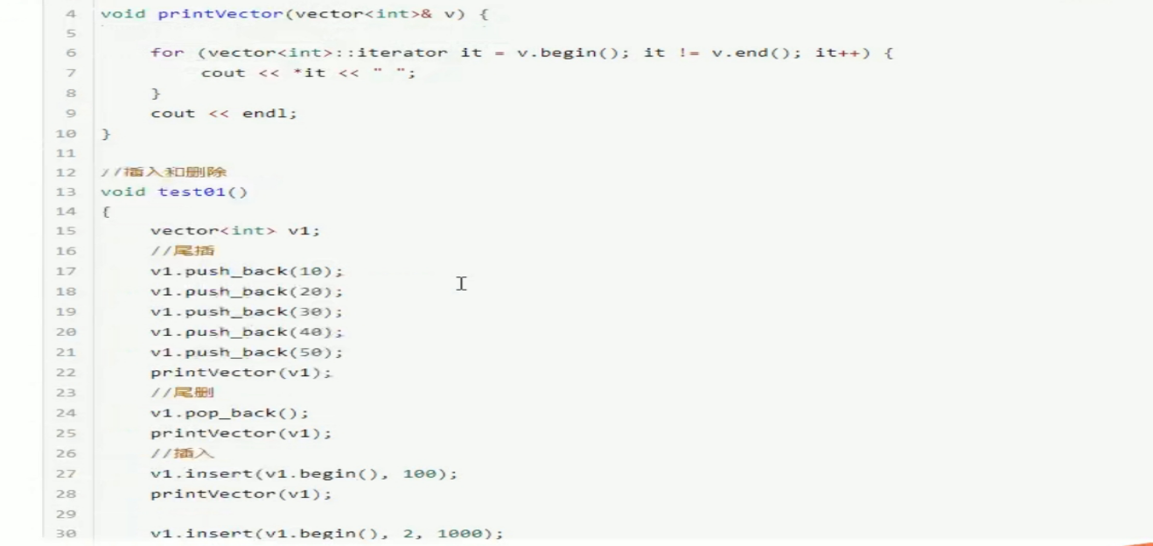

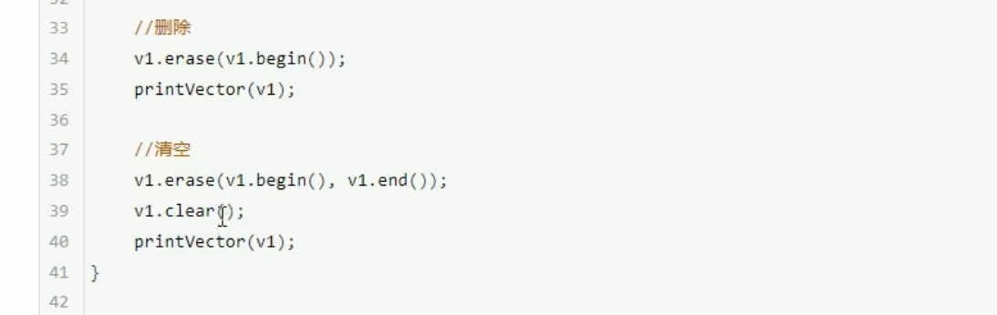

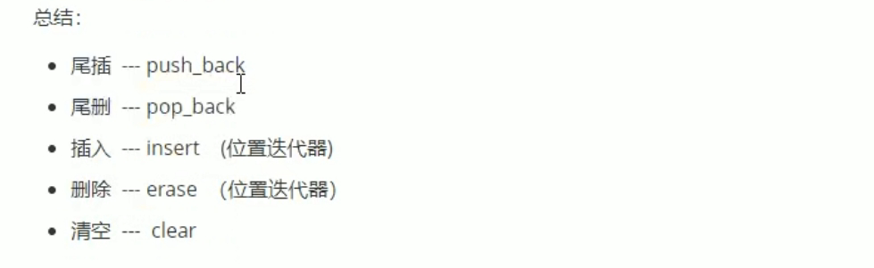

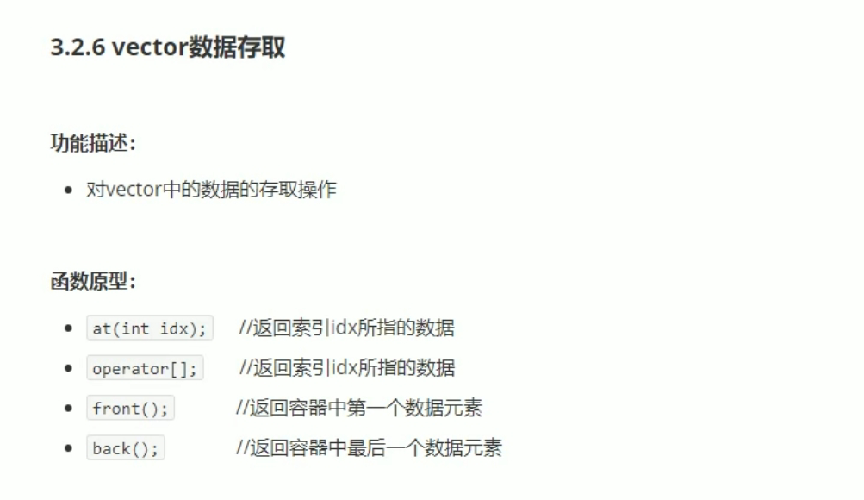

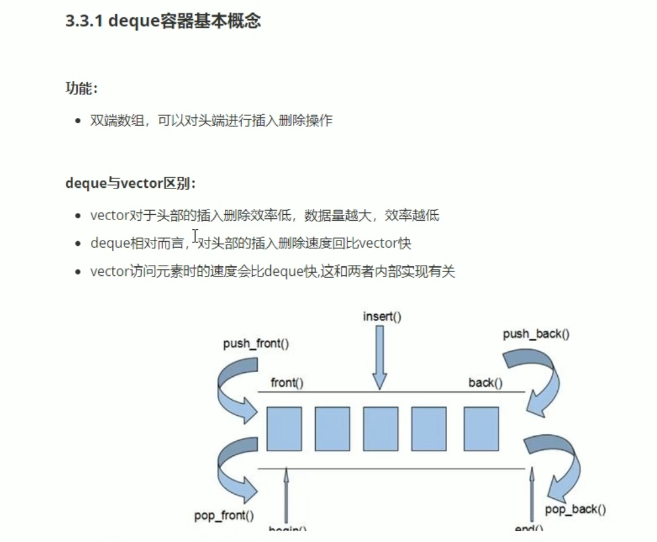

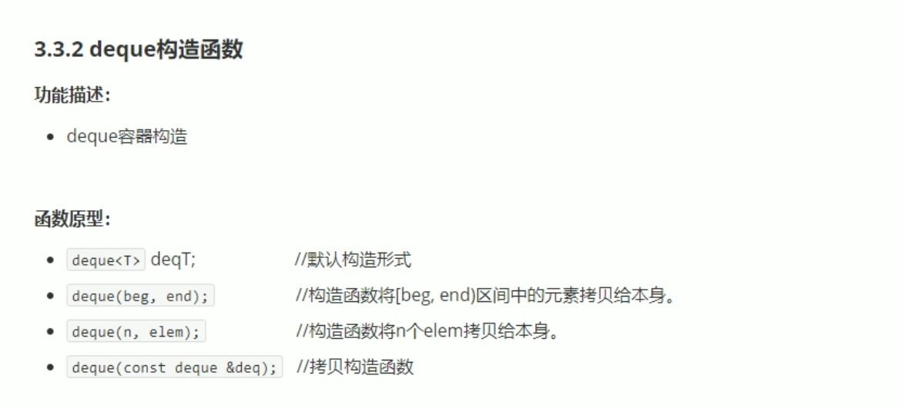

#include <iostream>

using namespace std;

#include <string>

#include <deque>

void printDeque(const deque<int>&d)

{

for (deque<int>::const_iterator it = d.begin(); it != d.end(); it++)

{

cout << *it << " ";

}

cout << endl;

}

void test01()

{

deque<int> d1;

for (int i = 0; i < 10; i++)

{

d1.push_back(i);

}

printDeque(d1);

deque<int>d2(d1.begin(), d1.end());

printDeque(d2);

deque<int>d3(10, 100);

printDeque(d3);

deque<int>d4(d3);

printDeque(d4);

}

int main()

{

test01();

system("pause");

return 0;

}

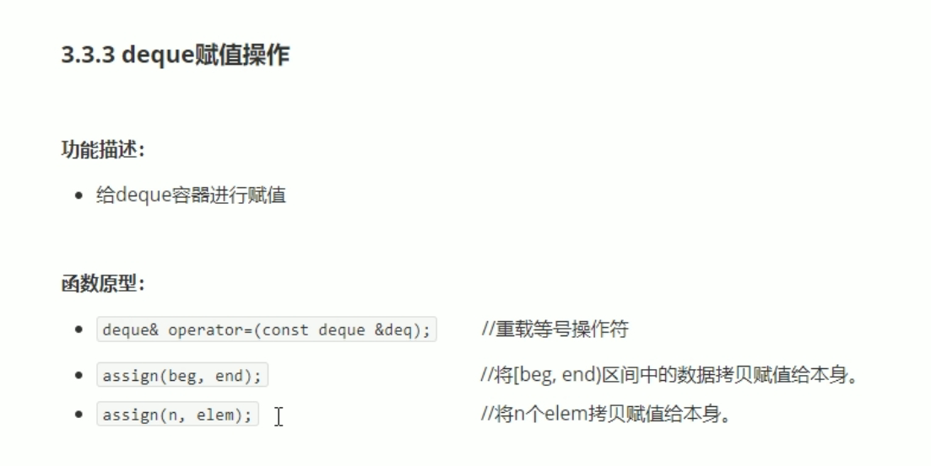

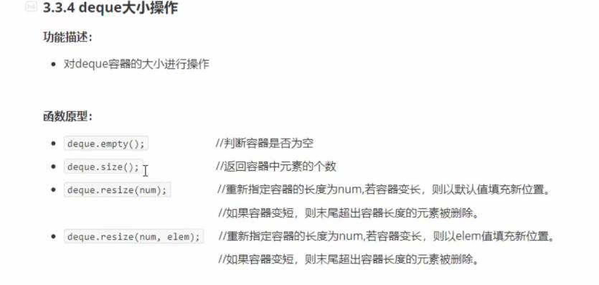

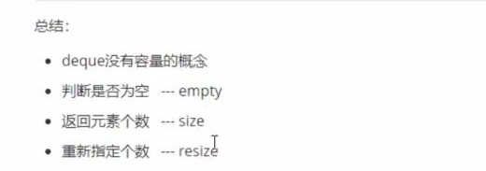

#include <iostream>

using namespace std;

#include <string>

#include <deque>

void printDeque(const deque<int>&d)

{

for (deque<int>::const_iterator it = d.begin(); it != d.end(); it ++)

{

cout << *it << " ";

}

cout << endl;

}

void test01()

{

deque<int> d1;

for (int i = 0; i < 10; i++)

{

d1.push_back(i);

}

printDeque(d1);

if (d1.empty())

{

cout << "d1为空。" << endl;

}

else

{

cout << "d1不为空。" << endl;

cout << "d1的大小为： " <<d1.size()<< endl;

}

d1.resize(15,1);

printDeque(d1);

}

int main()

{

test01();

system("pause");

return 0;

}

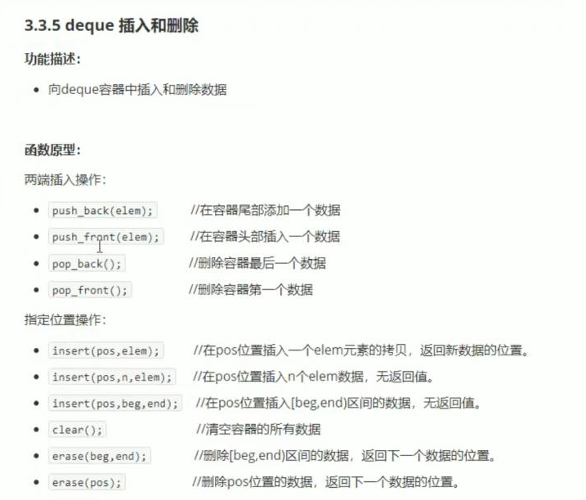

#include <iostream>

using namespace std;

#include <string>

#include <deque>

void printDeque(const deque<int> &d)

{

for (deque<int>::const_iterator it = d.begin() ; it != d.end(); it++)

{

cout << *it << " ";

}

cout << endl;

}

void test01()

{

deque<int> d1;

//尾插

d1.push_back(10);

d1.push_back(20);

//头插

d1.push_front(55);

d1.push_front(40);

printDeque(d1);

//尾删除

d1.pop_back();

printDeque(d1);

//头删除

d1.pop_front();

printDeque(d1);

}

void test02()

{

deque<int> d1;

d1.push_back(10);

d1.push_back(20);

d1.push_front(55);

d1.push_front(40);

printDeque(d1);

d1.insert(d1.begin(),2, 200);//2个200

printDeque(d1);

}

int main()

{

test02();

system("pause");

return 0;

}

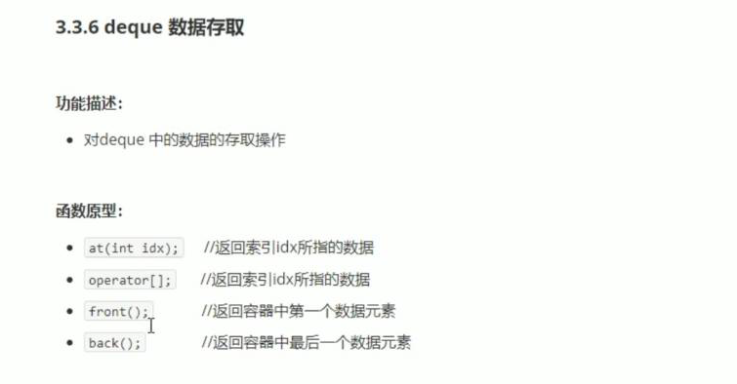

#include <iostream>

using namespace std;

#include <string>

#include <deque>

void test01()

{

deque<int> d1;

//尾插

d1.push_back(10);

d1.push_back(20);

d1.push_back(20);

d1.push_back(20);

d1.push_back(20);

//头插

d1.push_front(55);

d1.push_front(40);

d1.push_front(40);

d1.push_front(40);

d1.push_front(40);

for (int i = 0; i < d1.size(); i++)

{

cout << d1[i] << " " ;

}

cout<<endl;

for (int i = 0; i < d1.size(); i++)

{

cout << d1.at(i) << " ";

}

cout << endl;

cout << "访问第一个元素： " << d1.front() << endl;

cout << "访问最后一个元素： " << d1.back() << endl;

}

int main()

{

test01();

system("pause");

return 0;

}

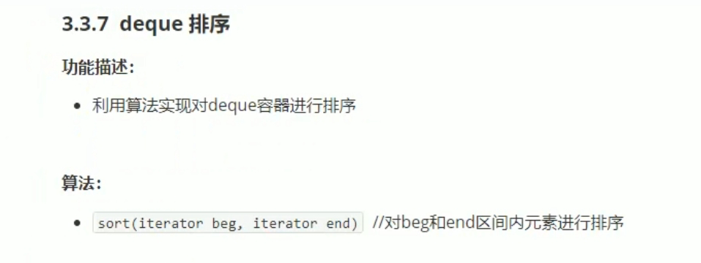

#include <iostream>

using namespace std;

#include <string>

#include <deque>

#include<algorithm>

void printDeque(const deque<int> &d)

{

for (deque<int>::const_iterator it = d.begin(); it != d.end(); it++)

{

cout << *it << " ";

}

cout << endl;

}

void test01()

{

deque<int> d1;

d1.push_back(10);

d1.push_back(5);

d1.push_back(55);

d1.push_back(25);

d1.push_front(500);

d1.push_front(200);

d1.push_front(100);

d1.push_front(300);

printDeque(d1);

cout << "排序后 ： " << endl;

sort(d1.begin(), d1.end());

printDeque(d1);

}

int main()

{

test01();

system("pause");

return 0;

}

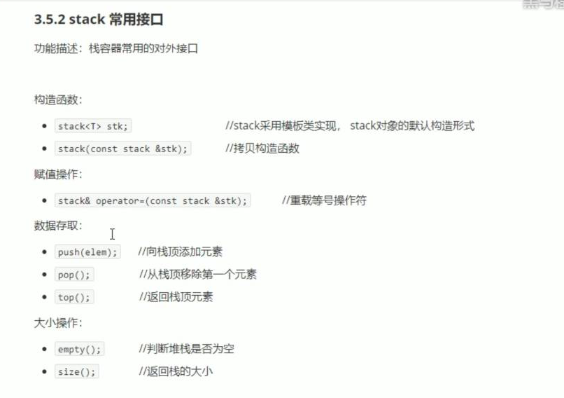

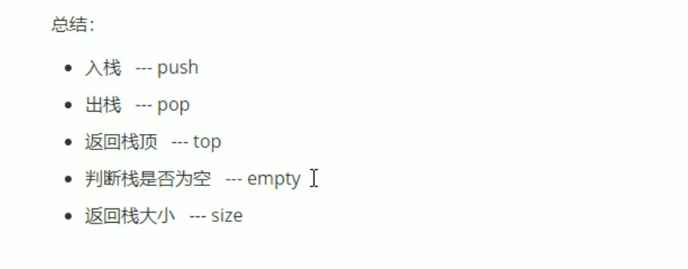

#include <iostream>

using namespace std;

#include <string>

#include <stack>

void test01()

{

stack<int> s;

s.push(10);

s.push(20);

s.push(30);

s.push(40);

s.push(50);

while (!s.empty())

{

cout << "栈顶元素为 ：" << s.top()<<endl;

s.pop();

}

cout << "栈的大小： " << s.size() << endl;

}

int main()

{

test01();

system("pause");

return 0;

}

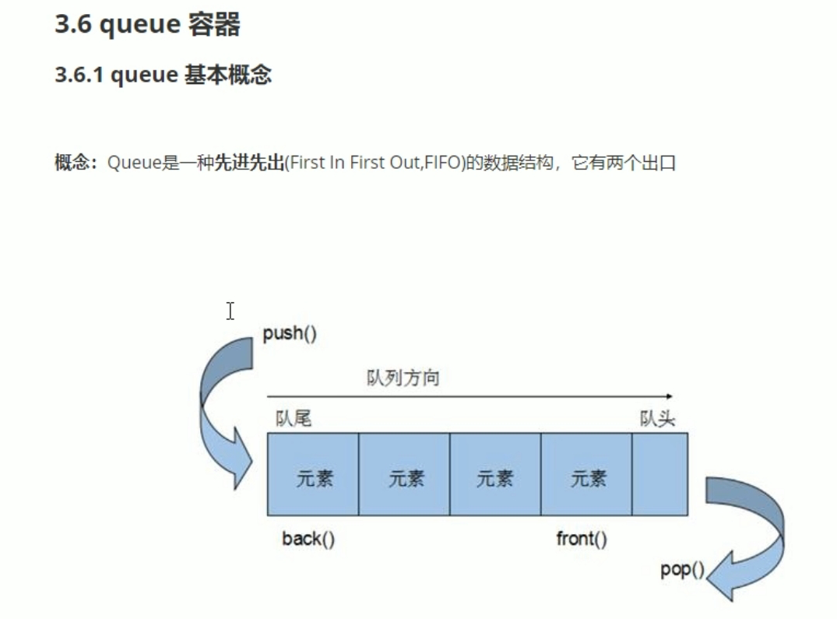

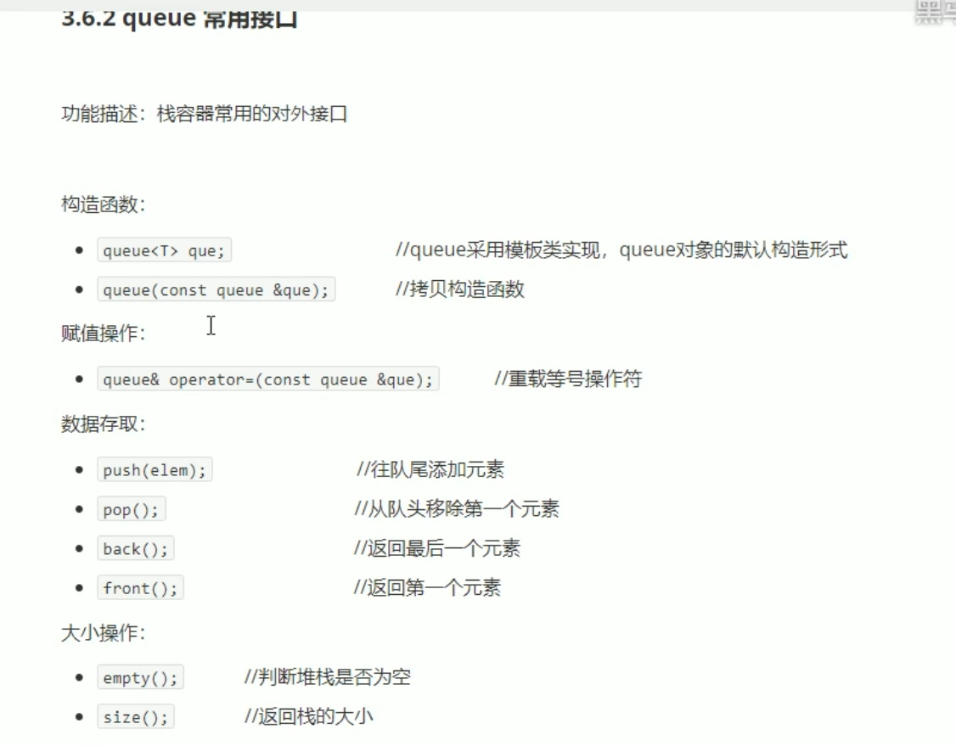

#include <iostream>

using namespace std;

#include <string>

#include <queue>

class Person

{

public:

Person(string name, int age)

{

this->m_Name = name;

this->m_Age = age;

}

string m_Name;

int m_Age;

};

void test01()

{

queue<Person>q;

Person p1("唐僧", 80);

Person p2("孙悟空", 2500);

Person p3("八戒", 30);

Person p4("沙僧", 100);

q.push(p1);

q.push(p2);

q.push(p3);

q.push(p4);

cout << "队列的大小：" << q.size() << endl;

while (!q.empty())

{

cout << "队头元素的姓名：" << q.front().m_Name << "年龄是 ：" << q.front().m_Age << endl;

cout << "队尾元素的姓名：" << q.back().m_Name << "年龄是 ：" << q.back().m_Age << endl;

q.pop();

}

cout << "队列的大小：" << q.size() << endl;

}

int main()

{

test01();

system("pause");

return 0;

}

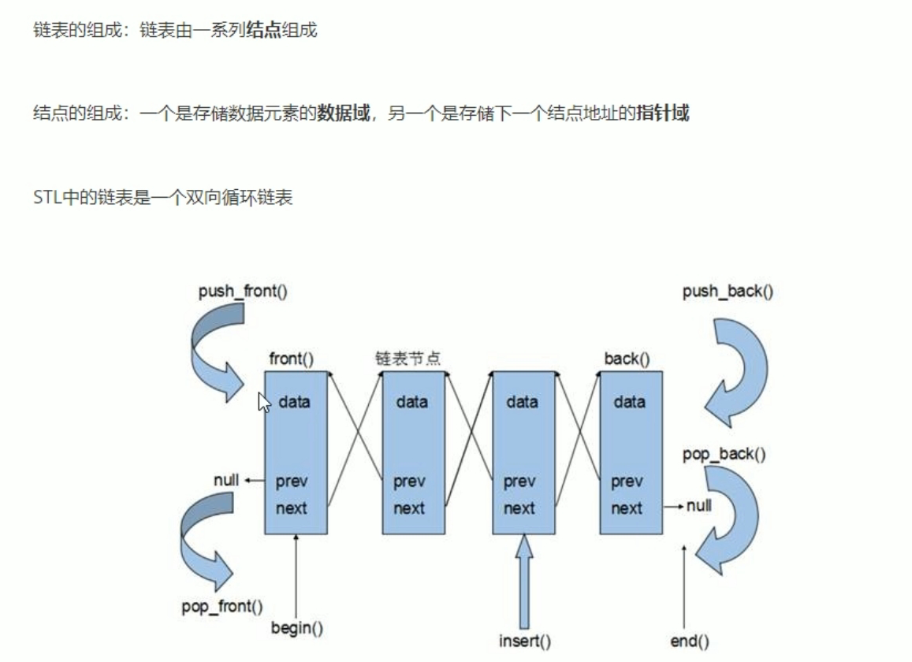

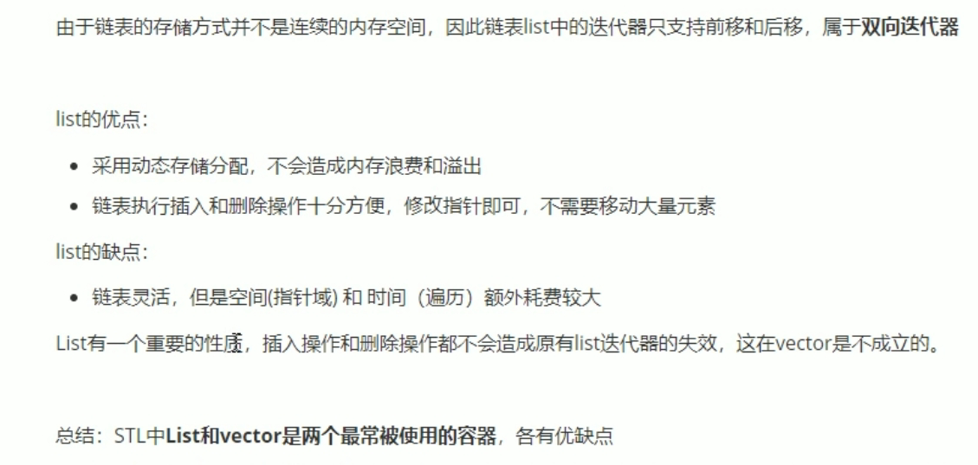

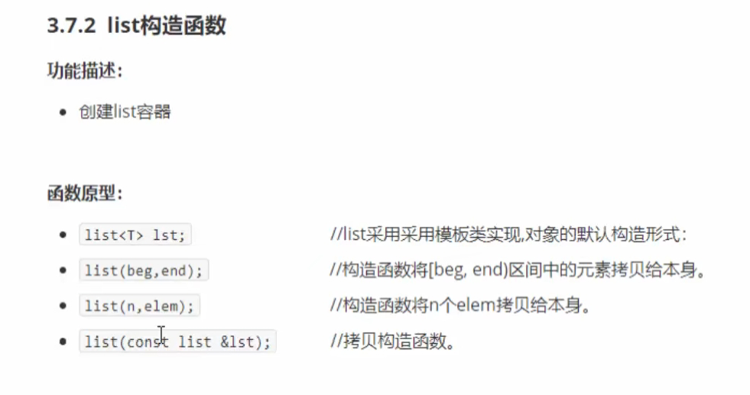

#include <iostream>

using namespace std;

#include <string>

#include <list>

void printList(const list<int>&L)

{

for (list<int>::const_iterator it =L.begin(); it != L.end(); it++)

{

cout << *it << " ";

}

cout << endl;

}

void test01()

{

list<int> L1;

L1.push_back(10);

L1.push_back(20);

L1.push_back(30);

L1.push_back(40);

L1.push_back(50);

printList(L1);

list<int>L2(L1.begin(), L1.end());

printList(L2);

list<int>L3(L2);

printList(L3);

list<int>L4(10,1000);

printList(L4);

}

int main()

{

test01();

system("pause");

return 0;

}

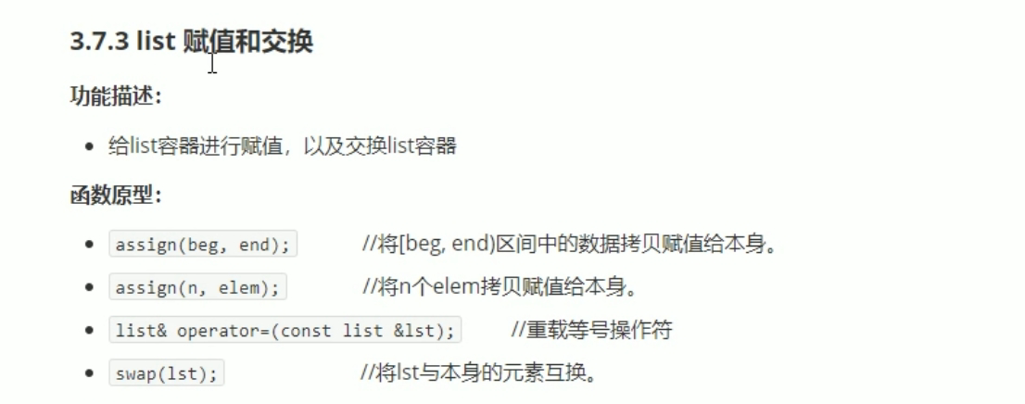

#include <iostream>

using namespace std;

#include <string>

#include <list>

void printList(const list<int>&L)

{

for (list<int>::const_iterator it =L.begin(); it != L.end(); it++)

{

cout << *it << " ";

}

cout << endl;

}

void test01()

{

list<int> L1;

L1.push_back(10);

L1.push_back(20);

L1.push_back(30);

L1.push_back(40);

L1.push_back(50);

printList(L1);

list<int>L2;

L2 = L1;

printList(L2);

list<int>L3;

L3.assign(L2.begin(), L2.end());

printList(L3);

list<int>L4;

L4.assign(9, 100);

printList(L4);

}

void test02()

{

list<int> L1;

L1.push_back(10);

L1.push_back(20);

L1.push_back(30);

L1.push_back(40);

L1.push_back(50);

list<int> L2;

L2.assign(7, 88);

cout << "交换前： " << endl;

printList(L1);

printList(L2);

L1.swap(L2);

cout << "交换后： " << endl;

printList(L1);

printList(L2);

}

int main()

{

test02();

system("pause");

return 0;

}

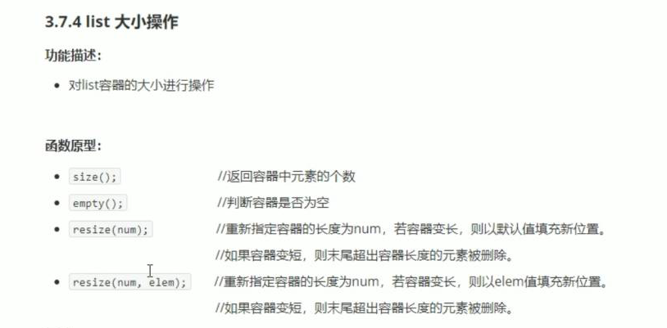

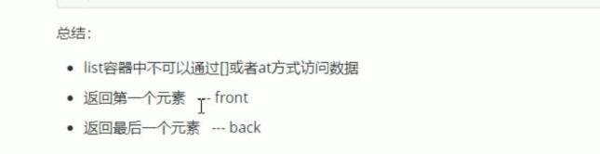

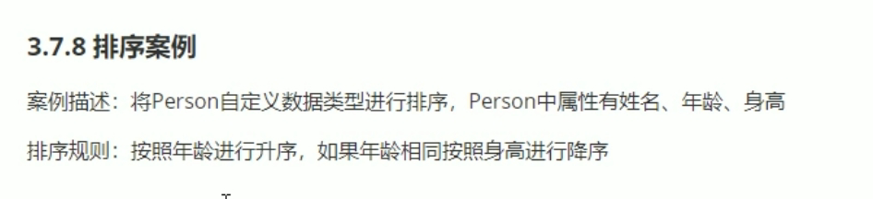

#include <iostream>

using namespace std;

#include <string>

#include<list>

#include<algorithm>

class Person

{

public:

Person(string name, int age, int height)

{

this->m_Name = name;

this->m_Age = age;

this->m_Height = height;

}

string m_Name;

int m_Age;

int m_Height;

};

bool comparePerson(Person &p1, Person &p2)

{

if (p1.m_Age == p2.m_Age)

{

return p1.m_Height > p2.m_Height;

}

else

{

return p1.m_Age < p2.m_Age;

}

return p1.m_Age < p2.m_Age;

}

void test01()

{

list<Person> L;

Person p1("刘备", 45, 200);

Person p2("张飞", 35, 170);

Person p3("关羽", 35, 180);

Person p4("黄忠", 60, 181);

Person p5("赵云", 35, 190);

Person p6("马超", 20, 185);

L.push_back(p1);

L.push_back(p2);

L.push_back(p3);

L.push_back(p4);

L.push_back(p5);

L.push_back(p6);

for (list<Person>::iterator it = L.begin(); it != L.end(); it++)

{

cout << "姓名是： " << (*it).m_Name << " 年龄是 ：" << (*it).m_Age << " 身高是：" << (*it).m_Height << endl;

}

cout << "---------------------------" << endl;

cout << "排序后：" << endl;

L.sort(comparePerson);

for (list<Person>::iterator it = L.begin(); it != L.end(); it++)

{

cout << "姓名是： " << (*it).m_Name << " 年龄是 ：" << (*it).m_Age << " 身高是：" << (*it).m_Height << endl;

}

}

int main()

{

test01();

system("pause");

return 0;

}

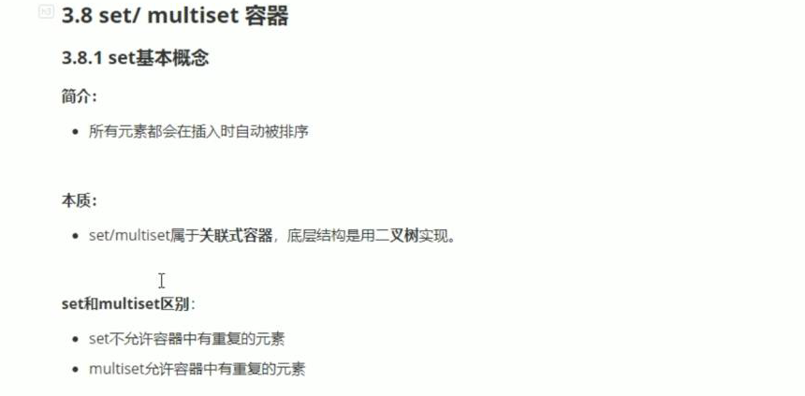

#include <iostream>

using namespace std;

#include <string>

#include <set>

void printSet(set<int>&s)

{

for(set<int>::iterator it = s.begin(); it != s.end(); it++)

{

cout << *it << " ";

}

cout << endl;

}

void test01()

{

set<int> s1;

s1.insert(20);

s1.insert(30);

s1.insert(40);

s1.insert(10);

s1.insert(30);//set容器按照所有元素插入的时候自动排序

//set你容许插入重复值。

printSet(s1);

set<int>s2(s1);

printSet(s2);

set<int> s3;

s3 = s2;

printSet(s3);

}

int main()

{

test01();

system("pause");

return 0;

}

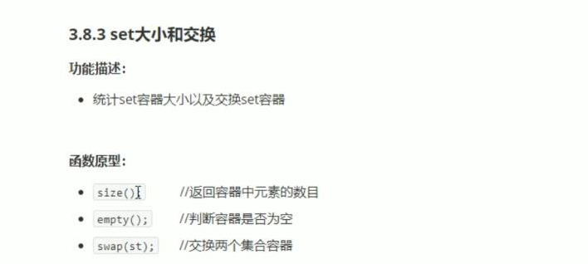

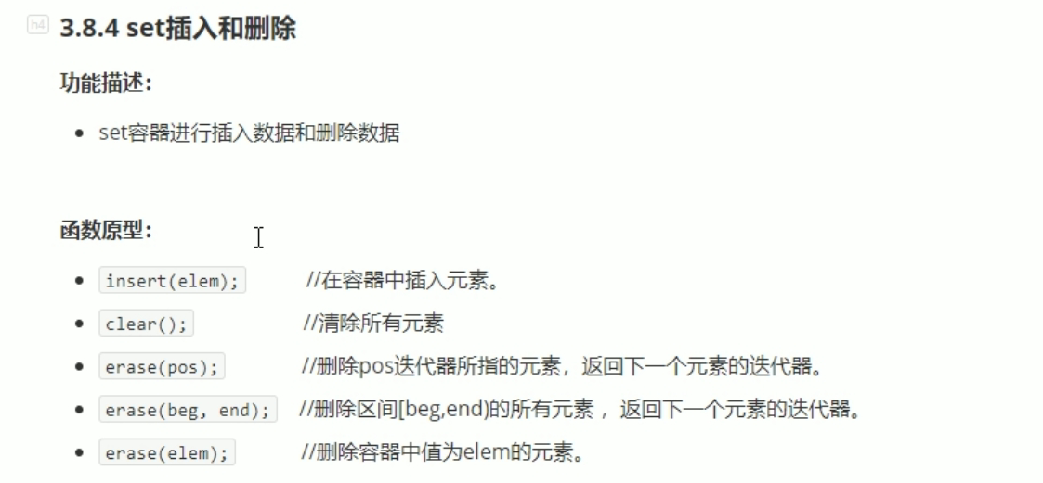

#include <iostream>

using namespace std;

#include <string>

#include <set>

void printSet(set<int>&s)

{

for(set<int>::iterator it = s.begin(); it != s.end(); it++)

{

cout << *it << " ";

}

cout << endl;

}

void test01()

{

set<int> s1;

s1.insert(20);

s1.insert(30);

s1.insert(40);

s1.insert(10);

s1.insert(30);//set容器按照所有元素插入的时候自动排序

//set你容许插入重复值。

printSet(s1);

//s1.erase(s1.begin());

//printSet(s1);

//s1.erase(30);

//printSet(s1);

}

int main()

{

test01();

system("pause");

return 0;

}

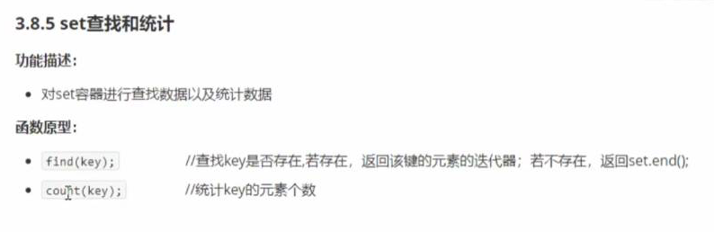

#include <iostream>

using namespace std;

#include <string>

#include <set>

void printSet(set<int>&s)

{

for(set<int>::iterator it = s.begin(); it != s.end(); it++)

{

cout << *it << " ";

}

cout << endl;

}

void test01()

{

set<int> s1;

s1.insert(20);

s1.insert(30);

s1.insert(40);

s1.insert(10);

s1.insert(30);

printSet(s1);

set<int>::iterator pos = s1.find(30);

if (pos != s1.end())

{

cout << "找到元素： " << *pos << endl;

}

else

{

cout << "未找到元素。" << endl;

}

}

void test02()

{

set<int> s1;

s1.insert(20);

s1.insert(30);

s1.insert(40);

s1.insert(10);

s1.insert(30);

printSet(s1);

int num = s1.count(30);

cout << "num = " << num<<endl;//set容器不能查重复的数字只能0和1

}

int main()

{

test02();

system("pause");

return 0;

}

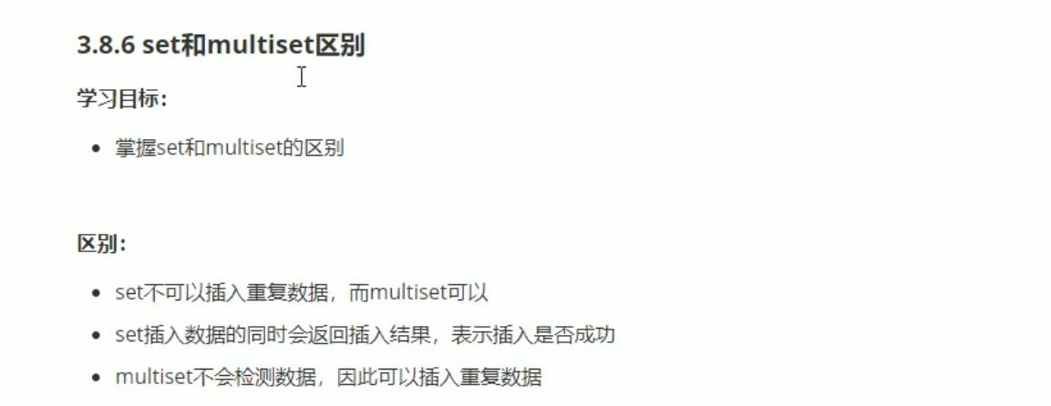

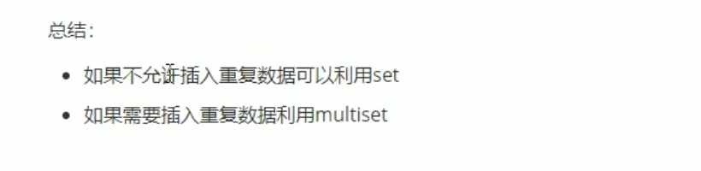

#include <iostream>

using namespace std;

#include <string>

#include <set>

void test01()

{

set<int> s1;

pair<set<int>::iterator ,bool> ret = s1.insert(20);

if (ret.second)

{

cout << "第一次插入成功。" << endl;

}

else

{

cout << "第一次插入失败。" << endl;

}

ret = s1.insert(20);

if (ret.second)

{

cout << "第一次插入成功。" << endl;

}

else

{

cout << "第一次插入失败。" << endl;

}

multiset<int> ms;

ms.insert(10);

ms.insert(10);

for (multiset<int> ::iterator it = ms.begin();it != ms.end(); it++)

{

cout << *it << " ";

}

cout << endl;

}

int main()

{

test01();

system("pause");

return 0;

}

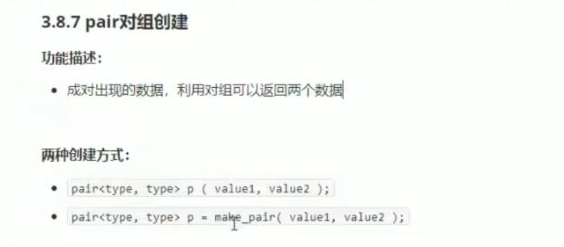

#include <iostream>

using namespace std;

#include <string>

void test01()

{

pair<string, int> p("tom", 20);

cout << "姓名是 ： " << p.first << " 年龄是： " << p.second << endl;

pair<string, int>p2 = make_pair("jerry", 18);

cout << "姓名是 ： " << p2.first << " 年龄是： " << p2.second << endl;

}

int main()

{

test01();

system("pause");

return 0;

}

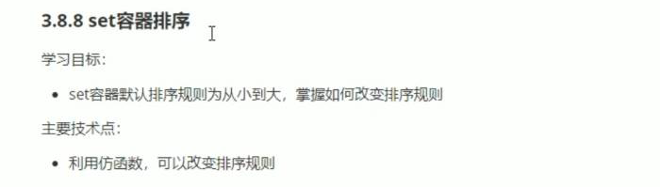

#include <iostream>

using namespace std;

#include <string>

#include<set>

class MyCompare

{

public:

bool operator()(int v1,int v2)

{

return v1 > v2;

}

};

void test01()

{

set<int> s1;

s1.insert(10);

s1.insert(20);

s1.insert(30);

s1.insert(40);

s1.insert(50);

s1.insert(60);

for (set<int>::iterator it = s1.begin(); it != s1.end(); it++)

{

cout << *it << " ";

}

cout << endl;

set<int, MyCompare> s2;

s2.insert(10);

s2.insert(20);

s2.insert(30);

s2.insert(40);

s2.insert(50);

s2.insert(60);

for (set<int, MyCompare>::iterator it = s2.begin(); it != s2.end(); it++)

{

cout << *it << " ";

}

cout << endl;

}

int main()

{

test01();

system("pause");

return 0;

}

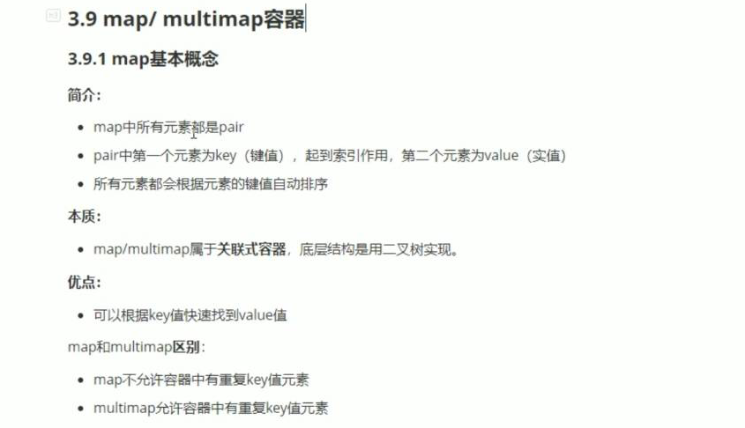

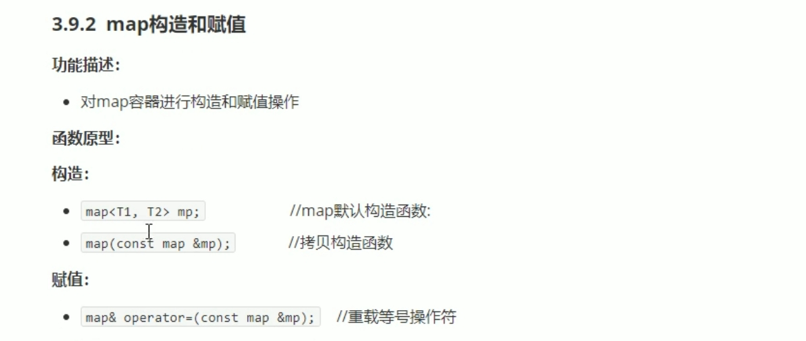



#include <iostream>

using namespace std;

#include <string>

#include <map>

void printMap(map<int, int> &m)

{

for (map<int, int>::iterator it = m.begin(); it != m.end(); it++)

{

cout << "key: " <<(*it).first<<" value = "<< it->second << endl ;

}

cout << endl;

}

void test01()

{

map<int, int> m;

m.insert(pair<int, int>(1, 10));

m.insert(pair<int, int>(3, 20));

m.insert(pair<int, int>(2, 30));

m.insert(pair<int, int>(4, 40));

printMap(m);

map<int, int> m2(m);

printMap(m2);

map<int, int> m3;

m3 = m2;

printMap(m3);

}

int main()

{

test01();

system("pause");

return 0;

}

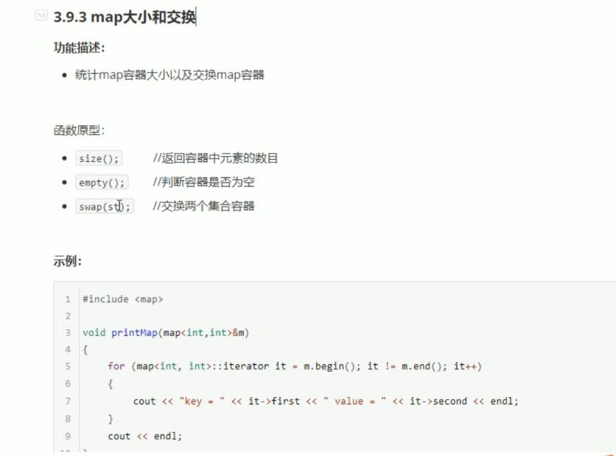

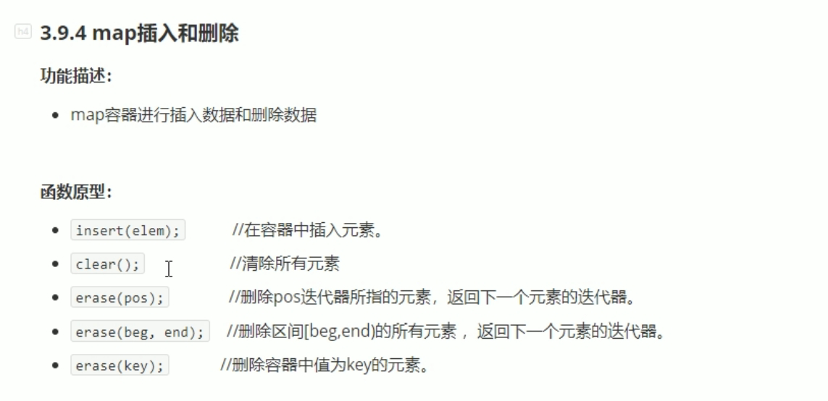

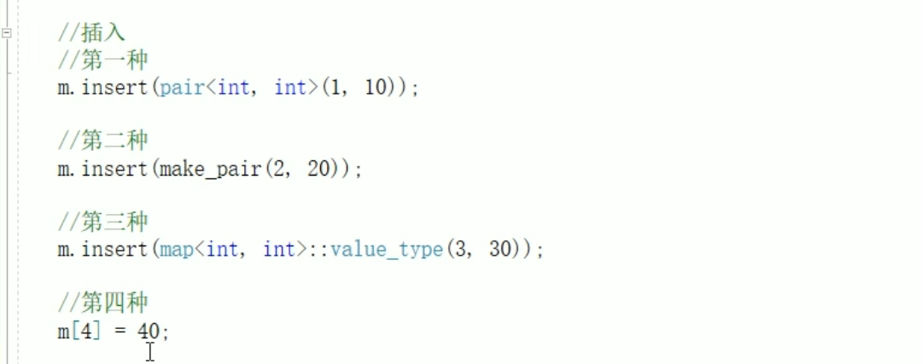

**Map与set用法基本一样。**

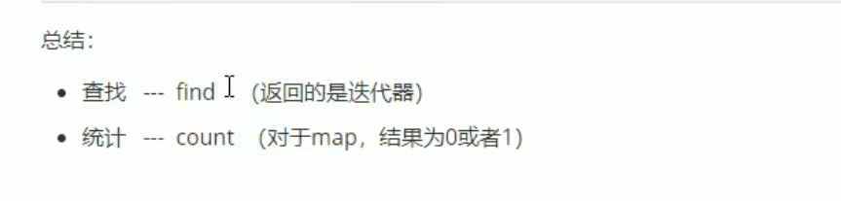

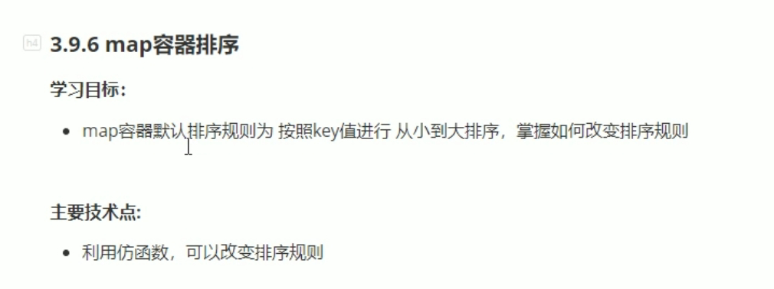

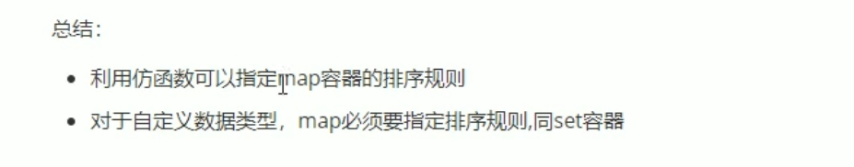

#include <iostream>

using namespace std;

#include <string>

#include<map>

class MyCompass

{

public:

bool operator()(int v1, int v2)

{

return v1 > v2;

}

};

void test01()

{

map<int, int, MyCompass>m;

m.insert(make_pair(1, 10));

m.insert(make_pair(2, 20));

m.insert(make_pair(5, 50));

m.insert(make_pair(3, 30));

m.insert(make_pair(4, 40));

for (map<int, int, MyCompass>::iterator it = m.begin(); it != m.end(); it++)

{

cout << "key: " << (*it).first << " value = " << it->second << endl;

}

cout << endl;

}

int main()

{

test01();

system("pause");

return 0;

}

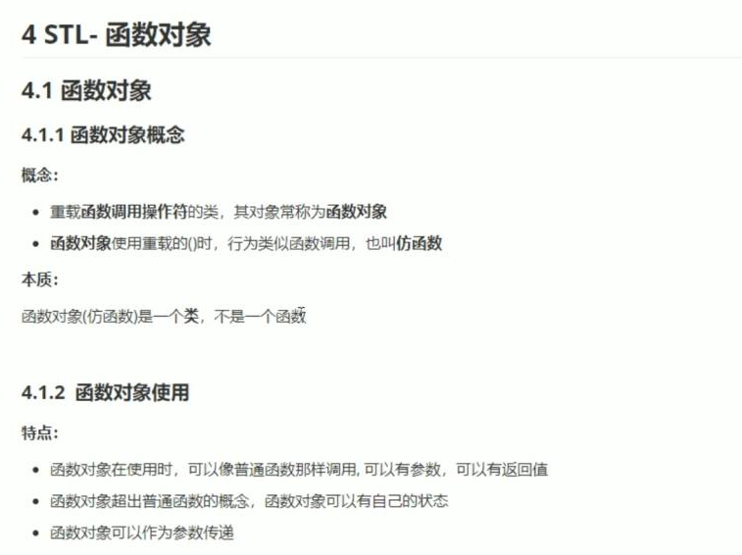

#include <iostream>

using namespace std;

#include <string>

class MyAdd

{

public:

int operator()(int v1, int v2)

{

return v1 + v2;

}

};

class MyPrint

{

public:

MyPrint()

{

this->count = 0;

}

void operator()(string test)

{

cout << test << endl;

this->count++;

}

int count;

};

void test01()

{

MyAdd myadd;

cout << myadd(10, 10) << endl;

}

void test02()

{

MyPrint myprint;

myprint("hello world");

myprint("hello world");

myprint("hello world");

cout << "myprint调用的次数为" << myprint .count << endl;

}

int main()

{

test02();

system("pause");

return 0;

}

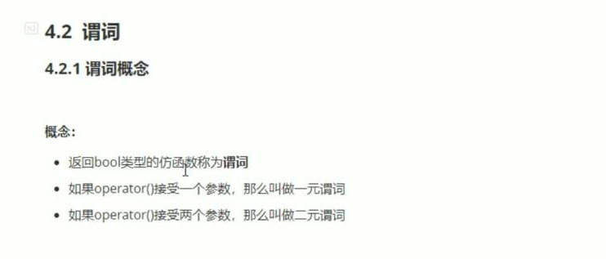

#include <iostream>

using namespace std;

#include <string>

#include <vector>

#include<algorithm>

class GreaterFive

{

public:

bool operator()(int val)

{

return val > 5;

}

};

void test01()

{

vector<int> v;

for (int i = 0; i < 10; i++)

{

v.push_back(i);

}

vector<int>::iterator it = find_if(v.begin(), v.end(), GreaterFive());

if (it == v.end())

{

cout << "未找到" << endl;

}

else

{

cout << "找到了 ，大于5的数字。" << *it << endl;

}

}

int main()

{

test01();

system("pause");

return 0;

}

二元谓词

#include <iostream>

using namespace std;

#include <string>

#include <vector>

#include<algorithm>

class MyCompare

{

public:

bool operator()(int val1, int val2)//bool 为谓词，两个参数二元谓词。

{

return val1 > val2;

}

};

void test01()

{

vector<int>v;

v.push_back(10);

v.push_back(40);

v.push_back(30);

v.push_back(20);

v.push_back(50);

sort(v.begin(), v.end());

for (vector<int>::iterator it =v.begin(); it!=v.end();it++)

{

cout << *it << endl;

}

cout << endl;

sort(v.begin(), v.end(), MyCompare());

cout << "-----------------------" << endl;

for (vector<int>::iterator it = v.begin(); it != v.end(); it++)

{

cout << *it << endl;

}

}

int main()

{

test01();

system("pause");

return 0;

}

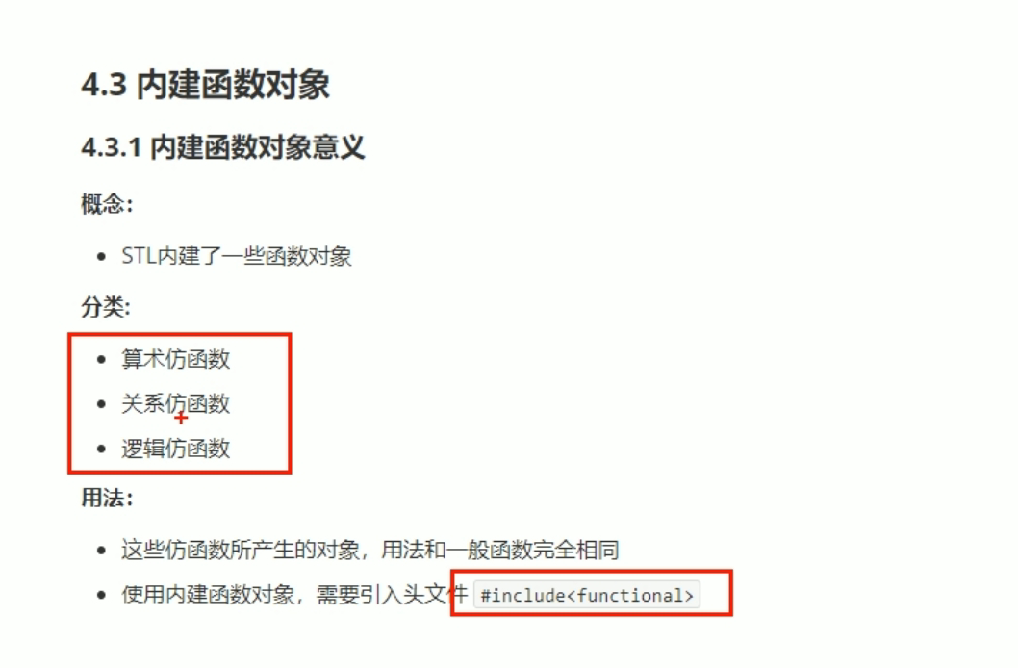

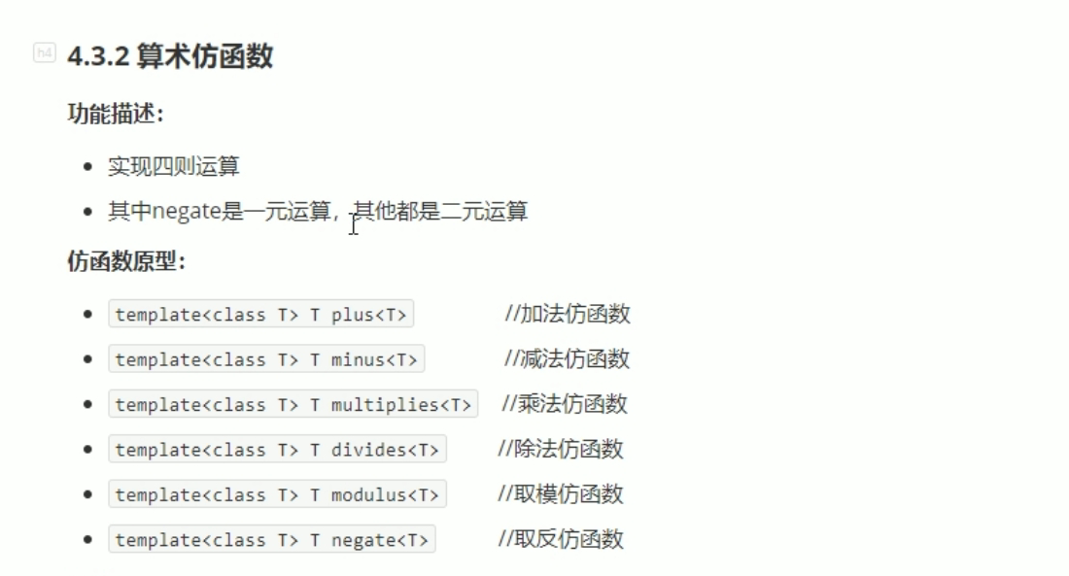

#include <iostream>

using namespace std;

#include <string>

#include<functional>

void test01()

{

negate<int> n;

cout << n(50) << endl;

}

void test02()

{

plus<int>p;

cout << p(10, 20) << endl;

}

int main()

{

test02();

system("pause");

return 0;

}

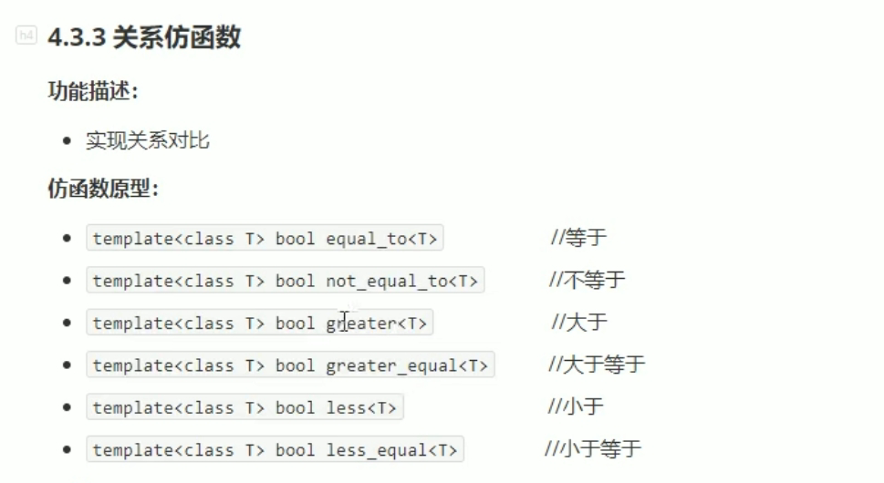

#include <iostream>

using namespace std;

#include <string>

#include<functional>

#include<vector>

#include<algorithm>

class MyCompare

{

public:

bool operator()(int val1, int val2)//bool 为谓词，两个参数二元谓词。

{

return val1 > val2;

}

};

void test01()

{

vector<int> v;

v.push_back(10);

v.push_back(20);

v.push_back(60);

v.push_back(40);

v.push_back(30);

for (vector<int>::iterator it = v.begin(); it != v.end(); it++)

{

cout << *it << " " ;

}

cout << endl;

//sort(v.begin(), v.end(), MyCompare());

sort(v.begin(), v.end(), greater<int>());//关系仿函数，大于

cout << "-----------------------" << endl;

for (vector<int>::iterator it = v.begin(); it != v.end(); it++)

{

cout << *it << " " ;

}

}

int main()

{

test01();

system("pause");

return 0;

}

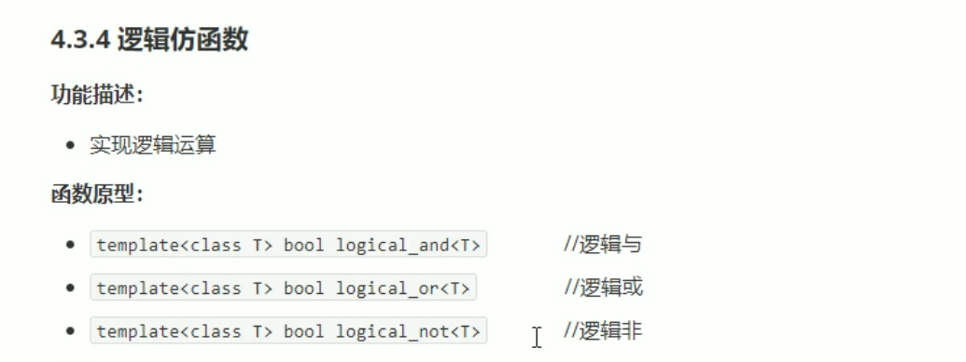

#include <iostream>

using namespace std;

#include <string>

#include<functional>

#include<vector>

#include<algorithm>

void test01()

{

vector<bool> v;

v.push_back(true);

v.push_back(false);

v.push_back(true);

v.push_back(false);

for (vector<bool>::iterator it = v.begin(); it != v.end(); it++)

{

cout << *it << " ";

}

cout << endl;

vector<bool> v2;

v2.resize(v.size());//重新开辟空间

transform(v.begin(), v.end(), v2.begin(), logical_not<bool>());//搬运算法。

for (vector<bool>::iterator it = v2.begin(); it != v2.end(); it++)

{

cout << *it << " ";

}

cout << endl;

}

int main()

{

test01();

system("pause");

return 0;

}

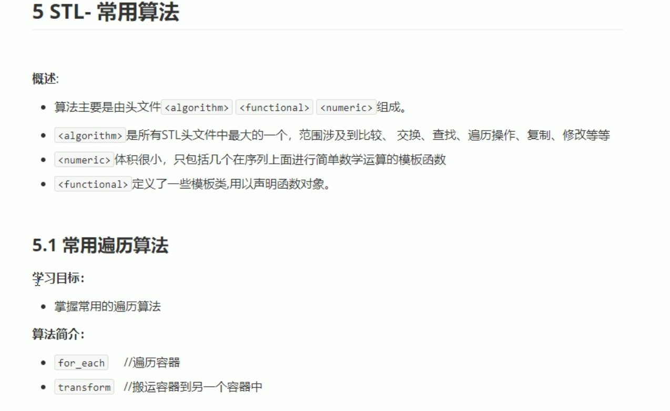

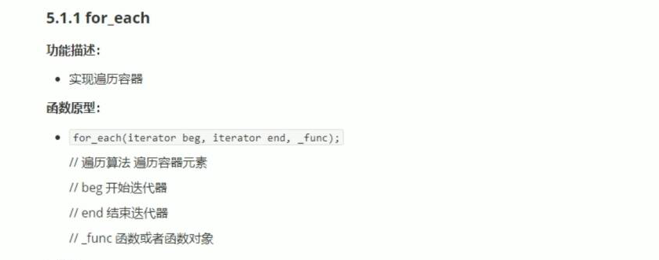

#include <iostream>

using namespace std;

#include <string>

#include <vector>

#include<algorithm>

void print01(int val)

{

cout << val << " ";

}

class print02

{

public:

void operator()(int val)

{

cout << val << " ";

}

};

void test01()

{

vector<int> v;

for (int i = 0; i < 10; i++)

{

v.push_back(i);

}

for_each(v.begin(), v.end(), print01);

cout << endl;

for_each(v.begin(), v.end(), print02());

cout << endl;

}

int main()

{

test01();

system("pause");

return 0;

}

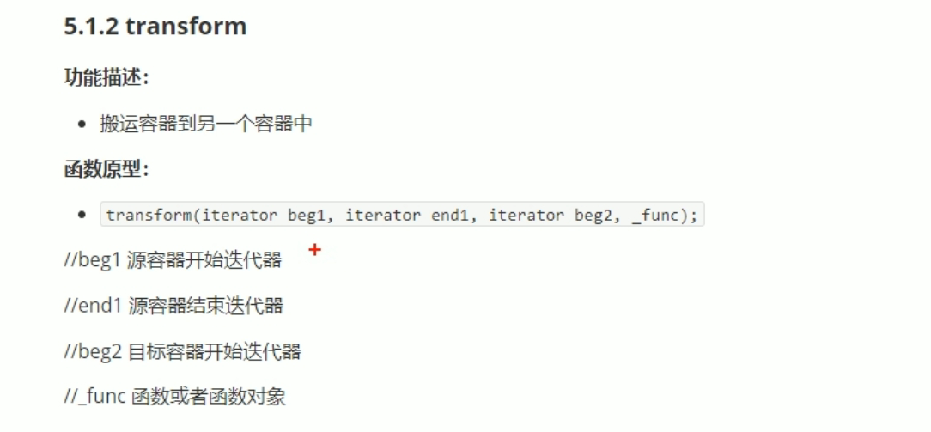

#include <iostream>

using namespace std;

#include <string>

#include <vector>

#include<algorithm>

#include<functional>

class TransForm

{

public:

int operator()(int v)

{

return v +1000;

}

};

class MyPrint

{

public:

void operator()(int val)

{

cout << val << " ";

}

};

void test01()

{

vector<int> v;

for (int i = 0; i < 10; i++)

{

v.push_back(i);

}

vector<int>vTarget;

vTarget.resize(v.size());//开辟空间

transform(v.begin(), v.end(), vTarget.begin(), TransForm());

for_each(vTarget.begin(), vTarget.end(), MyPrint());

cout << endl;

}

int main()

{

test01();

system("pause");

return 0;

}

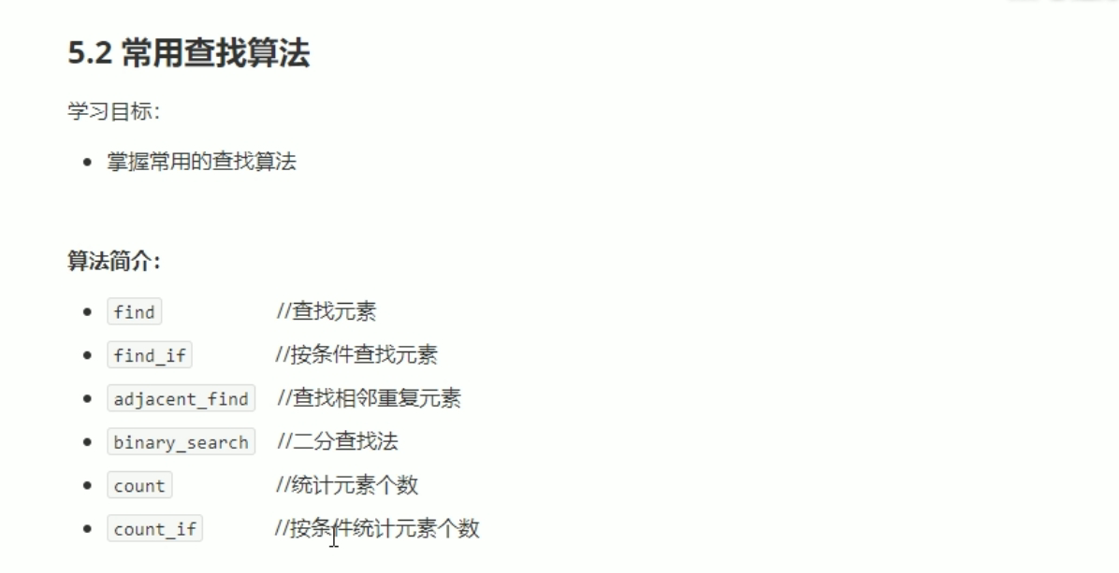

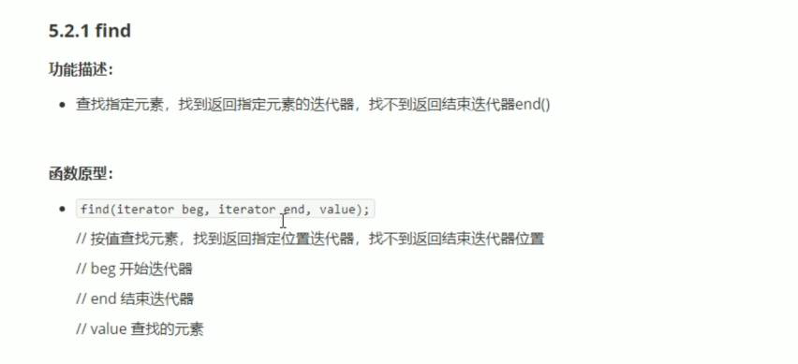

#include <iostream>

using namespace std;

#include <string>

#include<vector>

#include<algorithm>

void test01()

{

vector<int> v;

for (int i = 0; i < 10; i++)

{

v.push_back(i);

}

vector<int> ::iterator it= find(v.begin(), v.end(), 50);

if (it == v.end())

{

cout << "没有找到。" << endl;

}

else

{

cout << "找到了： " << *it << endl;

}

}

class Person

{

public:

Person(string name, int age)

{

this->m_Age = age;

this->m_Name = name;

}

//重载 == 底层find 不知道如何比较Person中的两个数据类型。

bool operator == (const Person &p)

{

if (this->m_Name == p.m_Name &&this->m_Age == p.m_Age)

{

return true;

}

else

{

return false;

}

}

string m_Name;

int m_Age;

};

void test02()

{

vector<Person> v;

Person p1("aaa", 10);

Person p2("bbb", 20);

Person p3("ccc", 30);

Person p4("ddd", 40);

Person p5("fff", 50);

v.push_back(p1);

v.push_back(p2);

v.push_back(p3);

v.push_back(p4);

v.push_back(p5);

vector<Person>::iterator it = find(v.begin(), v.end(), p2);

if (it == v.end())

{

cout << "没有找到。" << endl;

}

else

{

cout << "找到了：姓名 " << (*it).m_Name<<"年龄："<<(*it).m_Age<< endl;

}

}

int main()

{

test02();

system("pause");

return 0;

}

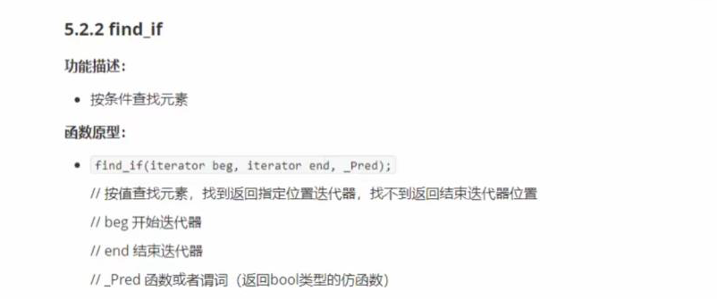

#include <iostream>

using namespace std;

#include <string>

#include<vector>

#include<algorithm>

class GreaterFive

{

public:

bool operator()(int val)

{

return val > 5;

}

};

void test01()

{

vector<int> v;

for (int i = 0; i < 10; i++)

{

v.push_back(i);

}

vector<int>::iterator it = find_if(v.begin(), v.end(), GreaterFive());

if (it == v.end())

{

cout << "没找到。" << endl;

}

else

{

cout << "找到大于5的数: " << *it << endl;

}

}

class Person

{

public:

Person(string name, int age)

{

this->m_Age = age;

this->m_Name = name;

}

string m_Name;

int m_Age;

};

class Greater20

{

public:

bool operator()(Person &p)

{

return p.m_Age > 20;

}

};

void test02()

{

vector<Person> v;

Person p1("aaa", 10);

Person p2("bbb", 20);

Person p3("ccc", 30);

Person p4("ddd", 40);

Person p5("fff", 50);

v.push_back(p1);

v.push_back(p2);

v.push_back(p3);

v.push_back(p4);

v.push_back(p5);

vector<Person>::iterator it = find_if(v.begin(), v.end(), Greater20());

if (it == v.end())

{

cout << "没找到。" << endl;

}

else

{

cout << "找到大于20的年龄的姓名： " << it->m_Name << endl;

}

}

int main()

{

test02();

system("pause");

return 0;

}

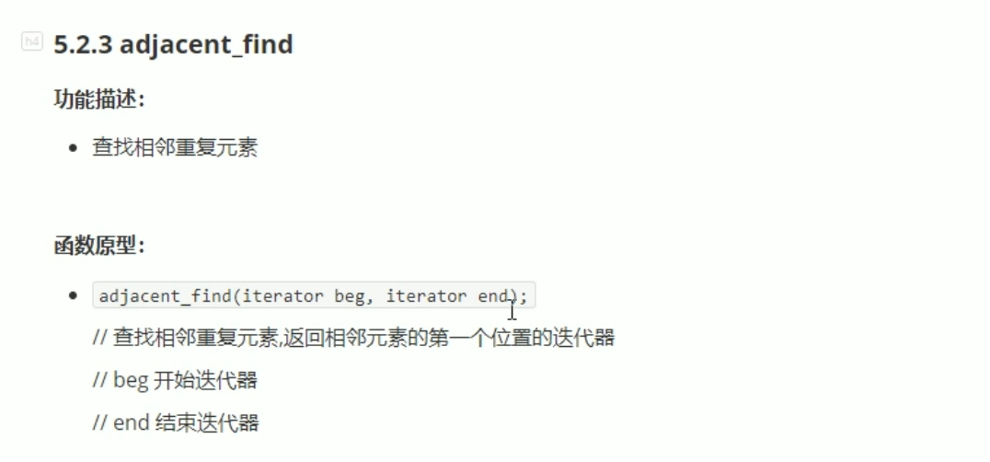

#include <iostream>

using namespace std;

#include <string>

#include <vector>

#include <algorithm>

void test01()

{

vector<int> v;

v.push_back(2);

v.push_back(0);

v.push_back(3);

v.push_back(3);

v.push_back(1);

v.push_back(9);

vector<int> ::iterator pos = adjacent_find(v.begin(), v.end());

if (pos == v.end())

{

cout << "未找到相邻重复元素。" << endl;

}

else

{

cout << "找到相邻重复元素。" << *pos << endl;

}

}

int main()

{

test01();

system("pause");

return 0;

}

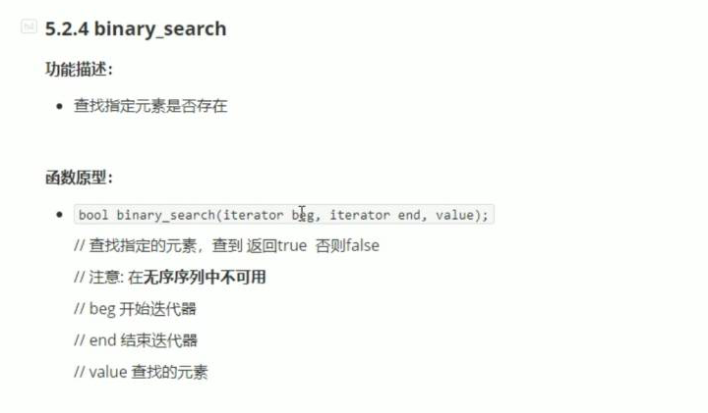

#include <iostream>

using namespace std;

#include <string>

#include <vector>

#include <algorithm>

void test01()

{

vector<int> v;

for (int i = 0; i < 10; i++)

{

v.push_back(i);

}

//容器下必须是有序的序列。如果无序，结果未知。

bool ret = binary_search(v.begin(), v.end(),5);

if (ret)

{

cout << "找到相邻重复元素。" << endl;

}

else

{

cout << "未找到相邻重复元素。" << endl;

}

}

int main()

{

test01();

system("pause");

return 0;

}

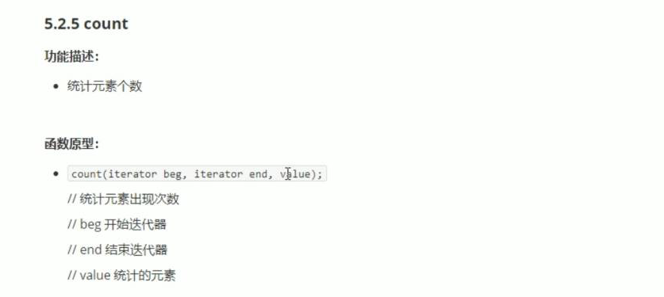

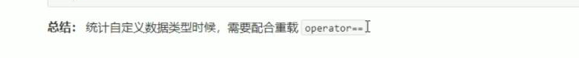

#include <iostream>

using namespace std;

#include <string>

#include <vector>

#include <algorithm>

void test01()

{

vector<int> v;

v.push_back(10);

v.push_back(50);

v.push_back(30);

v.push_back(40);

v.push_back(50);

int num = count(v.begin(), v.end(), 50);

cout << "50的个数为： " << num << endl;

}

class Person

{

public:

Person(string name, int age)

{

this->m_Age = age;

this->m_Name = name;

}

bool operator == ( const Person &p)

{

if (this->m_Age == p.m_Age)

{

return true;

}

else

{

return false;

}

}

string m_Name;

int m_Age;

};

void test02()

{

vector<Person> v;

Person p1("刘备", 30);

Person p2("关羽", 20);

Person p3("张飞", 20);

Person p4("赵云", 25);

Person p5("黄忠", 60);

v.push_back(p1);

v.push_back(p2);

v.push_back(p3);

v.push_back(p4);

v.push_back(p5);

Person p("诸葛亮", 20);

int num = count(v.begin(), v.end(),p);

cout << "和诸葛亮一样岁数的人： " << num << endl;

}

int main()

{

test02();

system("pause");

return 0;

}

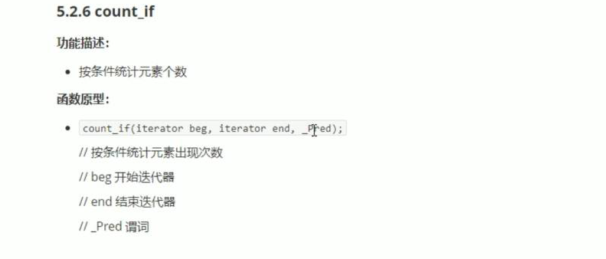

#include <iostream>

using namespace std;

#include <string>

#include <vector>

#include <algorithm>

class Greater20

{

public:

bool operator()(int val)

{

return val > 20;

}

};

void test01()

{

vector<int> v;

v.push_back(10);

v.push_back(50);

v.push_back(30);

v.push_back(40);

v.push_back(50);

int num = count_if(v.begin(), v.end(), Greater20());

cout << "大于20的个数为： " << num << endl;

}

class Person

{

public:

Person(string name, int age)

{

this->m_Age = age;

this->m_Name = name;

}

bool operator == ( const Person &p)

{

if (this->m_Age == p.m_Age)

{

return true;

}

else

{

return false;

}

}

string m_Name;

int m_Age;

};

class AgeGreater20

{

public:

bool operator()(const Person&p)

{

return p.m_Age > 20;

}

};

void test02()

{

vector<Person> v;

Person p1("刘备", 30);

Person p2("关羽", 20);

Person p3("张飞", 20);

Person p4("赵云", 25);

Person p5("黄忠", 60);

v.push_back(p1);

v.push_back(p2);

v.push_back(p3);

v.push_back(p4);

v.push_back(p5);

int num = count_if(v.begin(), v.end(), AgeGreater20());

cout << "年龄大于25的人数目： " << num << endl;

}

int main()

{

test02();

system("pause");

return 0;

}

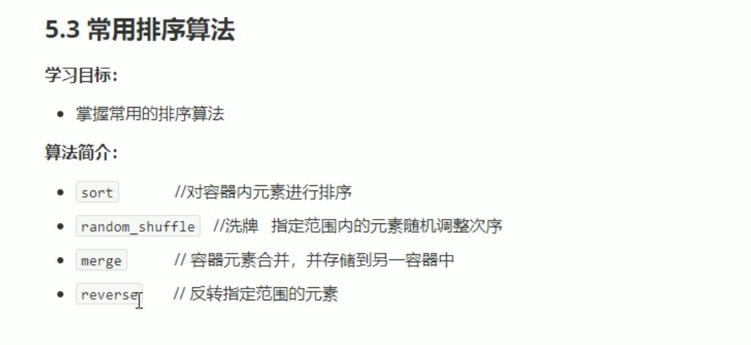

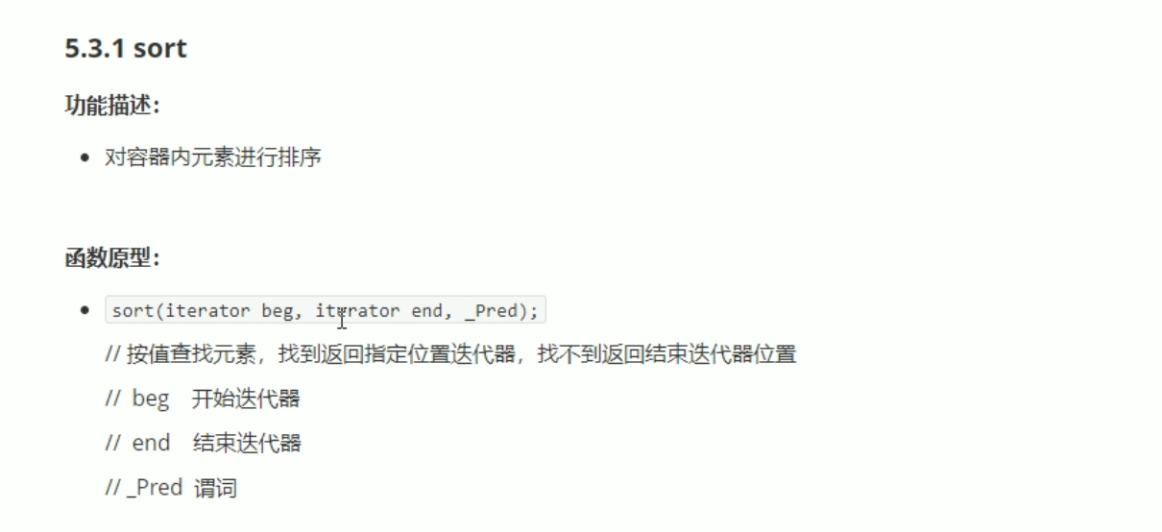

#include <iostream>

using namespace std;

#include <string>

#include <vector>

#include <algorithm>

#include<functional>

void myPrint(int val)

{

cout << val << " ";

}

void test01()

{

vector<int> v;

v.push_back(10);

v.push_back(50);

v.push_back(30);

v.push_back(40);

v.push_back(50);

sort(v.begin(), v.end());

for_each(v.begin(), v.end(), myPrint);

cout << endl;

sort(v.begin(), v.end(), greater<int>());

for_each(v.begin(), v.end(), myPrint);

cout << endl;

}

int main()

{

test01();

system("pause");

return 0;

}

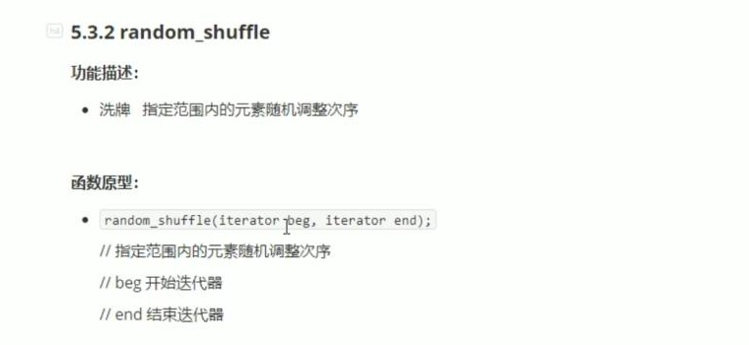

#include <iostream>

using namespace std;

#include <string>

#include <vector>

#include <algorithm>

#include<ctime>

void myPrint(int val)

{

cout << val << " ";

}

void test01()

{

srand((unsigned int)time(NULL));

vector<int> v;

for (int i = 0; i < 10; i++)

{

v.push_back(i);

}

random_shuffle(v.begin(), v.end());

for_each(v.begin(), v.end(), myPrint);

cout << endl;

}

int main()

{

test01();

system("pause");

return 0;

}

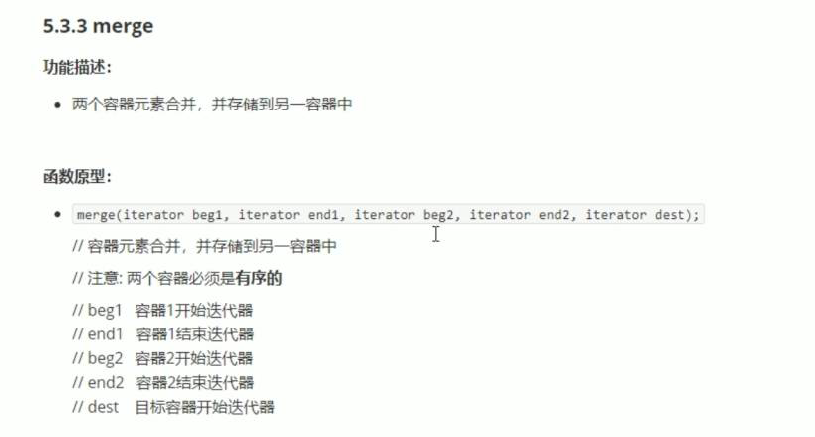



#include <iostream>

using namespace std;

#include <string>

#include <vector>

#include <algorithm>

void myPrint(int val)

{

cout << val << " ";

}

void test01()

{

vector<int> v1;

vector<int> v2;

for (int i = 0; i < 10; i++)

{

v1.push_back(i);

v2.push_back(i+2);

}

vector<int> vTarget;

vTarget.resize(v1.size() + v2.size());

merge(v1.begin(), v1.end(), v2.begin(), v2.end(), vTarget.begin());

for_each(vTarget.begin(), vTarget.end(), myPrint);

cout << endl;

}

int main()

{

test01();

system("pause");

return 0;

}

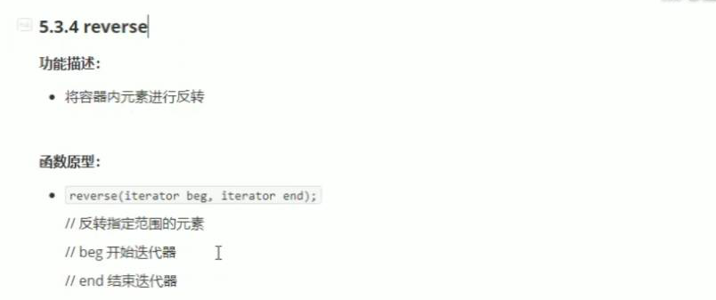

#include <iostream>

using namespace std;

#include <string>

#include <vector>

#include <algorithm>

#include<functional>

void myPrint(int val)

{

cout << val << " ";

}

void test01()

{

vector<int> v;

v.push_back(10);

v.push_back(50);

v.push_back(30);

v.push_back(40);

v.push_back(50);

cout << "反转前： " << endl;

for_each(v.begin(), v.end(), myPrint);

cout << endl;

cout << "反转后 ： " << endl;

reverse(v.begin(), v.end());

for_each(v.begin(), v.end(), myPrint);

cout << endl;

}

int main()

{

test01();

system("pause");

return 0;

}

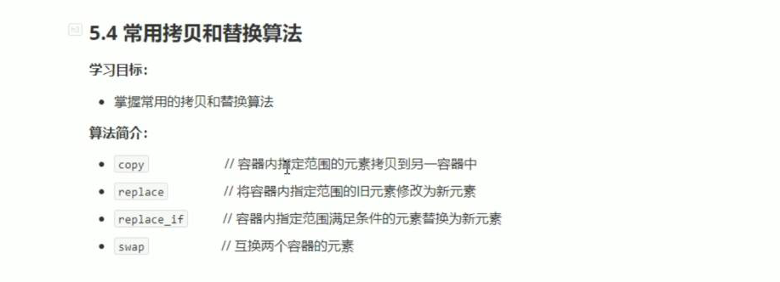

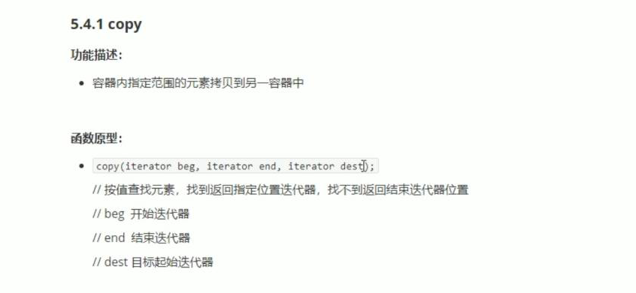

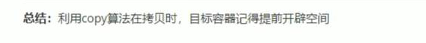

#include <iostream>

using namespace std;

#include <string>

#include<vector>

#include<algorithm>

void myPrint(int val)

{

cout << val << " ";

}

void test01()

{

vector<int> v1;

for (int i = 0; i < 10; i++)

{

v1.push_back(i);

}

vector<int> v2;

v2.resize(v1.size());

copy(v1.begin(), v1.end(), v2.begin());

for_each(v2.begin(), v2.end(), myPrint);

cout << endl;

}

int main()

{

test01();

system("pause");

return 0;

}

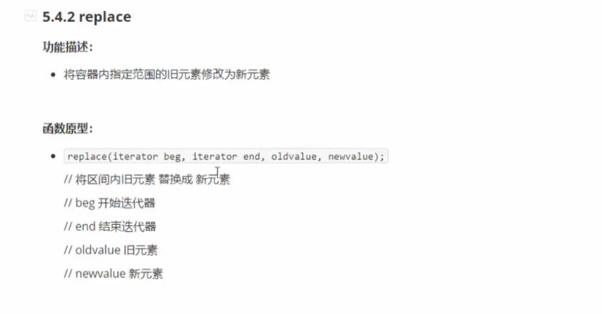

#include <iostream>

using namespace std;

#include <string>

#include<vector>

#include<algorithm>

void myPrint(int val)

{

cout << val << " ";

}

class MyPrint

{

public:

void operator()(int val)

{

cout << val << " ";

}

};

void test01()

{

vector<int> v;

v.push_back(10);

v.push_back(50);

v.push_back(30);

v.push_back(40);

v.push_back(50);

cout << "替换前： " << endl;

for_each(v.begin(), v.end(), MyPrint());

cout << endl;

replace(v.begin(), v.end(), 50, 1000);

cout << "替换后： " << endl;

for_each(v.begin(), v.end(), MyPrint());

cout << endl;

}

int main()

{

test01();

system("pause");

return 0;

}

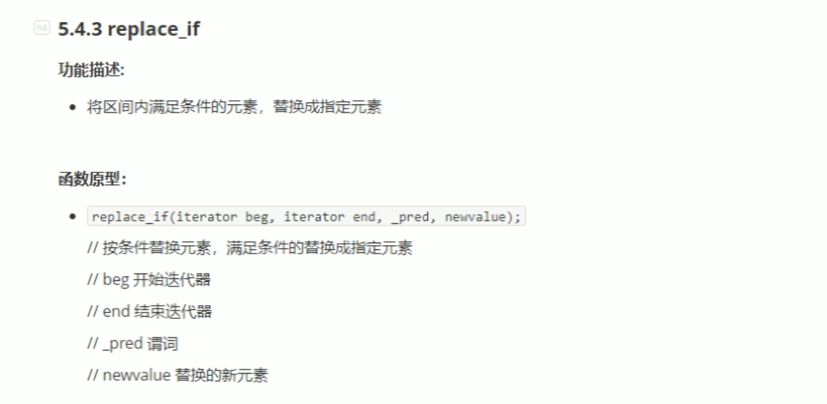#include <iostream>

using namespace std;

#include <string>

#include<vector>

#include<algorithm>

class MyPrint

{

public:

void operator()(int val)

{

cout << val << " ";

}

};

class Greater20

{

public:

bool operator()(int val)

{

return val > 20;

}

};

void test01()

{

vector<int> v;

v.push_back(10);

v.push_back(50);

v.push_back(30);

v.push_back(40);

v.push_back(50);

cout << "替换前： " << endl;

for_each(v.begin(), v.end(), MyPrint());

cout << endl;

replace_if(v.begin(), v.end(), Greater20(),2000);

cout << "替换后： " << endl;

for_each(v.begin(), v.end(), MyPrint());

cout << endl;

}

int main()

{

test01();

system("pause");

return 0;

}

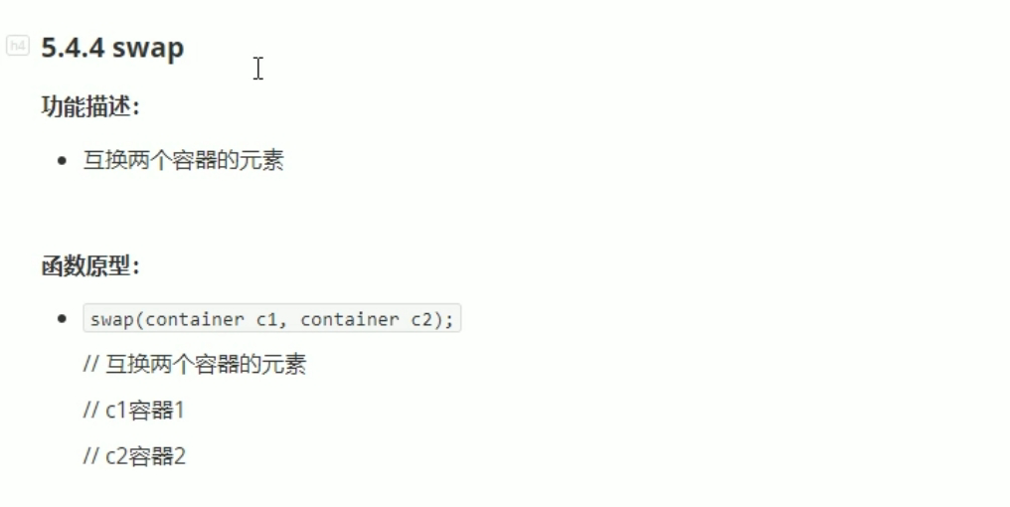

同种类型交换。

#include <iostream>

using namespace std;

#include <string>

#include <vector>

#include <algorithm>

void myPrint(int val)

{

cout << val << " ";

}

void test01()

{

vector<int> v1;

vector<int> v2;

for (int i = 0; i < 10; i++)

{

v1.push_back(i);

v2.push_back(i + 100);

}

cout << "交换前 ：" << endl;

for_each(v1.begin(), v1.end(), myPrint);

cout << endl;

for_each(v2.begin(), v2.end(), myPrint);

cout << endl;

cout << "----------------" << endl;

swap(v1, v2);

cout << "交换后 ：" << endl;

for_each(v1.begin(), v1.end(), myPrint);

cout << endl;

for_each(v2.begin(), v2.end(), myPrint);

cout << endl;

}

int main()

{

test01();

system("pause");

return 0;

}

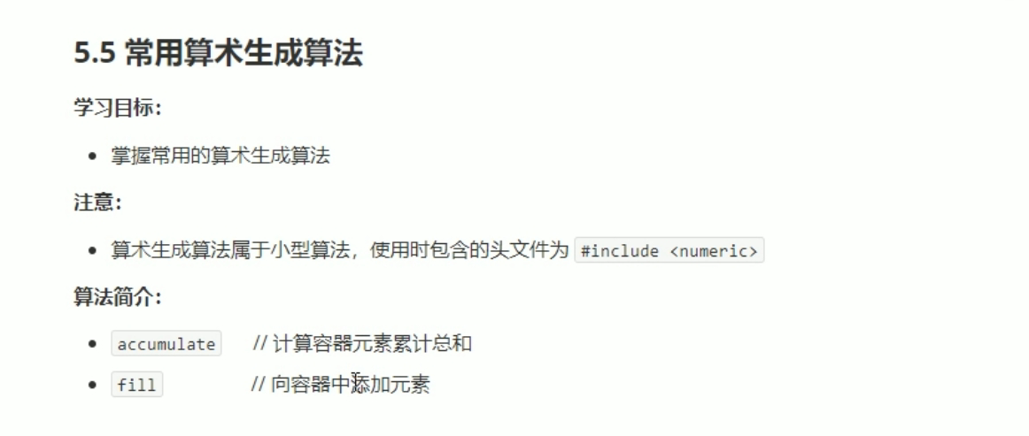

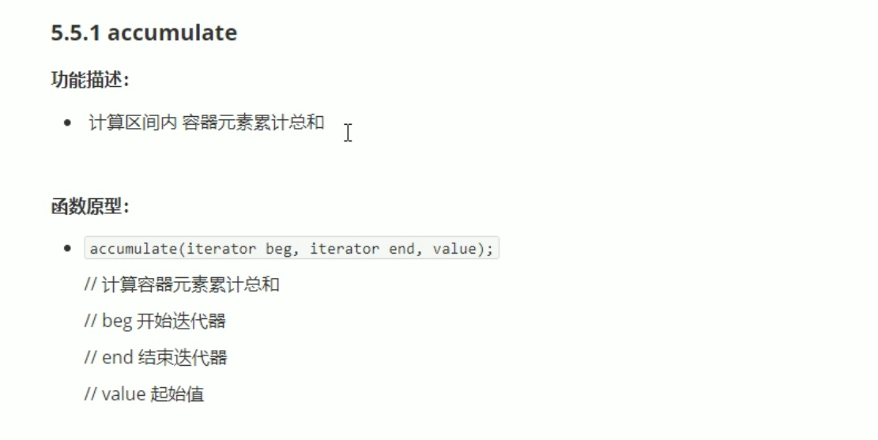

#include <iostream>

using namespace std;

#include <string>

#include <vector>

#include<numeric>

void myPrint(int val)

{

cout << val << " ";

}

void test01()

{

vector<int> v1;

vector<int> v2;

for (int i = 0; i <= 100; i++)

{

v1.push_back(i);

}

int total = accumulate(v1.begin(), v1.end(), 100);//起使累加值，总和加上 100

cout << "total = " << total << endl;

}

int main()

{

test01();

system("pause");

return 0;

}

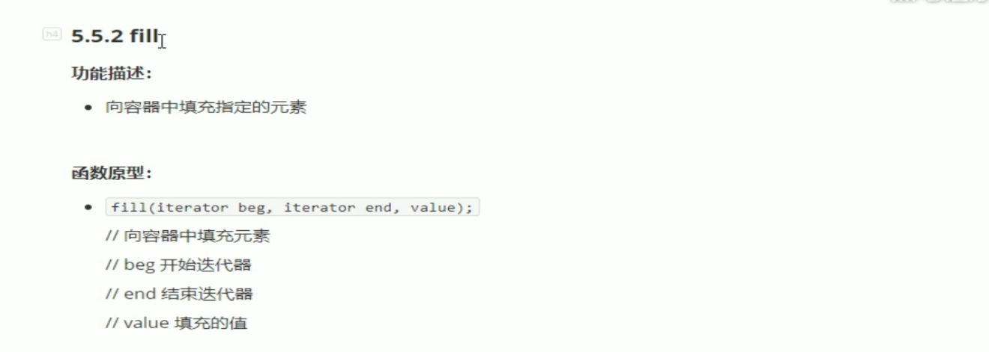

#include <iostream>

using namespace std;

#include <string>

#include <vector>

#include<numeric>

#include<algorithm>

void myPrint(int val)

{

cout << val << " ";

}

void test01()

{

vector<int> v1;

v1.resize(10);

cout << "填充前： " << endl;

for_each(v1.begin(), v1.end(), myPrint);

fill(v1.begin(), v1.end(), 100);//填充指定值100.

cout << endl;

cout << "填充后： " << endl;

for_each(v1.begin(), v1.end(), myPrint);

cout << endl;

}

int main()

{

test01();

system("pause");

return 0;

}

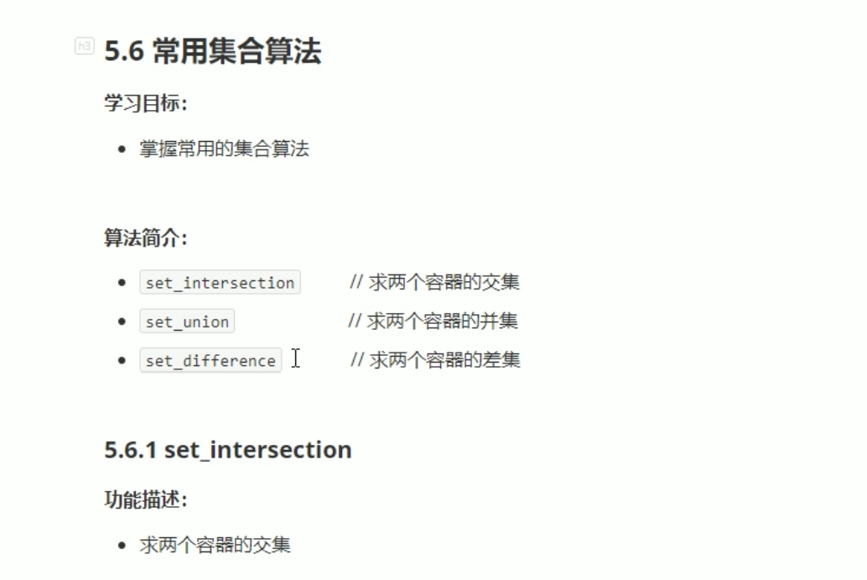

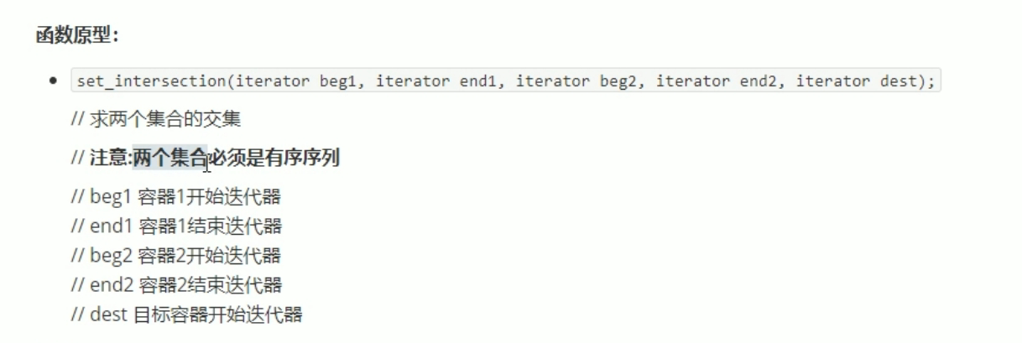

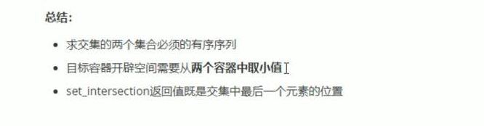

#include <iostream>

using namespace std;

#include <string>

#include <vector>

#include <algorithm>

void myPrint(int val)

{

cout << val << " ";

}

void test01()

{

vector<int> v1;

vector<int> v2;

for (int i = 0; i < 10; i++)

{

v1.push_back(i);

v2.push_back(i + 5);

}

vector<int>vTarget;

vTarget.resize(min(v1.size(),v2.size()));

vector<int>::iterator itEnd = set_intersection(v1.begin(), v1.end(), v2.begin(), v2.end(), vTarget.begin());

for_each(vTarget.begin(), itEnd, myPrint);

cout << endl;

}

int main()

{

test01();

system("pause");

return 0;

}

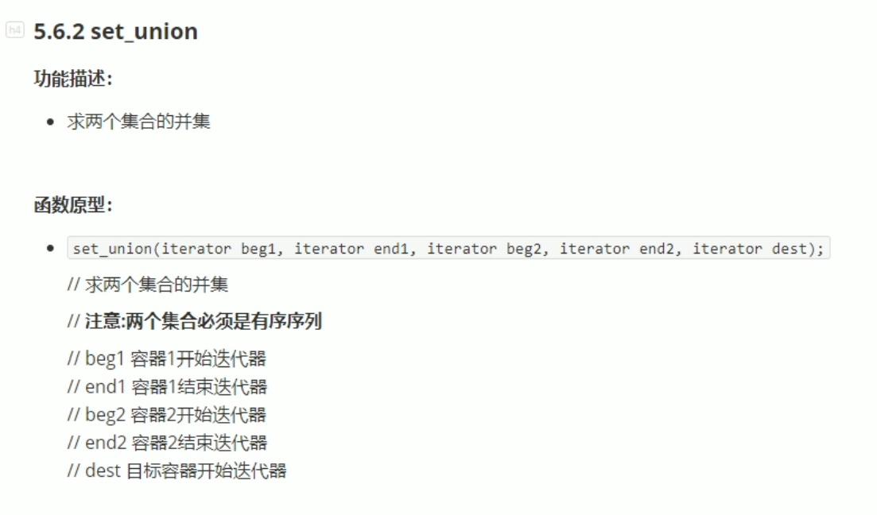

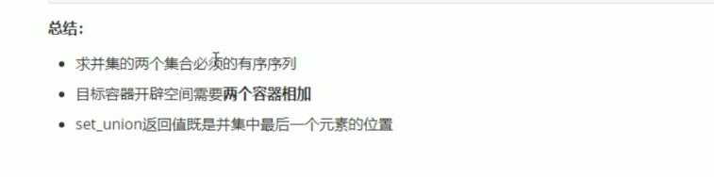

#include <iostream>

using namespace std;

#include <string>

#include <vector>

#include <algorithm>

void myPrint(int val)

{

cout << val << " ";

}

void test01()

{

vector<int> v1;

vector<int> v2;

for (int i = 0; i < 10; i++)

{

v1.push_back(i);

v2.push_back(i + 5);

}

vector<int>vTarget;

vTarget.resize(v1.size()+ v2.size());

vector<int>::iterator itEnd = set_union(v1.begin(), v1.end(), v2.begin(), v2.end(), vTarget.begin());

for_each(vTarget.begin(), itEnd, myPrint);//注意返回的迭代器itEnd。

cout << endl;

}

int main()

{

test01();

system("pause");

return 0;

}

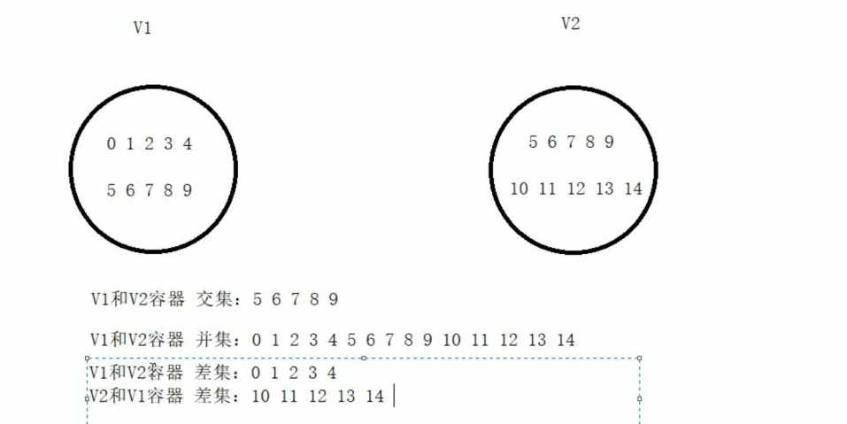

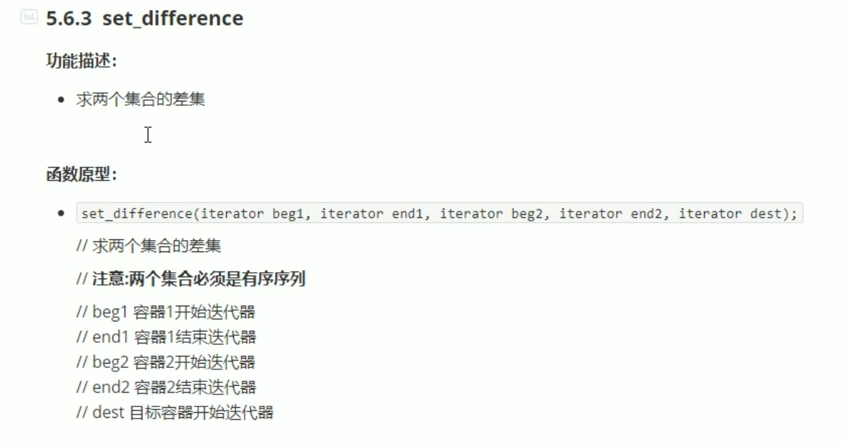

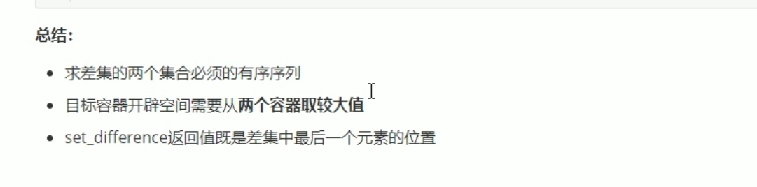

#include <iostream>

using namespace std;

#include <string>

#include <vector>

#include <algorithm>

void myPrint(int val)

{

cout << val << " ";

}

void test01()

{

vector<int> v1;

vector<int> v2;

for (int i = 0; i < 10; i++)

{

v1.push_back(i);

v2.push_back(i + 5);

}

vector<int>vTarget;

vTarget.resize(max(v1.size(), v2.size()));

cout << "v1和v2的差集是： " << endl;

vector<int>::iterator itEnd = set_difference(v1.begin(), v1.end(), v2.begin(), v2.end(), vTarget.begin());

for_each(vTarget.begin(), itEnd, myPrint);//注意返回的迭代器itEnd。

cout << endl;

}

int main()

{

test01();

system("pause");

return 0;

}